WATERSHED INVENTORY I: WATERSHED DESCRIPTION

Watershed Location
The Treaty Creek-Wabash River Watershed is part of the Middle Wabash-Little Vermilion watershed and covers portions of Miami and Wabash counties (Figure 1). The watershed includes a number of tributaries to the Wabash River from immediately upstream of Lagro, Indiana to immediately upstream of Peru, Indiana. The Wabash River starts in Ohio and drains about 1,600 square miles by the time it gains water from the Treaty Creek-Wabash River Watershed project area.

Subwatersheds

Treaty-Creek-Wabash River Tributary Watersheds
In total, seven 12-digit Hydrologic Unit Codes are contained within the Treaty Creek-Wabash River Watershed (Figure 2, Table 1). The subwatersheds range in size from about 10,000 acres or 16 square miles to nearly 19,000 acres or 29 square miles. Each of these drainages will be discussed in further detail under Watershed Inventory II.

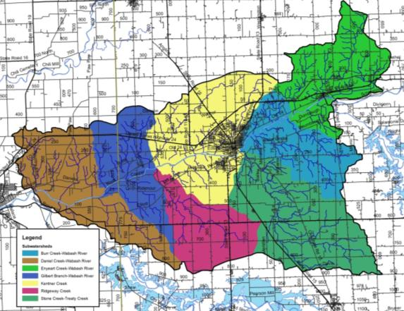
Figure 2. 12-digit Hydrologic Unit Codes in the Treaty Creek-Wabash River watershed.

Table 1. 12-digit Hydrologic Unit Code (HUC) watersheds in the Treaty Creek-Wabash River watershed.
Subwatershed Name | Hydrologic Unit Code | Area (acres) | Percent of Watershed
Enyeart Creek-Wabash River | 051201011401 | 13,848.7 | 13.7%
Stone Creek-Treaty Creek | 051201011402 | 19,267.6 | 19.1%
Burr Creek-Wabash River | 051201011403 | 11,245.7 | 11.1%
Ridgeway Creek | 051201011404 | 10,324.6 | 10.2%
Kentner Creek | 051201011405 | 18,634.9 | 18.5%
Gilbert Branch-Wabash River | 051201011406 | 11,224.0 | 11.1%
Daniel Creek-Wabash River | 051201011407 | 16,314.1 | 16.1%
Watershed Total |  | 100,859.6

Climate
In general, Indiana has a temperate climate with warm summers and cool to cold winters. The Treaty Creek-Wabash River Watershed is no different. Climate in this watershed is characterized by four distinct seasons throughout the year. High temperatures measure approximately 84 ºF in August, while low temperatures measure near freezing (17 ºF/-8.3 ºC) in January. The growing season typically extends from early April through late October. On average, 40 inches of precipitation occur within the Treaty Creek-Wabash River Watershed with precipitation occurring as small, frequent rain events spread almost evenly throughout the year.

Geology and Topography
The geology of the Treaty Creek-Wabash River Watershed is directly influenced by the advance and retreat of the Huron and Erie Lobes of the Wisconsin glaciation. As the Michigan, Erie, and Saginaw lobes of the glaciers advanced and retreated, they laid thick material over two-thirds of the state. End moraines, such as the Mississinewa Moraine, ground moraines, and lake and outwash plains create a geologically diverse landscape across northern Indiana, including the Treaty Creek-Wabash River Watershed. Glacial drift, outwash plains, and ground moraines cover much of the area along the length of the Wabash River within the watershed creating large, flat areas. Much of the bedrock geology across the watershed is comprised of limestone (Figure 2). The Wabash River cuts through sand and gravel outwash plains known as the Lagro Formation. These materials are from the Silurian and Devonian age. Icy meltwater from the more recent Wisconsin Age glaciers swept through the Lagro Formation to create the broad flat valley called the Maumee Terrace leaving steep limestone and dolomite bluffs behind.

Surficial geology indicates that the Treaty Creek-Wabash River Watershed lies within silty clay loam to clay loam with till, while the Wabash River floodplain is mostly limestone and dolomite within outwash. Surficial geology within the Treaty Creek-Wabash River Watershed originates from silty clay loam and clay loam till materials (Figure 3). The Wabash Formation, which is comprised of limestone, dolomite and argillaceous dolomite, underlies the entire Treaty Creek-Wabash River Watershed. The underlying bedrock is comprised of Silurian rocks (Gutschick, 1966).

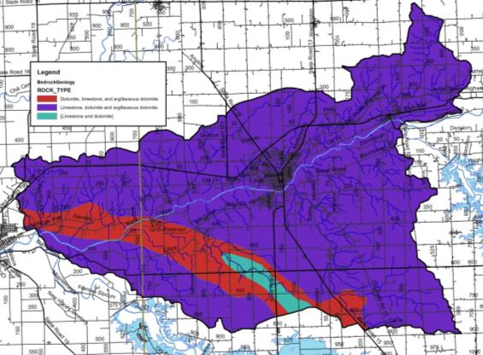
Figure 2. Bedrock in the Treaty Creek-Wabash River Watershed.

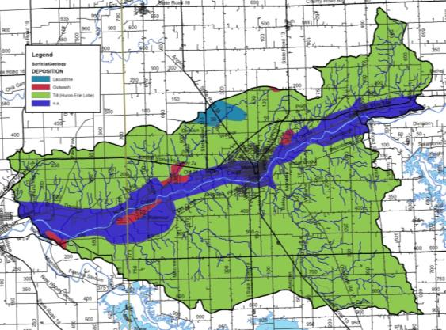
Figure 3. Surficial geology throughout the Treaty Creek-Wabash River Watershed.

The Treaty Creek-Wabash River Watershed has an average elevation of 760 feet msl (Figure 4). The watershed is relatively flat within the Wabash River floodplain; these flat areas extend one half to one full mile north and south of the Wabash River. The highest elevation of the watershed is nearly 890 feet above mean sea level (msl) occurring multiple times in the headwaters of Lagro and Treaty creeks. The lowest watershed elevation (640 ft msl) occurs at the Wabash River as it flows west out of the Treaty Creek-Wabash River Watershed. The steep limestone and dolomite bluffs occur north and south of the Wabash River throughout much of the river’s length within the watershed (Figure 3).
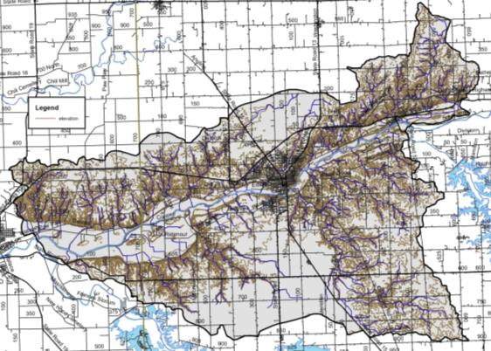
Figure 4. Surface elevation in the Treaty Creek-Wabash River Watershed.

Soil Characteristics
There are hundreds of different soil types located within the Treaty Creek-Wabash River Watershed. These soil types are delineated by their unique characteristics. The types are then arranged by relief, soil type, drainage pattern, and position within the landscape into soil associations. These associations provide the overall characteristics across the landscape. Soil associations are not used at the individual field level for decision making. Rather, the individual soil types are used for field-by-field management decisions. Some specific soil characteristics of interest, including septic limitations and soil erodibility, for watershed and water quality management are detailed below.

Soil Associations
The watershed is covered by 9 soil associations with three associations combining to cover more than two-thirds of the total watershed area. The Blount-Pewamo-Glynwood association is limited to the northern portion of the Lagro Creek drainage; the southern portion of the Treaty Creek, Burr Creek, and Ross Run drainages and the northern headwaters of the Miami County tributaries. These nearly level to moderately sloping, poorly drained soils are located on gently rolling topography where water ponds in depressions during wet periods. The Blount-Glynwood-Morley association covers a majority of the drainage east of the City of Wabash as well as the majority of Miami County tributaries north of the Wabash River, while the Fincastle-Brookston-Miamian association covers much of the Treaty Creek and Mill Creek drainages. These soils are located mixed row crop agriculture, pasture land, and remnant forested areas. This association is comprised of moderately steep, moderately well drained to well drained soils that formed on clay loam glacial till. These areas are typically located on rolling topography with knobs, ridges, and ravines cutting across the land surface. The mainstem of the Wabash River, its floodplain, and the relatively wide, flat valley located north and south of the river are covered by Sawmill-Lawson-Genesee soils in the west and Millsdale-Newglarus-Randolph soils to the east. These nearly level, well drained soils formed in outwash and underlying sand and gravel are located on terraces and deep depressional areas like the old glacial river channel that surrounds the Wabash River.

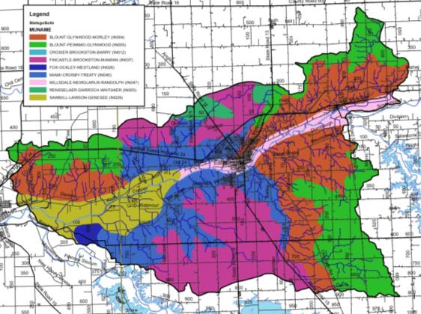
Figure 5. Soil associations in the Treaty Creek-Wabash River Watershed. Source: NRCS, 2018.

Soil Erodibility
Soils that move from the landscape to adjacent waterbodies result in degraded water quality, limited recreational use, and impaired aquatic habitat and health. Soils carry attached nutrients and pesticides, which can result in impaired water quality by increasing plant and algae growth or even killing aquatic life. The ability and/or likelihood for soils to move from the landscape to waterbodies are rated by the Natural Resources Conservation Service (NRCS). The NRCS uses soil texture and slope to classify soils into those that are considered highly erodible, potentially highly erodible, and not highly erodible. The classification is based on an erodibility index which is determined by dividing the potential average annual rate of erosion by the soil unit’s soil loss T value or tolerance value. The T value is the maximum annual rate of erosion that can occur for a particular soil type without causing a decline in long-term productivity. Potentially highly erodible soil determinations are based on the slope steepness and length in addition to the erodibility index value.

Watershed stakeholders are concerned about soil erosion. As detailed above, soils which have high erodibility index values are those that are located on steep slopes and are easily moved by wind, water, or land uses. Figure 6 details locations of highly erodible and potentially highly erodible soils within the Treaty Creek-Wabash River watershed. Highly erodible soils cover 21% of the watershed or 2,532 acres, while potentially highly erodible soils cover an additional 15% of the watershed or approximately 14,639 acres. Highly erodible soils are found throughout the watershed, but are concentrated on steep bluffs adjacent to the Wabash River and along tributaries east of the City of Wabash. Potentially highly erodible soils are located adjacent to highly erodible soils along the less steep areas of Treaty Creek-Wabash River drainages.

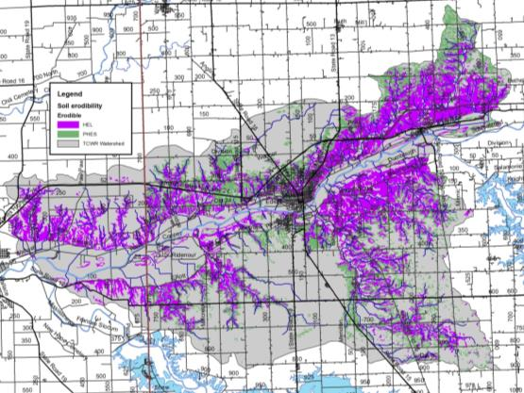
Figure 6. Highly erodible (HES) and potentially highly erodible soils (PHES) in the Treaty Creek-Wabash River Watershed. Source: NRCS, 2018.

Hydric Soils
Hydric soils are those which remain saturated for a sufficient period of time to generate a series of chemical, biological, and physical processes. The oxidation and reduction of iron in the soil, or “redox”, causes color changes characteristic of prolonged fluctuations in the water table. After undergoing these processes, the soils maintain the resultant characteristics even after draining or use modification occurs. Watershed stakeholders are concerned about the conversion of wetlands into agricultural and urban land uses. Historically, approximately 19,619 acres (19%) of the watershed was covered by hydric soils (Figure 7). Hydric soils are found throughout the watershed, with the highest densities located on flat plains away from the watershed drainageways. As these soils are considered to have developed under wetland conditions, they are a good indicator of historic wetland locations and therefore will be revisited in the land use section.
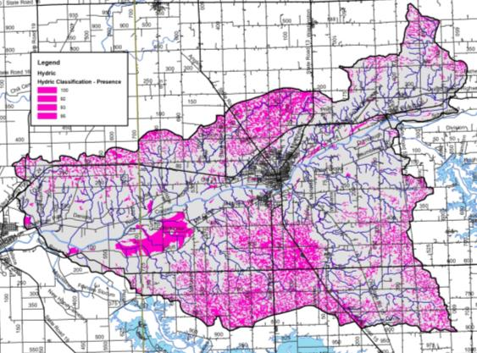
Figure 7. Hydric soils in the Treaty Creek-Wabash River Watershed. Source: NRCS, 2018.

Tile-Drained Soils
Soils drained by tile drains cover 64,288 acres or 64% of the Treaty Creek-Wabash River Watershed as estimated utilizing methods details in Sugg, 2007 (Figure 9). This method of drainage is widely used in row crop agricultural settings within the watershed, and has become even more intensively used within the last ten years. This results in altered hydrology, allowing the water to drain from the landscape more quickly to improve conditions for farming, but also potentially exacerbating downstream flooding and incising streams which cuts them off from their natural floodplains. In these areas, materials such as nutrients applied to agricultural soils are directly transported downstream, bypassing natural features such as filter strips that might otherwise filter out or assimilate nutrients. Both counties represented in the Treaty Creek-Wabash River Watershed use extensive series of tile to drain their lands. As the demands of production on each acre of land increases more tile is put in, typically in a network or series as extensive as 30 to 50 foot spacing between tiles. Impacts to stream water quality can be reduced by the use of tile control structures and drainage water management. Most of these areas are relatively flat where drainage augmentation is required to move water from agricultural fields in order to produce row crops. In these areas, materials applied to agricultural soils are directly transported to downstream waterbodies.

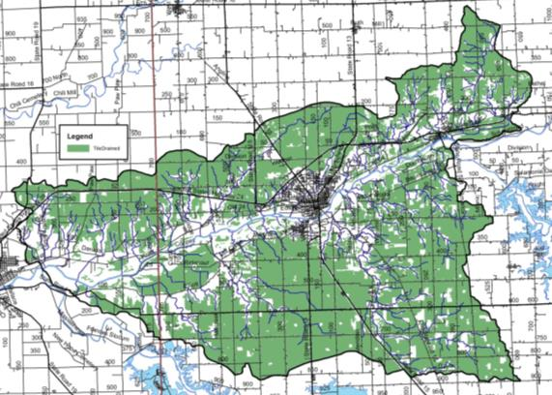
Figure 9. Tile-drained soils in the Treaty Creek-Wabash River Watershed. Source: NLCD, 2011 and NRCS, 2018.

Wastewater Treatment

Soil Septic Tank Suitability
Throughout Indiana, households depend upon septic tank absorption fields in order to treat wastewater. Seven soil characteristics, including position in the landscape, soil texture, slope, soil structure, soil consistency, depth to limiting layers, and depth to seasonal high water table, are utilized to determine suitability for on-site septic treatment. Septic tanks require soil characteristics that allow for gradual movement of wastewater from the surface into the groundwater. A variety of characteristics limit the ability for soils to adequately treat wastewater. High water tables, shallow soils, compact till, and coarse soils all limit soils abilities in their use as septic tank absorption fields. Specific system modifications are necessary to adequately address soil limitation; however, in some cases, soils are too poor for treatment and therefore prove inadequate for use in septic tank absorption fields.

Until 1990, residential homes located on 10 acres or more and occurring at least 1,000 feet from a neighboring residence were not required to comply with any septic system regulations. In 1990, a new septic code corrected this loophole. Current regulations address these issues and require that individual septic systems be examined for functionality. Additionally, newly constructed systems cannot be placed within the 100-year floodplain and systems installed at existing homes must be placed above the 100-year flood elevation. However, many residences grandfathered into this code throughout the state have not upgraded or installed fully functioning systems (Krenz and Lee, 2005). In these cases, septic effluent discharges into field tiles or open ditches and waterways and will likely continue to do so due to the high cost of repairing or modernizing systems ($4,000 to $15,000; ISDH, 2001). Lee et al. (2005) estimates that 76,650 gallons of untreated wastewater is expelled in the state of Indiana annually. The true impact of these systems on the water quality in the Treaty Creek-Wabash River Watershed cannot be determined without a complete survey of systems.

The NRCS ranks each soil series in terms of its limitations for use as a septic tank absorption field. Each soil series is placed in one of three categories: severely limited, moderately limited, and slightly limited. Some soils are also unranked. Severe or very limited limitations delineate areas whose soil properties present serious restrictions to the successful operation of a septic tank tile disposal field. Using soils with a severe limitation increases the probability of the system's failure and increases the costs of installation and maintenance. Areas designated as having moderate or somewhat limited limitations have soil qualities which present some drawbacks to the successful operation of a septic system; correcting these restrictions will increase the system's installation and maintenance costs. Slight limitations delineate locations whose soil properties present no known complications to the successful operation of a septic tank tile disposal field. Use of soils that are rated moderately or severely limited generally require special design, planning, and/or maintenance to overcome limitations and ensure proper function.

Watershed stakeholders are concerned about the lack of maintenance associated with septic tanks, the use of soils that are not suited for septic treatment, and the presence of straight pipe systems within the watershed. These concerns are exacerbated by the fact that severely limited soils cover essentially the entire watershed (Figure 10). Nearly 97,939 acres or 97% of the watershed is covered by soils that are considered very limited for use in septic tank absorption fields. Nearly 1,253 (1.2%) acres are somewhat limited meaning that these soils are generally suitable for septic systems. The remaining 1,667 acres (1.7%) not rated for septic usage as it is not generally industry standard to install a septic system in these geographic locations..

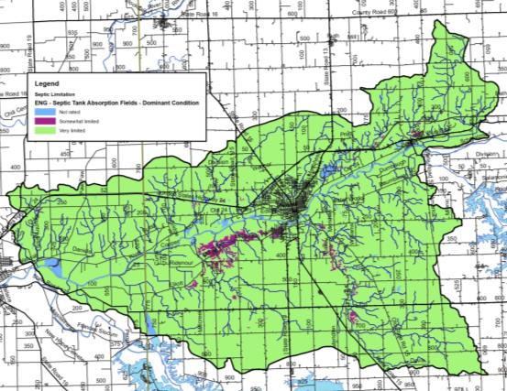
Figure 10. Suitability of soils for septic tank usage in the Treaty Creek-Wabash River Watershed. Source: NRCS, 2018.

Wastewater Treatment and Solids Disposal
Several facilities which treat wastewater and are permitted to discharge the treated effluent are located within the watershed. These facilities are regulated by National Pollution Discharge Elimination System (NPDES) permits. These include several wastewater treatment plants ranging in size from small, local plants to larger, publicly-owned facilities, and school facilities. In total, 8 NPDES-regulated facilities are located within the watershed (Figure 11). Table 2 details the NPDES facility name, activity, and permit number. More detailed information for each facility will be discussed on a subwatershed basis in subsequent sections.

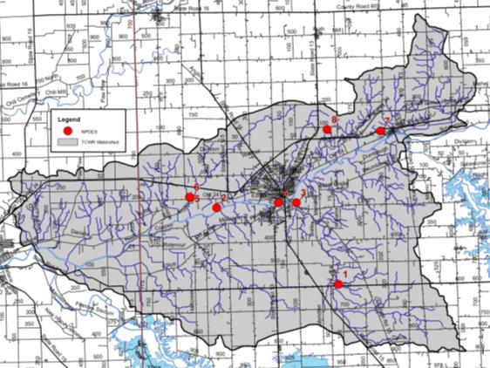
Figure 11. NPDES-regulated facilities in the Treaty Creek-Wabash River Watershed.

Table 2. NPDES-regulated facility information.
MapID | NPDES ID | Facility Name | Receiving Stream | Designed Flow
1 | IN0030635 | SOUTHWOOD ELEMENTARY SCHOOL | Treaty Creek | 0.011
2 | IN0039063 | WABASH ALLOYS, L.L.C. | Wabash River | 0.060
3 | IN0059510 | WABASH WATER TREATMENT/IAWC | Treaty Creek | 0.190
4 | IN0024741 | WABASH MUNICIPAL SEWAGE TR. PL | Wabash River | 4.000
5 | IN0045357 | LAKEVIEW TRAILER COURT & SUBDI | Kentner Creek | 0.010
6 | IN0054127 | LAKEVIEW MOBILE HOME WWTP | Kentner Creek | 0.012
7 | IN0003484 | CELOTEX CORP | Wabash River | 0.055
8 | IN0051861 | CARRIAGE HOUSE ESTATES MHP | Chamberlain Ditch | 0.006
Source: USEPA EnviroFacts Warehouse, 2018

Municipal Wastewater Treatment and Combined Sewer Overflows
In the relatively rural Treaty Creek-Wabash RIver Watershed, there are two wastewater treatment facilities located within and discharging to Kentner Creek, both are part of the Lakeview Mobile Home Park; one wastewater treatment plant discharging to Chamberlain Ditch from Carriage House Estates; one wastewater water facility discharging to the Wabash River from the City of Wabash; and the Southwood Elementary School wastewater facility and Indiana American Water, a drinking water facility, which discharges to Treaty Creek. Sludge from municipal wastewater treatment plants is applied on XX acres throughout the watershed. Much of this application occurs within the XX Subwatersheds (Figure 12).

City of Wabash WWTP
Lakeview Mobile Home Park
Carriage House Estates
Indiana American Water
Southwood Elementary School

Unsewered Areas
XX unsewered areas were identified within the watershed (Figure 12). Areas that have at least 25 houses within a square mile outside of the sanitary district boundaries were classified as dense, unsewered areas. Details about each area inserted here.

Figure 12. Wastewater treatment plant service areas, municipal biosolids land application sites, dense unsewered housing, and combined sewer overflow outfalls within the Treaty Creek-Wabash River Watershed.

Hydrology
Watershed streams, reservoirs, legal drains, floodplains, wetlands, storm drains, groundwater, subsurface conveyances, and manmade drainage channels all contribute to the watershed’s hydrology. Each component moves water into, out of, or through the system. Their contributions will be covered in further detail in subsequent sections.

Watershed Streams
The Treaty Creek-Wabash River Watershed contains approximately 297 miles of streams, regulated drains, and regulated tile drains. Of these, approximately 7.8 miles are regulated drains. Including Koontz Drain, Peebles Ditch, Unger Ditch, and Stauffer Ditch. The majority of streams in the Treaty Creek-Wabash River Watershed are not regulated; however, drain status and locations should be confirmed on a case by case basis with the Wabash County Surveyor. It should be noted that regulated drains are maintained by the county surveyor’s office and both of the regulated drains within the watershed have both a regular maintenance fund and a regular maintenance schedule. Maintenance practices can include dredging with large construction equipment to maintain flow, debris removal, and vegetation management both within the regulated drain and the riparian zone. As these waterbodies are subject to periodic cleaning, it is important to work with the county surveyor to establish priorities for these waterbodies in terms of water quality improvement and erosion control.

The major tributaries to the Wabash River within the Treaty Creek-Wabash River include Treaty Creek, Shrock Creek, Schrom Creek, Ross Run, Ridgeway Creek, Rager Creek, Mill Creek, Charley Creek, Lagro Creek, Kentner Creek, Helm Creek, Enyeart Creek, Gilbert Branch, Engleman Creek, Asher Branch, Daniel Branch, Burr Creek, and Daniel Cree (Figure 13). Treaty Creek and the Wabash River are used for recreational kayaking and canoeing, as well as fishing, swimming, and aesthetic enjoyment. Charly Creek and its waterfall are a common source of aesthetic enjoyment within the watershed. Stakeholders are concerned with maintaining the recreational value of the Wabash River and its tributaries, and have some concerns because portions of the watershed have been designated as impaired by IDEM for E. coli, nutrients, and impaired biotic communities.

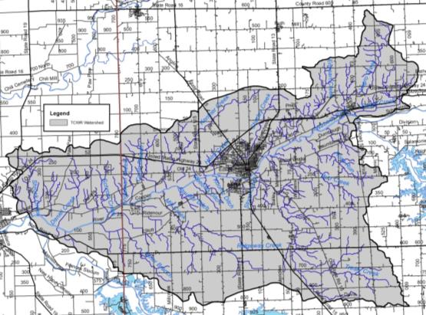
Figure 13. Streams in the Treaty Creek-Wabash River Watershed. Source: USGS, 2018.

Lakes, Ponds and Impoundments
Multiple small lakes and farm ponds dot the Treaty Creek-Wabash RIver Watershed landscape. These provide local swimming holes, recreational boating options, and localized fishing as well as providing water storage and retention to assist with flooding. Many are located in tributary headwaters and offer some water retention; however, most are insignificant in size or water quality impact. Most recreational boating and fishing occurs on the adjacent Salamonie or Mississinewa Reservoirs or on the Wabash River itself.

Impaired Waterbodies (303(d) List)
The impaired waterbodies, or 303(d), list is prepared biannually by the Indiana Department of Environmental Management. Waterbodies are included on the list if water quality assessments indicate that they do not meet their designated use. More information on the listing process is included in section 3.2.1. Seven stream segments within the Treaty Creek-Wabash River Watershed are included on the list of impaired waterbodies. Table 3 details the listings in the watershed, while Figure 14 maps the segments and their locations within the watershed. Waterbodies are listed as impaired for E. coli (15.2 miles), impaired biotic communities (13.0 miles), nutrients (15.2 miles), mercury and PCBs (15.2 miles). Based on the development of the Wabash River Nutrient and Pathogen TMDL Development (TetraTech, 2008), the E. coli impaired segments are considered category 4 impaired waterbodies, while nutrient, impaired biotic community, and mercury and PCB impaired segments are considered category 5 impairments.

Table 3. Impaired waterbodies in the Treaty Creek-Wabash RIver Watershed 2016 IDEM 303(d) list.
HUC | Waterbody | Assessment Unit | County | Impairment
051201011401 | Wabash River | INB01E3_M1011 | Wabash | E.coli, nutrients, mercury, PCBs
051201011401 | Wabash River | INB01F1_M1012 | Wabash | E.coli, nutrients, mercury, PCBs
051201011403 | Wabash River | INB01F2_M1013 | Wabash | E.coli, nutrients, mercury, PCBs
051201011405 | Wabash River | INB01F2_M1014 | Wabash | E.coli, nutrients, mercury, PCBs
051201011406 | Wabash River | INB01F5_M1015 | Miami, Wabash | E.coli, nutrients, mercury, PCBs
051201011406 | Wabash River | INB01F8_M1015 | Wabash | E.coli, nutrients, mercury, PCBs
051201011404 | Mill Creek | INB01F7_00 | Wabash | Impaired biotic communities

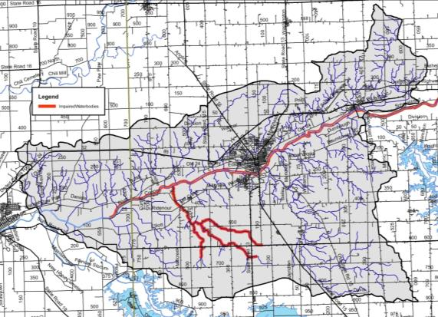
Figure 14. Impaired waterbody locations in the Treaty Creek-Wabash River Watershed. Source: IDEM, 2013.

Floodplains
Flooding is a common hazard that can affect a local area or an entire river basin. Increased imperviousness, encroachment on the floodplain, deforestation, stream obstruction, tiling, or failure of a flood control structure all are mechanisms by which flooding occurs. Impacts of flooding include property and inventory damage, utility damage and service disruption, bridge or road impasses, streambank erosion and riparian vegetation loss, water quality degradation, and channel or riparian area modification.

Floodplains are lands adjacent to streams, rivers, and other waterbodies that provide temporary storage for water. These systems act as nurseries for wildlife, offer green space for humans and wildlife, improve water quality, and buffer the waterbody from adjacent land uses. Local stakeholders are concerned about impacts to floodplains from development, lack of landowner maintenance, and soil erosion and deposition within the floodplain.

Figure 16 details the locations of floodplains within the Treaty Creek-Wabash River Watershed. Extensive floodplains lie adjacent to the Wabash River with narrow floodplain areas adjacent to Mill Creek, Charley Creek, and Treaty Creek. Wabash River flooding, especially when the Salamonie Reservoir is releasing water into the river, has been noted as a historic issue and continues to be of concern to stakeholders. Approximately 7.6% (8,472 acres) of the Treaty Creek-Wabash River Watershed lies within the 100-year floodplain (Figure 15). This 100-year floodplain is composed of three regions:
- Zone A is the area inundated during a 100-year flood event for which no base flood elevations (BFE) have been established. Slightly more than half of the Treaty Creek-Wabash River Watershed floodplain is in Zone A or nearly 4,210 acres (3.8% of the watershed).
- Zone AE is the area inundated during a 100-year flood event for which BFEs have been determined. The chance of flooding in Zone AE is the same as the chance of flooding in Zone A; however, floodplain boundaries in Zone A are approximated, while those in Zone AE are based on detailed hydraulic models which allows Zone AE floodplains to be more accurate. Nearly half of the Treaty Creek-Wabash River Watershed floodplain is in Zone AE or 4,001 acres (3.6 % of the watershed).
- Zone X includes areas outside the 100-year and 500-year floodplains which have a 1% chance of flooding to a depth of one foot of water. No BFEs are available for these areas and no flood insurance is required. The remainder of the watershed is classified as Zone X. An additional 260 acres (0.2 %) of Treaty Creek-Wabash River Watershed floodplain lies in Zone 3.

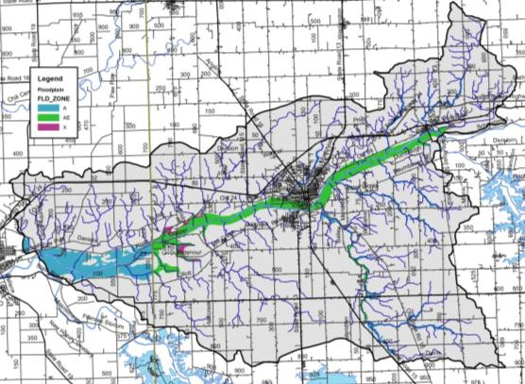
Figure 15. Floodplain locations within the Treaty Creek-Wabash River Watershed.

Wetlands
Approximately 25% of Indiana was covered by wetlands prior to European settlement (IDEM, 2007). Overall, 85% of wetlands have been lost resulting in Indiana ranking fourth in the nation in terms of percentage of wetland loss. Wetlands provide numerous valuable functions that are necessary for the health of a watershed and waterbodies. Wetlands play critical roles in protecting water quality, moderating water quantity, and providing habitat. Wetland vegetation adjacent to waterways stabilizes shorelines and streambanks, prevents erosion, and limits sediment transport to waterbodies. Additionally, wetlands have the capacity to increase stormwater detention capacity, increase stormwater attenuation, and moderate low water levels or flow volumes by allowing groundwater to slowly seep back into waterbodies. These benefits help to reduce flooding and erosion. Wetlands also serve as high quality natural areas providing breeding grounds for a variety of wildlife. They are typically diverse ecosystems which can provide recreational opportunities such as fishing, hiking, boating, and bird watching. It should be noted that natural wetlands are regulated through the IDEM and the U.S. Army Corps of Engineers while USDA has jurisdiction over wetlands on agricultural fields. Any modification to wetlands requires permits from these agencies.

Wetlands cover 1,389 acres, or 1.3%, of the watershed. When hydric soil coverage is used as an estimate of historic wetland coverage, it becomes apparent that more than 85% of wetlands have been modified or lost over time. This represents 28.5 square miles of wetland loss within the Treaty Creek-Wabash River Watershed. As commodity prices continue to go up and down, area land values remain high and as a result individuals are spending a great deal of money to drain small natural wetlands in their fields in order to be able to farm that additional couple acres of land as it is cheaper to tile it than to buy ground already in production.

Figure 17 shows the current extent of wetlands within the Treaty Creek-Wabash River Watershed. Wetlands displayed in Figure 16 results from compilation efforts by the U.S. Fish and Wildlife Service as part of the National Wetland Inventory (NWI). The NWI was not intended to map specific wetland boundaries that would compare exactly with boundaries derived from ground surveys. As such, NWI boundaries are not exact and should be considered to be estimates of wetland coverage. Using this map will help us to identify which portions of the watershed would make ideal candidates for wetland restoration efforts which would reduce the amount of sediment and nutrients reaching the creek, as well as helping to restore the natural hydrology of the area which could help to reduce flooding impacts locally.

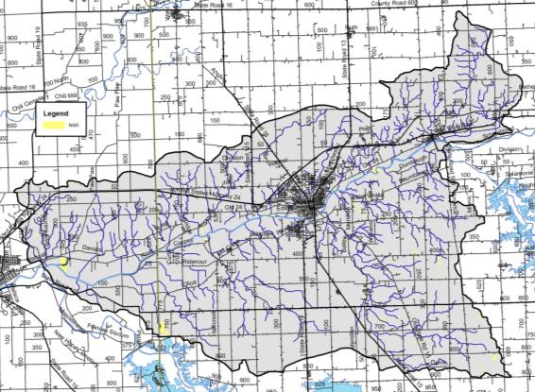
Figure 16. Wetland locations within the Treaty Creek-Wabash River Watershed. Source: USFWS, 2017.

Stormwater and Storm Drains
Under natural conditions, the majority of precipitation is allowed to infiltrate the soil and recharge groundwater resources. The volume of infiltration and groundwater recharge diminishes as development increases. To handle the large volume of precipitation falling in urban areas, stormwater systems have been constructed. Storm drain systems are present in most urban areas throughout the watershed. In total, more than 30 miles of storm drain pipe are present within the watershed. The City of Wabash works to mitigate stormwater impacts to the Treaty Creek-Wabash River watershed including Charley Creek, the most urban tributary in the watershed via its MS4 program (Figure 17).

Figure 17. City of Wabash MS4s boundary and CSO overflow locations.

The City of Wabash has eight combined sewer overflows (CSOs) which discharge to three streams: an unnamed tributary to Charley Creek, locally known as Priser Ditch; Charley Creek; and the Wabash River (United Consulting, 2003). CSOs 007 and 008 discharge to Priser Dich, CSOs 005 and 006 discharge to Charley Creek, and CSOs 001, 002, 003, and 004 discharge directly to the Wabash River (Figure 17). The city’s Stream Reach Characterization and Evaluation Report concluded that the CSO discharges negatively impact receiving streams. To address these impacts, the city enacted a best operation and maintenance plan including posting warning signs at all CSO outfalls, continued system inspection and maintenance, employee education, enacting a downspout disconnection program, and establishing a public education program including news releases.

Wellfields/Groundwater
In general, municipal water which supplies, Lagro and Wabash, is taken from unconsolidated deposits of relatively clean, coarse-textured sand and gravel deposited in gravel outwash (Grove, 2007). In total, seven aquifers cover Wabash and Miami counties. Aquifer thickness varies from 50 to 125 feet in some areas and exceed 400 feet near LaFontaine and trending northwest into Miami County along the Wabash River. The Till Veneer Aquifer System covers much of the Wabash River mainstem. This aquifer encompasses areas of unconsolidated material which is predominantly thin glacial till or alluvium overlying eroded bedrock (Grove, 2007). Much of the Treaty Creek-Wabash River Watershed is drained by the Bluffton Till and Bluffton Complex aquifer systems. These aquifers generally contain deposits of varying material and thickness but typically measure greater than 50 feet in thickness. Intratill sand and gravel lenses are overlain by thick deposits or separated from the surface by thick till layers within these aquifer systems (Grove, 2007).

Table 4 lists wellhead protection areas within and adjacent to the Treaty Creek-Wabash River Watershed. The wellhead protection areas and wellhead protection plans associated with each area will be discussed in additional detail in subsequent sections. Potential pollution from construction, sewage outfalls or overflows, illegal dumping, agriculture, and storm water runoff must be avoided or controlled due to the recharge of these aquifers from runoff and river water. The sensitivity to surface contamination is shown in Figure 18. While areas of aquifer within Wabash County north and south of Wabash and along the western Wabash County/eastern Miami County border are highly sensitive to contamination, much of the Treaty Creek-Wabash River Watershed possess low to moderate sensitivity to surface contamination.

Table 4. Wellhead protection areas in and adjacent to the Treaty Creek-Wabash River Watershed.
County | PWSID | System name | Population
Wabash | 5285003 | Indiana American Water - Wabash | 11,015
Wabash | 5285005 | Lagro Municipal Water Department | 454
Wabash | 5285006 | Lake View Mobile Home Park | 50
Wabash | 5285011 | Rhoades Wheel In Mobile Home Park | 60
Wabash | 5285019 | Carriage House Estates | 25

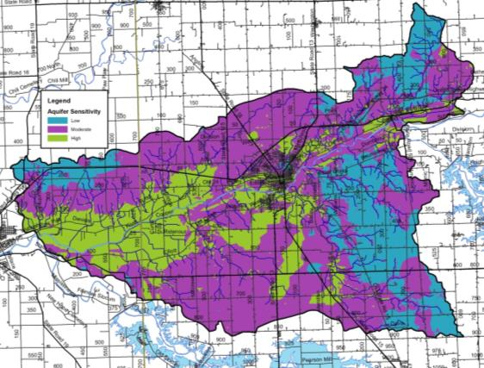
Figure 18. Aquifer sensitivity within the Treaty Creek-Wabash River Watershed. Source: IGS, 2015.

Natural History
Geology, climate, geographic location, and soils all factor into shaping the native flora and fauna which occurs in a particular area. Categorization of these floral and faunal communities has been completed by a number of ecologists since the earliest efforts by Coulter in 1886. Since this time, Petty and Jackson (1966) identified regional communities; Homoya et al. (1985) classified Indiana into natural regions, while Omernik and Gallant (1988) categorized Indiana into ecoregions. Homoya et al. (1985) note that prior to European settlement, much of Miami and Wabash counties were covered by a mix of wetland land uses, including bog, fen, marsh, sedge meadow, swamp, seep, and spring, as well as a mix of lakes and deciduous forest. Upland areas were likely covered by red, white, and black oak; maple, and shagbark and pignut hickory. More wet areas were covered by beech, sugar maple, black maple, and tulip poplar. Historically, wet habitat mixed with upland habitat throughout the watershed.

Natural and Ecoregion Descriptions
According to Homoya et al.’s (1985) classification of natural regions in Indiana, the Treaty Creek-Wabash River Watershed lies in Homoya’s Central Till Plain Natural Region. The Treaty Creek-Wabash River Watershed also lies in the Clayey High Lime Till Plains within the Eastern Corn Belt Plains Ecoregion as defined by Omernik and Gallant (1988). Petty and Jackson (1966) indicate that the Treaty Creek-Wabash River Watershed is within the Beech-Maple Association.

Wildlife Populations and Pets
Individuals are concerned about local wildlife and pet populations, the impact that these have on pathogen levels, and the impact that changing land uses could have on these populations. These will be quantified in subsequent sections. With these concerns in mind, wildlife density can be estimated from a variety of sources. The Indiana Department of Natural Resources (IDNR) is tasked with managing wildlife populations throughout the state. In order to complete this task, the IDNR must have an idea of the population density within specific areas, counties, or regions. The most recent survey of wildlife populations for which data are publicly available occurred in 2005. Those densities are shown in Table 5 with deer, squirrels and turkey being the most common wildlife present within the region. It should be noted that these numbers could both underestimate and overestimate populations within the watershed. Densities are recorded based on animal observations per 1000 hours of overall observation. If observations areas are not equally spread throughout the region, over or underestimates of the populations could occur. Likewise, animals are not likely equally distributed throughout the region; therefore, the regional density may again over or underestimate the true density of the animal in question. Nonetheless, these estimates provide the best guess at wildlife densities.

Table 5. Surrogate estimates of wildlife density in the IDNR northeast region, which includes the Treaty Creek-Wabash River Watershed.
Animal | 2005 Population Observation  (per 1000 hrs of observation)
Beaver | 0.7
Bobcat | 1.6
Bobwhite | 8.1
Coyote | 19.6
Deer | 1112.5
Fox squirrel | 640.3
Gray fox | 2.0
Gray squirrel | 89.1
Grouse | 7.2
Domestic cat | 26.8
Muskrat | 6.3
Opossum | 16.4
Rabbit | 33.1
Raccoon | 72.8
Red fox | 1.7
Skunk | 5.1
Turkey | 15.4
Source: Plowman, 2006.

Pet populations can affect pathogen levels similar to the impacts provided by wildlife. While a count of pets for the Treaty Creek-Wabash River Watershed was not completed, dog and cat populations were estimated for the Watershed using statistics reported in the 2012 U.S. Pet Ownership & Demographics Sourcebook. Specifically, the Sourcebook reports that on average 37.4 percent of households own dogs and 32.9 percent of households own cats. Typically, the average number of pets per household is 1.7 dogs and 2.2 cats. However, pets are likely only a significant source of E. coli in population centers. The estimated number of domestic pets in cities and towns in the Treaty Creek-Wabash River Watershed is based on the average number of pets per household multiplied by the population of the watershed resulting in a suggested population of 9,823 cats and 7,590 dogs.

Endangered Species
The Indiana Natural Heritage Data Center, part of the Indiana Department of Natural Resources, Division of Nature Preserves, maintains a database documenting the presence of endangered, threatened, or rare species; high quality natural communities; and natural areas in Indiana. The database originated as a tool to document the presence of special species and significant natural areas and to assist with management of said species and areas where high quality ecosystems are present. The database is populated using individual observations which serve as historical documentation or as sightings occur; no systematic surveys occur to maintain the database.

The state of Indiana uses the following definitions to list species:
- Endangered: Any species whose prospects for survival or recruitment with the state are in immediate jeopardy and are in danger of disappearing from the state. This includes all species classified as endangered by the federal government which occur in Indiana. Plants currently known to occur on five or fewer sites in the state are considered endangered.
- Threatened: Any species likely to become endangered within the foreseeable future. This includes all species classified as threatened by the federal government which occur in Indiana. Plants currently known to occur on six to ten sites in the state are considered threatened.
- Rare: Plants and insects currently known to occur on eleven to twenty sites.

In total, 47 observations of listed species and/or high quality natural communities occurred within the Treaty Creek-Wabash River Watershed (Figure 21; Clark, personal communication). These observations include one amphibian, five bird species, two mammals, nine mollusks, four plants, and four community types or geologic features. Many of these species were historically located adjacent to the Wabash River or a tributary or within their riparian habitats. State endangered species include mollusk species: round hickory nut (1989, 2008, 2009), eastern fanshell pearlymussel (1988), snuffbox (1988, 2008, 2009), rayed bean (1988, 2009); the greater redhorse (1989), redside dace (2008, 2010), and the cerulean warbler (1994). State threatened species include the prairie-rocket wallflower, while state rare species include the false hop sedge and Michaux’s stitchwort. Species of special concern include the bald eagle, American badger, hooded warbler, broad-winged hawk, least weasel, Ohio pigtoe, kidneyshell, wavyraded lampmussel, and four-toed salamander. High quality natural communities include the waterfall and cascade, central till plain mesic upland forest, central till plain dry-mesic upland forest, and limestone cliff and are located on high quality natural areas including the Asherwood Nature Preserve, Frances Slocum State Recreation Area, Hathaway Preserve at Ross Run Nature Preserve and Salamonie River State Forest. Appendix C includes the database results for the Treaty Creek-Wabash River Watershed, as well as county-wide listings for Miami and Wabash Counties.

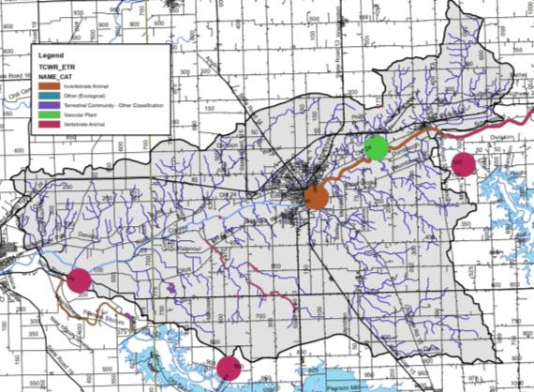
Figure 21. Locations of special species and high quality natural areas observed in the Treaty Creek-Wabash River watershed. Source: Clark, 2018.

Recreational Resources and Significant Natural Areas
A variety of recreational opportunities and natural areas exist within the Treaty Creek-Wabash Watershed. Recreational opportunities include parks, fish and wildlife areas, nature preserves, fairgrounds, golf courses, and school grounds (Figure 22). Portions of the Salamonie State Forest and Mississinewa Dam properties are located within the watershed. Additionally, Acres Land Trust owns and manages Ross Run and the Hanging Rock and Wabash Reef National Monument, a portion of which is located in the watershed, while Marion County Schools manages Asherwood Nature Preserve. The City of Wabash maintains the Paradis Spring Historical Park and Riverwalk, Hanna Park, Erie Community Center, Charley Creek Park, and Broadmore Park, while the Town of Lagro manages the Lagro Park and Community Building. The Wabash River is also a popular stream with canoe and kayak enthusiasts at certain times of the year. Additional recreational opportunities exist at various schools, golf complexes and sporting clay facilities.

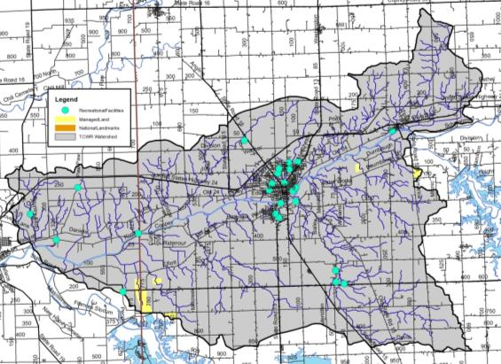
Figure 22. Recreational opportunities and natural areas in the Treaty Creek-Wabash River Watershed.

Land Use
Water quality is greatly influenced by land use both past and present. Different land uses contribute different contaminants to surface waters. As water flows across agricultural lands it can pick up pesticides, fertilizers, nutrients, sediment, pathogens, and manure, to name a few. However, when water flows across parking lots or from roof tops it not only picks up motor oil, grease, transmission fluid, sediment, and nutrients, but it reaches a waterbody faster than water flowing over natural or agricultural land. Hard or impervious surfaces present in parking lots or on rooftops create a barrier between surface and groundwater. This barrier limits the infiltration of surface water into the groundwater system resulting in increased rates of transport from the point of impact on the land to the nearest waterbody.

Current Land Use
Today, the Treaty Creek-Wabash River Watershed is dominated by row crop agriculture (71%) with an additional 2.5% of the watershed covered by pasture or hay (Table 7, Figure 23). Nearly 9% of the watershed is covered by developed open space or is in low, medium, or high intensity developed areas. Grassland, evergreen forest, open water, and wetlands cover the remaining 3.3% of the watershed. Definitions for each land cover type are included in Appendix D.

Table 7. Detailed land use in the Treaty Creek-Wabash RIver Watershed.
Classification | Area (acres) | Percent of Watershed
Row crop | 79,250.5 | 70.9%
Deciduous forest | 15,804.2 | 14.1%
Developed open space | 7,313.9 | 6.5%
Pasture/hay | 2,780.5 | 2.5%
Low intensity developed | 2,227.2 | 2.0%
Shrub/scrub | 1,174.0 | 1.0%
Open water | 1,099.0 | 1.0%
Grassland | 1,044.5 | 0.9%
Medium intensity developed | 512.9 | 0.5%
High intensity developed | 303.9 | 0.3%
Emergent wetland | 221.9 | 0.2%
Evergreen forest | 65.0 | 0.1%
Woody wetland | 38.1 | 0.0%
Total | 111,835.7 | 100%
Source: USGS, 2011

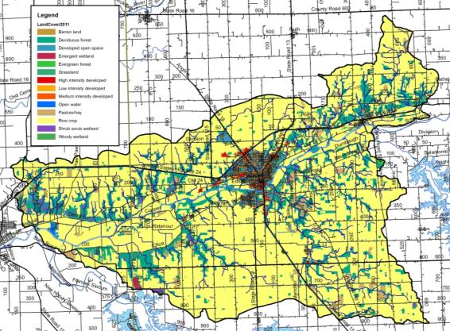
Figure 23. Land use in the Treaty Creek-Wabash River Watershed. Source: NLCD, 2011.

Agricultural Land Use
Individuals are concerned about the impact of agricultural practices on water quality. Specifically, the volume of exposed soil entering adjacent waterbodies, the prevalence of tiled fields and thus the transport of chemicals into waterbodies, the use of agricultural chemicals, and the volume of manure applied via small animal farms and through confined animal feeding operations are concerning to local residents. Each of these issues will be discussed in further detail below.

Tillage Transect
Tillage transect information data for Miami and Wabash counties was compiled for 2017 (Table 8; ISDA, 2017A-B). As reported by ISDA, members of Indiana’s Conservation Partnership (ICP) conduct a field survey of tillage methods. A tillage transect is an on-the-ground survey that identifies the types of tillage systems farmers are using and long-term trends of conservation tillage adoption using GPS technology, plus a statistically reliable model for estimating farm management and related annual trends. Table 7 provides the number of acres and percent of acres on which conservation tillage was utilized for each county by corn and soybeans.

Table 8. Tillage transect data by county for corn and soybeans (ISDA, 2017).
County | Corn (acres) | Corn (%) | Soybeans (acres) | Soybeans (%)
Miami | 61,734 | 83% | 97,306 | 76%
Wabash | 73,315 | 78% | 98,926 | 64%

Agricultural Chemical Usage
Agricultural pesticides and fertilizers are commonly applied to row crops in Indiana. These chemicals can be carried into adjacent waterbodies through surface runoff and via tile drainage. This is especially an issue if a storm occurs prior to the chemicals being broken down and used by the crops.

Data for chemical usage on an individual county or watershed level are not currently collected. Rather, data is collected for the state as a whole in two forms. First, the National Agricultural Statistics Survey (NASS) collects information on chemical usage, number of applications per year, type of chemical applied, and the application rate. These data were last collected in 2006 (NASS, 2006). Additionally, NASS collects farmland data for the number of acres in agricultural production by type (i.e. corn, soybeans, grains) (NASS, 2017). These data indicate that corn (135,050 acres) and soybeans (196,230 acres) are the two primary crops grown in the watershed (Table 9).

Nitrogen is more typically applied to corn than to soybeans. Soybeans have symbiotic bacteria on their roots that act as nitrogen fixers, which means that they pull the nitrogen that they need from the atmosphere then convert it into a form which they can use. Corn does not fix nitrogen; therefore nitrogen needs to be applied. Nitrogen is typically applied twice in Indiana – once at or before planting and a second time when corn reaches approximately one foot in height (NASS, 2007). Fall application of nitrogen also occurs, and is particularly problematic. Agricultural data indicate that corn receives 98% of the nitrogen applied in the state and 87% of the phosphorus. For these reasons, nutrient calculations were only completed for corn as applications to soybeans are likely negligible. Based on these data, it is estimated that 9,953 tons of nitrogen and 4,923 tons of phosphorus are applied annually within Miami and Wabash counties (Table 9).

Table 9. Agricultural nutrient usage for corn in the Treaty Creek-Wabash River Watershed.
Nutrient | Acres of Corn | % of Area Applied | Applications (#/year) | Rate/Application (lb/acre) | Total Applied/Year  (tons)
Nitrogen | 135,050 | 100 | 2.2 | 67 | 9,953
Phosphorus | 135,050 | 93 | 1.4 | 56 | 4,923
Source: NASS, 2007

Pesticides are also used on crops grown in Indiana. The Office of the Indiana State Chemist indicates that the two predominant herbicide active ingredients applied are atrazine and glyphosate. Atrazine is most commonly applied as a corn herbicide, while glyphosate is used on both corn and soybean fields as an herbicide. NASS indicates that in 2005, an average of 1.24 pounds of atrazine and 0.6 pounds of glyphosate were applied per acre of corn, and 0.73 pounds of glyphosate were applied per acre of soybeans (NASS, 2006). Using these rates, we estimated that a little over 83 tons of atrazine and approximately 112 tons of glyphosate are applied to cropland in Miami and Wabash Counties annually (Table 10).

Table 10. Agricultural herbicide usage in the Treaty Creek-Wabash River Watershed.
Crop | Acres | Application Rate  (lb/acre) | Total Applied  (lbs) | Total Applied/Year  (tons)
Corn (Atrazine) | 135,050 | 1.24 | 167,462 | 83.7
Corn (Glyphosate) | 135,050 | 0.60 | 81,030 | 40.5
Soybeans (Glyphosate) | 196,230 | 0.73 | 143,248 | 71.6
Source: NASS, 2006

Confined Feeding Operations and Hobby Farms
A mixture of small, unregulated and larger, regulated livestock operations (confined feeding operations) is found within the Treaty Creek-Wabash River Watershed. Small farms are those which house less than 300 animals, while larger farms that house large numbers of animals for longer than 45 days per year are regulated by IDEM. These regulations are based on the number and type of animals present. IDEM requires permit applications which document animal housing, manure storage and disposal, and nutrient management plans for farms which maintain 300 or more cows, 600 or more hogs, or 30,000 or more fowl. These facilities are considered confined feeding operations (CFO). There are 38 active and 10 voided confined feeding operations located in the watershed, none of which are large enough to be classified as a concentrated animal feeding operation (CAFO) (Figure 25). The facilities house hogs, veal, and dairy and beef cattle with a combined total of 139 boars, 3,958 sows, 19,841 finishing hogs, 13,238 nursery hogs for a total of 37,016 hogs; 4,155 dairy cattle, 1,122 beef cattle, and 2,050 veal. In total, approximately 44,300 animals per year are housed in CFOs in the watershed, generating approximately 510,183,400 pounds of manure per year spread over more than 3,200 acres in the watershed. Manure produced on permitted CFOs contains nearly 538,340 pounds of nitrogen and 392,490 pounds of phosphorus.

XX small, unregulated animal farms were identified during the windshield survey, which is most likely an underestimate of the actual number. These small “mini farms” contain small numbers of cattle, horses, or goats, which could be sources of nutrients and E. coli as these animals exist on small acreage lots with limited ground cover.

Figure 25. Confined feeding operation and unregulated animal farm locations within the Treaty Creek-Wabash River Watershed.

Natural Land Use
Natural land uses including forest, wetlands, and open water cover approximately 3.3% of the watershed. Forest cover occurs adjacent to waterbodies throughout the watershed, while wetland land uses are isolated throughout the watershed (Figure 23). Many forested tracts are contiguous and large lengths the Wabash River and smaller riparian forests lie adjacent to streams as intact riparian buffers.

Urban Land Use
Urban land uses cover nearly 12% of the watershed (Table 7). Although this is only a very small portion of the watershed, there are some significant issues related to the dev areas. Especially troublesome are issues related to failing septic systems, combined sewer overflows, impervious surfaces, flooding, and stormwater runoff that allow untreated sewage and stormwater to flow into the watershed during heavy rain events. Upgrades needed for facilities such as WWTP’s can be cost-prohibitive.

Impervious Surfaces
Impervious surfaces are hard surfaces which limit surface water from infiltrating into the land surface to become groundwater thereby creating high overland flow rates. Hard surfaces include concrete, asphalt, compacted soils, rooftops, and buildings or structures. In developed areas like Wabash and Lagro, land which was once permeable has been covered by hard, impervious surfaces. This results in rain which once absorbed into the soil running off of rooftops and over pavement to enter the stream with not only higher velocity but also higher quantities of pollutants.

Overall, the watershed is covered by low levels of impervious surfaces. However, high impervious densities are present in Lagro and Wabash and along roads throughout the watershed. Estimates indicate that 8,130 acres (7%) of the watershed are 25% or more covered by hard surfaces. Elvidge et al. (2004) indicated that streams in watersheds with greater than 10% impervious surfaces clearly exhibited degradation. The Center for Watershed Protection (CWP) identified similar impacts from impervious surface density on water quality. The CWP study indicates that stream ecology degradation begins with only 10% impervious cover in a watershed. Higher impervious surface coverage results in further impairments including water quality problems, increased bacteria concentrations, higher levels of toxic chemicals, high temperatures, and lower dissolved oxygen concentrations (CWP, 2003).

Remediation Sites
Remediation sites including industrial waste, leaking underground storage tanks (LUST), open dumps, and brownfields are present throughout the Treaty Creek-Wabash River Watershed (Figure 26). Most of these sites are located within the developed areas of Wabash and along US Highway 24. In total, 13 industrial waste sites, 43 LUST facilities, 3 solid waste facilities, one restricted waste site, and seven brownfields are present within the watershed. There are no Superfund sites within the watershed.

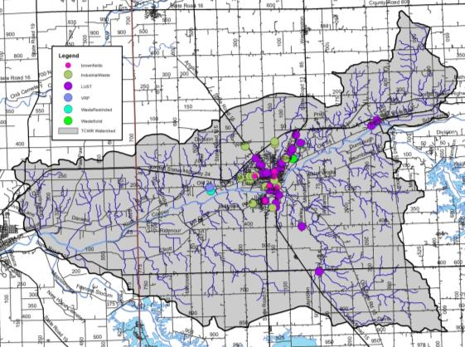
Figure 26. Industrial remediation and waste sites within the Treaty Creek-Wabash River Watershed. Source: IDEM.

Population Trends
The Treaty Creek-Wabash River Watershed is relatively a sparsely populated area in general and includes the entirety of the Town of Lagro and City of Wabash. Tracking population changes within a watershed is challenging as data is published by counties and townships rather than watershed boundaries. Estimates of the population of the watershed are derived by calculating percentage of the watershed within a county and extrapolating from county-wide data. The Treaty Creek-Wabash River Watershed lies within two counties. It drains nearly 13% of Miami County and 3% of Wabash County. Population trends for these counties derived from the most recently completed census (2010) are shown in Table 11, while Table 12 displays estimated populations for the portion of each county located within the watershed (StatsIndiana, 2018). These data indicate modest growth in all three counties over the past decade; however most of that growth is associated with Terre Haute and the immediate area.

Table 11. County demographics for counties within Treaty Creek-Wabash River Watershed.
County | Area  (sq mi) | Population (2010) | Population Growth  (2000-2010) | Pop. Density  (#/sq. mi)
Miami | 373.8 | 35,862 | -1063 | 95.8
Wabash | 412.4 | 32,885 | -1442 | 76.2

Table 12. Estimated watershed demographics for the Treaty Creek-Wabash River Watershed.
County | Acres of County  in Watershed | Percent of County  in Watershed | Population
Miami | 239,232 | 6.9% | 1,781
Wabash | 263,936 | 32.9% | 10,513
Total Estimated Population |  |  | 12,294

Planning Efforts in the Watershed
While no one single plan has been dedicated to the Treaty Creek-Wabash River Watershed until the development of this one, several larger plans have encompassed portions of the Treaty Creek-Wabash River Watershed or areas which it drains or outlets into. Planning efforts include those by the Wabash River Heritage Corridor Commission along the length of the Wabash River, into which Treaty Creek-Wabash River drains, the Miami and Wabash County SWCD Master Plans and the Miami and Wabash county-wide master plans.

Wabash River Heritage Corridor Commission Master Plan
In 1990, the Indiana Department of Natural Resources created the Wabash River Heritage Corridor Fund to provide assistance with conservation and recreational development projects along the Wabash River. In 1991, the Wabash River Heritage Corridor Commission (WRHCC) was created by House Enrolled Act 1382. The WRHCC protects and enhances the natural, cultural, historical and recreational resources of the Wabash River within the nineteen counties through which the river runs. This includes Warren and Tippecanoe counties, which are part of the current planning project. Since 1990, approximately 60 projects received funding totaling more than $13 million through the corridor fund (WRHCC, 2004). Additional efforts by the WRHCC include maintenance of a visible presence within the corridor counties, provision of interaction along the length of the corridor, and promotion of the Wabash River and its historical and recreational opportunities.

In 2004, the WRHCC updated its master plan via a series of public meetings along the Wabash River corridor. Since 2010, the WRHCC has updated the master plan as part of their regular bimonthly meeting efforts. The 2004 master plan focused on eight main areas including land use, natural resources, historic resources, recreational resources, corridor connection and linkages, scenic by-way linkages, thematic connections, and tourism. The updated plan includes these same foci. As portions of the watershed are contained within the Wabash River Heritage Corridor, it is important that the goals, strategies, and actions developed as part of this plan be in line with those developed as part of the WRHCC master plan. The 2004 master plan identified the following action items:
- Maintain and enhance the natural diversity of the corridor.
- Restore natural landscapes of the Wabash River Heritage Corridor.
- Ensure that mineral extraction is environmentally sensitive.
- Stabilize the riverbank.
- Re-establish riparian forests and wetlands along the Wabash River.
- Develop and implement set-back programs to reduce surface runoff and non-point source pollution.
- Enforce existing regulations regarding point source pollution related to wastewater treatment plants and septic systems and explore the need for new regulations.
- Promote monitoring of water quality and public education about water quality.
- Preserve large regional natural areas.
- Fish stocking and wildlife reintroduction in and along the Wabash River.
- Conduct a historic resource inventory of the corridor resource and nominate eligible properties for National Register designation within the corridor.
- Develop a prioritized list of historic and cultural resources that are threatened for focused preservation effort by county.
- Identify long-term funding opportunities for historic preservation along the corridor.
- Acquire and develop more recreational areas and opportunities.
- Promote and enhance hunting and fishing opportunities.
- Promote and enhance birding opportunities in the corridor.
- Promote and enhance bicycling opportunities in the corridor.
- Develop trail connections along the river linking corridor communities.
- Increase access to the Wabash River for recreational use, boating, fishing, and enjoyment of the river. Increase overnight facilities access.
- Establish designation of scenic by-way along the river.
- Install directional or identification signs for scenic by-ways along the river.
- Create an image to connect and interpret significant resources.
- Develop a Wabash River Heritage Corridor Center that would introduce and interpret the significance of the Wabash River and the Heritage Corridor and serve as a central repository or records center for Wabash studies.
- Develop a Wabash River and Heritage Corridor education curriculum for teacher training opportunities.
- Create corridor identification.
- Promote and market corridor resources and events.
- Develop and coordinate corridor events as part of the Heritage Corridor identity.
- Provide information to promote local and corridor recreational resources and facilities.
- Develop a natural resources guide specific to the Wabash River Heritage Corridor that will be site specific including river and public access information.

In 2009 legislation was revised to allow a new source of dedicated money to be placed in the fund, derived from royalties of oil and mineral rights beneath the Wabash River. This fund will be used to once again fund projects in the Wabash River Corridor.

The grants have been awarded every other year, in 2012 and 2014 so far, and total approximately $300,000 every two years. Both Treaty Creek-Wabash River Watershed counties are eligible to apply for funding.

County SWCD Master Plans
County Area Master Plans

Watershed Summary: Parameter Relationships
Several relationships among watershed parameters become apparent when watershed-wide data are examined. These relationships are discussed here in general, while relationships within specific subwatersheds are discussed in more detail in subsequent sections.

Insert relationship categories here

