TABLE OF CONTENTS
PAGE

1.0 WATERSHED INTRODUCTION 1
1.1 Watershed Community Initiative 1
1.2 Project History 2
1.3 Stakeholder Involvement 3
1.4 Public Input 4

2.0 WATERSHED INVENTORY I: WATERSHED DESCRIPTION 5
2.1 Watershed Location 5
2.2 Subwatersheds 5
2.3 Climate 6
2.4 Geology and Topography 7
2.5 Soil Characteristics 9
2.6 Wastewater Treatment 13
2.7 Hydrology 17
2.8 Natural History 24
2.9 Land Use 28
2.10 Population Trends 34
2.11 Planning Efforts in the Watershed 35
2.12 Watershed Summary: Parameter Relationships 40

3.0 WATERSHED INVENTORY II-A: WATER QUALITY AND WATERSHED ASSESSMENT 41
3.1 Water Quality Targets 42
3.2 Historic Water Quality Sampling Efforts 42
3.3 Current Water Quality Assessment 52

4.0 WATERSHED INVENTORY II-B: SUBWATERSHED DISCUSSIONS 55
4.1 Enyeart Creek-Wabash River Subwatershed 56
4.2 Stone Creek-Wabash River Subwatershed 59
4.3 Burr Creek-Wabash River Subwatershed 62
4.4 Ridgeway Creek Subwatershed 65
4.5 Kentner Creek Subwatershed 68
4.6 Gilbert Branch-Wabash River Subwatershed 71
4.7 Daniel Creek-Wabash River Subwatershed 74

5.0 LITERATURE CITED 78

TABLE OF FIGURES
PAGE

Figure 1. Wabash River watershed highlighting the Treaty Creek-Wabash River Drainage. 1
Figure 2. 12-digit Hydrologic Unit Codes in the Treaty Creek-Wabash River watershed. 6
Figure 3. Bedrock in the Treaty Creek-Wabash River Watershed. 7
Figure 4. Surficial geology throughout the Treaty Creek-Wabash River Watershed. 8
Figure 5. Surface elevation in the Treaty Creek-Wabash River Watershed. 9
Figure 6. Soil associations in the Treaty Creek-Wabash River Watershed.. 10
Figure 7. Highly erodible (HES) and potentially highly erodible soils (PHES) in the
Treaty Creek-Wabash River Watershed. 11
Figure 8. Hydric soils in the Treaty Creek-Wabash River Watershed 12
Figure 9. Tile-drained soils in the Treaty Creek-Wabash River Watershed 13
Figure 10. Suitability of soils for septic tank usage in the Treaty Creek-Wabash River Watershed.. 15
Figure 11. NPDES-regulated facilities in the Treaty Creek-Wabash River Watershed. 16
Figure 12. Wastewater treatment plant service areas, municipal biosolids land application sites,
dense unsewered housing, and combined sewer overflow outfalls within the
Treaty Creek-Wabash River Watershed. 17
Figure 13. Streams in the Treaty Creek-Wabash River Watershed. 18
Figure 14. Impaired waterbody locations in the Treaty Creek-Wabash River Watershed. 19
Figure 15. Floodplain locations within the Treaty Creek-Wabash River Watershed. 21
Figure 16. Wetland locations within the Treaty Creek-Wabash River Watershed. 22
Figure 17. City of Wabash MS4s boundary and CSO overflow locations. 23
Figure 18. Aquifer sensitivity within the Treaty Creek-Wabash River Watershed.. 24
Figure 19. Locations of special species and high quality natural areas observed in the Treaty
Creek-Wabash River watershed. 27
Figure 20. Recreational opportunities and natural areas in the Treaty Creek-Wabash River
Watershed. 28
Figure 21. Land use in the Treaty Creek-Wabash River Watershed 29
Figure 22. Confined feeding operation and unregulated animal farm locations and associated
farm fields for confined feeding operation manure and municipal wastewater
treatment plant sludge spreading within the Treaty Creek-Wabash River Watershed. 32
Figure 23. Industrial remediation and waste sites within the Treaty Creek-Wabash River Watershed.. 34
Figure 24. Selected long-term control plan mitigation projects to address combined sewer
overflows in the City of Wabash. 37
Figure 25. Historic water quality assessment locations. 43
Figure 26. Total phosphorus (TP), nitrate (NO3), and E. coli load reductions identified in the
Wabash River TMDL for the J. Edward Roush Lake portion of the Wabash River 47
Figure 27. Sites sampled as part of the Treaty Creek-Wabash River Watershed Management Plan. 53
Figure 28. Stream-related watershed concerns identified during watershed inventory efforts. 55
Figure 29. 12-digit Hydrologic Unit Codes in the Treaty Creek-Wabash River Watershed. 56
Figure 30. Enyeart Creek-Wabash River Subwatershed. 57
Figure 31. Point and non-point sources of pollution and suggested solutions in the Enyeart Creek-Wabash River Subwatershed. 58
Figure 32. Locations of historic water quality data collection and impairments in the Enyeart
Creek-Wabash River Subwatershed. 59
Figure 33. Stone Creek-Wabash River Subwatershed. 60

Figure 34. Point and non-point sources of pollution and suggested solutions in the Stone Creek-
Wabash River Subwatershed. 61
Figure 35. Locations of historic water quality data collection and impairments in the Stone Creek-Wabash River Subwatershed. 62
Figure 36. Burr Creek-Wabash River Subwatershed. 63
Figure 37. Point and non-point sources of pollution and suggested solutions in the Burr Creek-
Wabash River Subwatershed. 64
Figure 38. Locations of current and historic water quality data collection and impairments in the
Burr Creek-Wabash River Subwatershed. 65
Figure 39. Ridgeway Creek Subwatershed. 66
Figure 40. Point and non-point sources of pollution and suggested solutions in the Ridgeway
Creek Subwatershed. 67
Figure 41. Locations of historic water quality data collection and impairments in the Ridgeway
Creek Subwatershed. 68
Figure 42. Kentner Creek Subwatershed. 69
Figure 43. Point and non-point sources of pollution and suggested solutions in the Kentner
Creek Subwatershed. 70
Figure 44. Locations of historic water quality data collection and impairments in the Kentner
Creek Subwatershed. 71
Figure 45. Gilbert Branch-Wabash River Subwatershed. 72
Figure 46. Point and non-point sources of pollution and suggested solutions in the Gilbert
Branch-Wabash River Subwatershed. 73
Figure 47. Locations of historic water quality data collection and impairments in the Gilbert
Branch-Wabash River Subwatershed. 74
Figure 48. Daniel Creek-Wabash River Subwatershed. 75
Figure 49. Point and non-point sources of pollution and suggested solutions in the Daniel Creek-Wabash River Subwatershed. 76
Figure 50. Locations of current and historic water quality data collection and impairments in the
Daniel Creek-Wabash River Subwatershed. 77

TABLE OF TABLES
PAGE

Table 1. Treaty Creek-Wabash River Watershed steering committee members and their affiliation. 3
Table 2. Stakeholder concerns identified during public input sessions, steering committee
meetings, and watershed inventory process from February through June, 2018. 5
Table 3. 12-digit Hydrologic Unit Code (HUC) watersheds in the Treaty Creek-Wabash River
watershed. 6
Table 4. NPDES-regulated facility information. 15
Table 5. Impaired waterbodies in the Treaty Creek-Wabash River Watershed 2016 IDEM 303(d) list. 20
Table 6. Wellhead protection areas in and adjacent to the Treaty Creek-Wabash River Watershed. 24
Table 7. Surrogate estimates of wildlife density in the IDNR northeast region, which includes the
Treaty Creek-Wabash River Watershed. 26
Table 8. Detailed land use in the Treaty Creek-Wabash River Watershed. 30
Table 9. Tillage transect data by county for corn and soybeans 30
Table 10. Agricultural nutrient usage for corn in the Treaty Creek-Wabash River Watershed
counties. 31
Table 11. Agricultural herbicide usage in the Treaty Creek-Wabash River Watershed counties. 31
Table 12. County demographics for counties within Treaty Creek-Wabash River Watershed. 34
Table 13. Estimated watershed demographics for the Treaty Creek-Wabash River Watershed. 35
Table 14. Water quality benchmarks used to assess water quality from historic and current water
quality assessments. – Finalize at June steering committee meeting and replace 42
Table 15. Fish Consumption Advisory listing for the Treaty Creek-Wabash River Watershed. 45

WATERSHED INTRODUCTION

Watershed Community Initiative
A watershed is the land area that drains to a common point, such as a location on a river. All of the water that falls on a watershed will move across the landscape collecting in low spots and drainageways until it moves into the waterbody of choice. All activities that take place in a watershed can impact the water quality of the river that drains it. What we do on the land, such as constructing new buildings, fertilizing lawns, or growing crops, affects the water and the ecosystem that lives in it. A healthy watershed is vital for a healthy river, and a healthy river can enhance the community and helps maintain a healthy local economy. Watershed planning is especially important in that it will help communities and individuals determine how best to preserve water functions, prevent water quality impairment, and produce long-term economic, environmental, and political health.

The Wabash River watershed includes all the land that drains into the Wabash River. The river starts in Ohio and drains about 1,024,382 acres by the time it passes through the current watershed project area (Figure 1). The Treaty Creek-Wabash River includes portions of Wabash and Miami Counties in north-central Indiana.

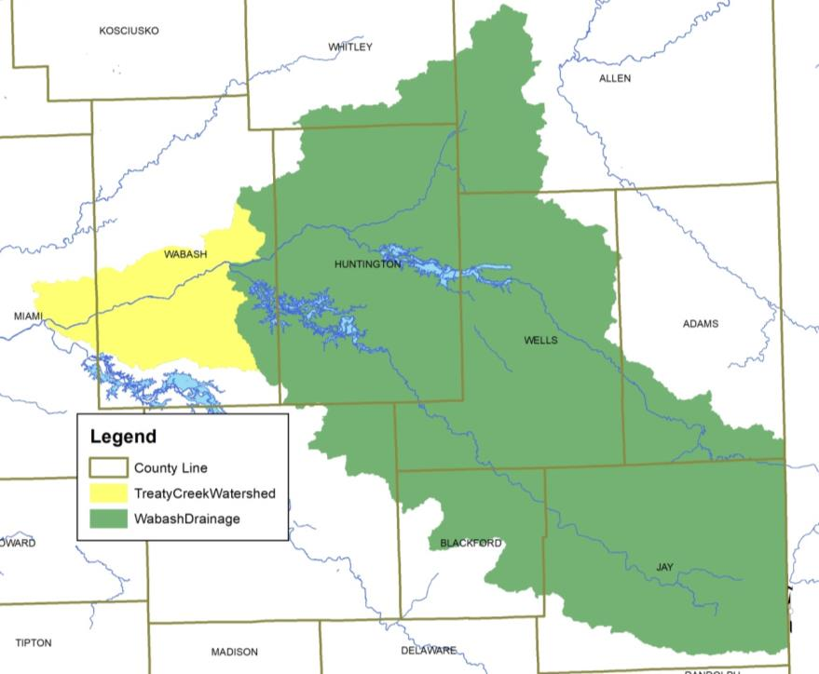
Figure 1. Wabash River watershed highlighting the Treaty Creek-Wabash River Drainage.

Project History
In the fall of 2015, the Wabash River Defenders submitted a grant request to the Indiana Department of Environmental Management with a focus on assessing and improving water quality within the Treaty Creek-Wabash River Drainage within Wabash and Miami Counties, Indiana. The Wabash River Defenders goal is complete water quality planning for all waterbodies that drain to the Wabash River within Wabash County. The Wabash River Defenders selected the Treaty Creek-Wabash River Watershed as it contained most of the tributaries that drain to the Wabash River within Wabash County that have not already been included in a watershed planning process. They completed a brief inventory of the watershed identifying predominant land uses and potential associated water quality issues that could be associated with the predominantly row crop agriculture watershed. Additionally, the Wabash River Defenders identified several preliminary partners as well as concerns associated with the various practices and uses in the watershed. Specifically, the watershed includes the entire City of Wabash MS4 boundary, which requires the input and participation of the City of Wabash. The watershed is predominantly agricultural with 73% of the watershed covered by row crop agriculture or pasture land, 14% in forest or wetland and 9% in developed land uses including the City of Wabash and Town of Lagro. The engagement of the Miami and Wabash Soil and Water Conservation Districts, Natural Resources Conservation District, and Purdue Extension staff as well as producers across the watershed would be paramount. A majority of the land within the watershed is privately-owned and in a soybean-corn rotation. More than 30 active confined feeding operations are located within the Treaty Creek-Wabash River watershed. These operations house more than 10,000 head of cattle and more than 50,000 head of hogs. Between these animals and those housed on small, unregulated farms, more than 100 tons of manure are produced daily within the Treaty Creek-Wabash River watershed.

Additionally, the Wabash River Defenders completed an initial assessment of the watershed reviewing available water chemistry data and identified that it contains high nutrient, sediment and E. coli concentrations and limited biotic communities. Assessments completed via IDEM's monthly fixed station sampling (1991 to current) at the Wabash River at SR 105, which is upstream of this watershed, indicate that nutrient concentrations routinely exceed target nitrate-nitrogen (75% of samples measure greater than 2 mg/L) and total phosphorus (99% of samples measure greater 0.08 mg/L) concentrations. Additionally, IDEM-collected turbidities measured within the stream indicate higher than target levels (78% of samples measured higher than 25 NTU). In the Wabash River at Lagro, limited nutrient, sediment and E. coli data collected in rotational basin assessments (1990 to present) indicate that concentrations are typically higher than the state standard and targets. The source of these issues is currently unknown as only two watershed tributaries have been sampled by IDEM in the past. Sample results from historic sampling efforts completed by IDEM (1990 to present) indicate impaired biotic communities in Mill Creek, Ridgeway Creek and a tributary to Ridgeway Creek but provide little data for other watershed tributaries. The Wabash River TMDL identifies the following load reductions from nonpoint sources at the Roush Lake sample point: 0% less nitrate, 20% less total phosphorus, and 95% less E. coli (TetraTech, 2008).

The Wabash River Defenders approached commuity groups and individuals throughout the watershed that might be intersted in working with them to assess and improve water quality wihtin the Wabash River. Identified potential partners include: The Community Foundation of Wabash County, Grow Wabash County, City of Wabash Utilities, Visit Wabash County, Indiana American Water, Miami County Soil and Water Conservation District and Natural Resources Conservation Service, Wabash County Surveyors office, Wabash County Soil and Water Conservation District and Natural Resources Conservation Service, Wabash County Purdue Extension, Wabash County Solid Waste Management District, Wabash County Area Plan Commission, Wabash County United Fund, and Wabash County Emergency Management. This group formed a Steering Committee (Table 1), conducted windshield surveys of the watershed, and held several meetings open to the public in order to generate input in the development of a watershed management plan for the Treaty Creek-Wabash River Watershed. All of these efforts were guided by the following mission and vision developed by public participants and committee members:

Mission: concerned citizens working together to improve water quality and habitat in the Wabash River and its tributaries for all generations.

Vision: Improved water quality for humans and wildlife

Stakeholder Involvement
Development of a watershed management plan requires input from interested citizens, local government leaders, and water resource professionals. These individuals are required to not only buy into the project and the process but must also become an integral part of identifying the solution(s) which will result in improved water quality. We involved stakeholders in the watershed management planning process through a series of public meetings, and education and outreach events including windshield surveys, water quality monitoring opportunities, and meetings with local officials.

Steering Committee
Individuals representing the towns and counties within the watershed, environmental groups, natural resource professionals, agricultural and commercial representatives, and private citizens comprised the steering committee. The steering committee has met nearly every other month to develop the WMP, starting in December 2017. Table 1 identifies the steering committee members and their affiliation.

Table 1. Treaty Creek-Wabash River Watershed steering committee members and their affiliation.
Individual | Organization(s) Represented
Bob Gray | City of Wabash
Christine Flohr | Visit Wabash County
Keith Gillenwater | Economic Development Group
Brandon France | Indiana American Water
Mary Lou Musselman | Miami County SWCD
David Grant | Strauss Veal Feeds
Cheri Slee | Wabash County Surveyor
Mike Howard | Wabash County Area Plan
Tashina Lahr-Manifold | Wabash County SWCD
Steve Johnson | Wabash County United Fund
Adam Jones | Wabash County NRCS
Ed Sprunger | Miami County NRCS
Gregg Wilkinson | Miami County Surveyor
Curtis Campbell | Wabash County Purdue Extension
Kimberly Frazier | Miami County Purdue Extension
Jen Rankin | Wabash County Solid Waste
Keith Poole | Wabash River Defenders
Mike Beauchamp | Wabash River Defenders
Bob Brown | Wabash County Emergency Management

Public Meetings
Public participation is necessary for the long-term success of any watershed planning and subsequent implementation effort. One component of public participation for this project was public meetings. There were two public meetings held in February 2018 and XXX to introduce the project and develop a concerns list, then review the plan’s goals, strategies and actions and confirm that those meet the public’s desire for the future of water quality within the Treaty Creek-Wabash River Watershed. The purpose of the public meetings was to provide information on the overall planning effort and its progress; solicit stakeholder input, opinions, and participation; create opportunities for the public to recommend programs, policies, and projects to improve water quality; and build support for future phases of the project.

The public meetings were advertised through press releases distributed to local newspapers in the watershed. The meetings were also advertised through word of mouth as staff from the Soil and Water Conservation District put together mailings that advertised the events and the Wabash River Defenders distributed information via their website and social media pages as well as through their email distribution list.

The first public meeting was held on February 13, 2018 at the Honeywell Center in Wabash, Indiana. Attendees represented citizens, farmers, and city officials. During this meeting, the Wabash River Defenders detailed the history of the project; described opportunities for individuals to volunteer as part of the project; and provided attendees with the opportunity to identify their concerns about the Treaty Creek-Wabash River Watershed and develop goals for the long-term vision of the stream.

A second public meeting was held on XXX.

Educational Materials and Events
A Treaty Creek-Wabash River Watershed brochure was developed to highlight opportunities for individuals to get involved with the project, identify community partners, and provide general information and fun facts about the watershed, watershed management planning, and the project (Appendix XX). The brochure will be distributed at committee, public, and group meetings and at education events throughout the lifetime of the project.

Public Input
Throughout the planning process, project stakeholders, the steering committee, and the general public listed concerns for the Treaty Creek-Wabash River Watershed including the Wabash River, its tributaries, and its watershed. Public and committee meetings were the primary mechanism of soliciting individual concerns. All comments were recorded and included as part of the concern documentation and prioritization process. Concerns voiced throughout the process are listed in Table 2
. Similar stakeholder concerns were grouped roughly by topic and condensed by the committee. The order of concern listing does not reflect any prioritization by watershed stakeholders.

Table 2. Stakeholder concerns identified during public input sessions, steering committee meetings, and watershed inventory process from February through June, 2018 as prioritized by the steering committee.
Stakeholder Concerns
River is muddy – where does sediment originate?
Flooding impacts from non-natural stream flows –Salamonie dam releases
Flooding impacts/topsoil loss/impacts from agricultural land
Fertilizers and pesticides flowing into the river
Livestock access to Wabash River tributaries
Engaging local individuals with the river
Agricultural producer & landowner participation in existing conservation programs
Redside dace (ETR) occurs in Mill Creek- impacts of water quality/habitat on this species?
Landfill – is this impacting the Wabash River
Indiana American Water drinking water supply – Wabash River in wellhead protection area
Septic impacts
Habitat loss along the river and its tributaries
Invasive species impacts to water quality
Streambank erosion – mouth of Treaty Creek, areas along Mill Creek, island erosion, near Lagro, along River and tributary sharp bends
Hardscape impacts/water quantity impacts during stormwater runoff events
Industrial impacts to the Wabash River including materials from manufacturing process and/or inputs from runoff
Long-term efforts to remove trash –are there still sources and if so, where?
Preserving local high quality areas
Impact of potential Riverwalk on wildlife
Gravel pits/gravel pit overflow as source of sediment
Potential for spills from the railroad
Miami County impact may be limited – land is largely owned/managed by one owner and is already in conservation programs

WATERSHED INVENTORY I: WATERSHED DESCRIPTION

Watershed Location
The Treaty Creek-Wabash River Watershed is part of the Middle Wabash-Little Vermilion watershed and covers portions of Miami and Wabash counties (Table 3). The watershed includes a number of tributaries to the Wabash River from immediately upstream of Lagro, Indiana to immediately upstream of Peru, Indiana. The Wabash River starts in Ohio and drains about 1,600 square miles by the time it gains water from the Treaty Creek-Wabash River Watershed project area.

Subwatersheds

Treaty-Creek-Wabash River Tributary Watersheds
In total, seven 12-digit Hydrologic Unit Codes are contained within the Treaty Creek-Wabash River Watershed (Figure 2; Table 3. The subwatersheds range in size from about 10,000 acres or 16 square miles to nearly 19,000 acres or 29 square miles. Each of these drainages will be discussed in further detail under Watershed Inventory II.

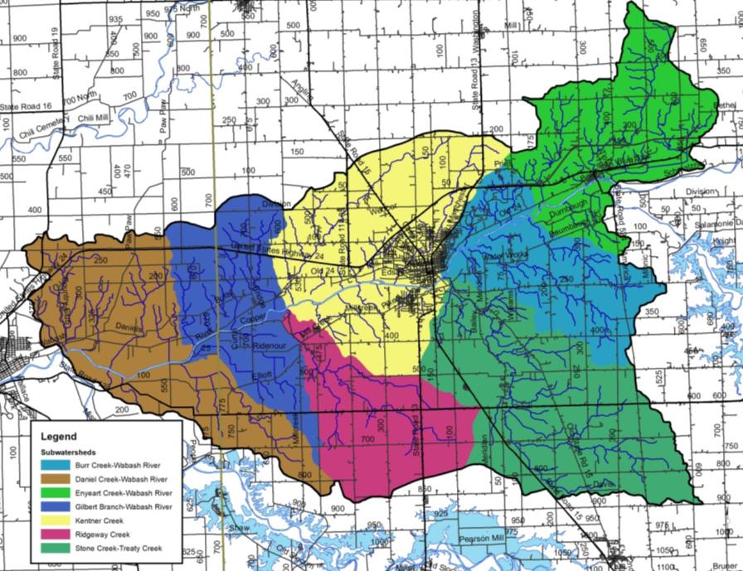
Figure 2. 12-digit Hydrologic Unit Codes in the Treaty Creek-Wabash River watershed.

Table 3. 12-digit Hydrologic Unit Code (HUC) watersheds in the Treaty Creek-Wabash River watershed.
Subwatershed Name | Hydrologic Unit Code | Area (acres) | Percent of Watershed
Enyeart Creek-Wabash River | 051201011401 | 13,848.7 | 13.7%
Stone Creek-Treaty Creek | 051201011402 | 19,267.6 | 19.1%
Burr Creek-Wabash River | 051201011403 | 11,245.7 | 11.1%
Ridgeway Creek | 051201011404 | 10,324.6 | 10.2%
Kentner Creek | 051201011405 | 18,634.9 | 18.5%
Gilbert Branch-Wabash River | 051201011406 | 11,224.0 | 11.1%
Daniel Creek-Wabash River | 051201011407 | 16,314.1 | 16.1%
Watershed Total |  | 100,859.6

Climate
In general, Indiana has a temperate climate with warm summers and cool to cold winters. The Treaty Creek-Wabash River Watershed is no different. Climate in this watershed is characterized by four distinct seasons throughout the year. High temperatures measure approximately 84 ºF in August, while low temperatures measure near freezing (17 ºF/-8.3 ºC) in January. The growing season typically extends from early April through late October. On average, 40 inches of precipitation occur within the Treaty Creek-Wabash River Watershed with precipitation occurring as small, frequent rain events spread almost evenly throughout the year.

Geology and Topography
The geology of the Treaty Creek-Wabash River Watershed is directly influenced by the advance and retreat of the Huron and Erie Lobes of the Wisconsin glaciation. As the Michigan, Erie, and Saginaw lobes of the glaciers advanced and retreated, they laid thick material over two-thirds of the state. End moraines, such as the Mississinewa Moraine, ground moraines, and lake and outwash plains create a geologically diverse landscape across northern Indiana, including the Treaty Creek-Wabash River Watershed. Glacial drift, outwash plains, and ground moraines cover much of the area along the length of the Wabash River within the watershed creating large, flat areas. Much of the bedrock geology across the watershed is comprised of limestone (Figure 3). The Wabash River cuts through sand and gravel outwash plains known as the Lagro Formation. These materials are from the Silurian and Devonian age. Icy meltwater from the more recent Wisconsin Age glaciers swept through the Lagro Formation to create the broad flat valley called the Maumee Terrace leaving steep limestone and dolomite bluffs behind.

Surficial geology indicates that the Treaty Creek-Wabash River Watershed lies within silty clay loam to clay loam with till, while the Wabash River floodplain is mostly limestone and dolomite within outwash. Surficial geology within the Treaty Creek-Wabash River Watershed originates from silty clay loam and clay loam till materials (Figure 4). The Wabash Formation, which is comprised of limestone, dolomite and argillaceous dolomite, underlies the entire Treaty Creek-Wabash River Watershed. The underlying bedrock is comprised of Silurian rocks (Gutschick, 1966).

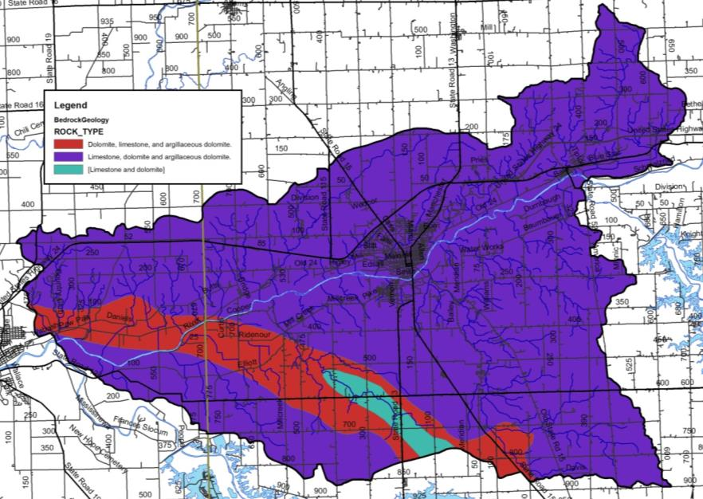
Figure 3. Bedrock in the Treaty Creek-Wabash River Watershed.

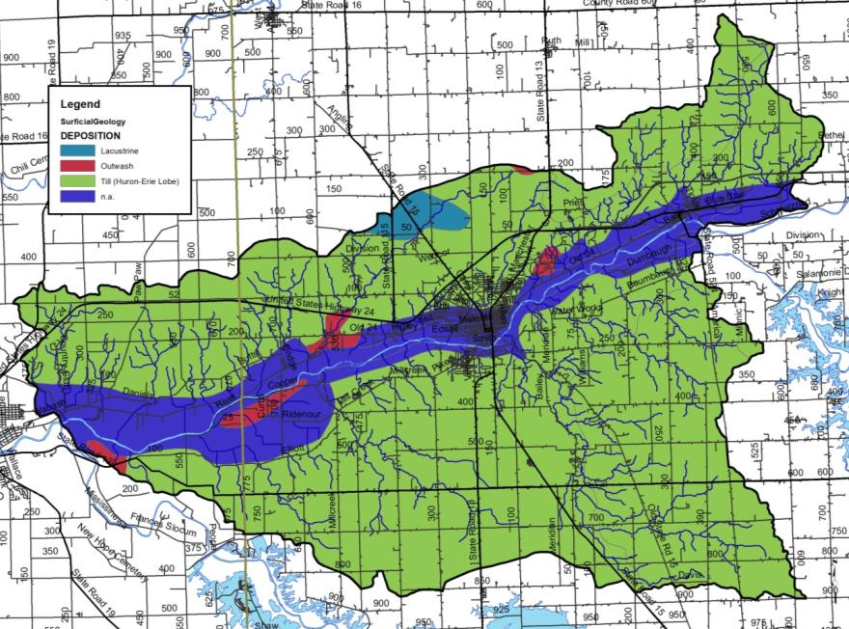
Figure 4. Surficial geology throughout the Treaty Creek-Wabash River Watershed.

The Treaty Creek-Wabash River Watershed has an average elevation of 760 feet msl (Figure 5). The watershed is relatively flat within the Wabash River floodplain; these flat areas extend one half to one full mile north and south of the Wabash River. The highest elevation of the watershed is nearly 890 feet above mean sea level (msl) occurring multiple times in the headwaters of Lagro and Treaty creeks. The lowest watershed elevation (640 ft msl) occurs at the Wabash River as it flows west out of the Treaty Creek-Wabash River Watershed. The steep limestone and dolomite bluffs occur north and south of the Wabash River throughout much of the river’s length within the watershed.
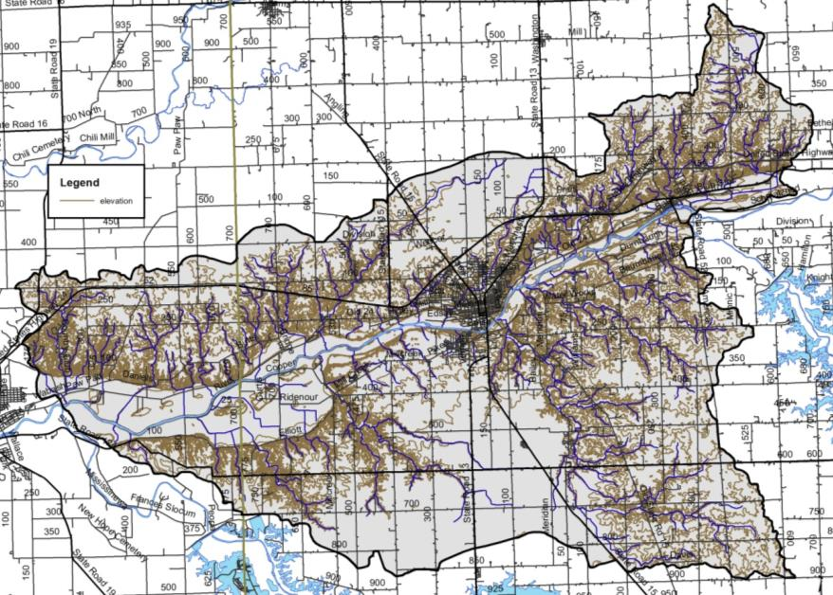
Figure 5. Surface elevation in the Treaty Creek-Wabash River Watershed.

Soil Characteristics
There are hundreds of different soil types located within the Treaty Creek-Wabash River Watershed. These soil types are delineated by their unique characteristics. The types are then arranged by relief, soil type, drainage pattern, and position within the landscape into soil associations. These associations provide the overall characteristics across the landscape. Soil associations are not used at the individual field level for decision making. Rather, the individual soil types are used for field-by-field management decisions. Some specific soil characteristics of interest, including septic limitations and soil erodibility, for watershed and water quality management are detailed below.

Soil Associations
The watershed is covered by 9 soil associations with three associations combining to cover more than two-thirds of the total watershed area. The Blount-Pewamo-Glynwood association is limited to the northern portion of the Lagro Creek drainage; the southern portion of the Treaty Creek, Burr Creek, and Ross Run drainages and the northern headwaters of the Miami County tributaries. These nearly level to moderately sloping, poorly drained soils are located on gently rolling topography where water ponds in depressions during wet periods. The Blount-Glynwood-Morley association covers a majority of the drainage east of the City of Wabash as well as the majority of Miami County tributaries north of the Wabash River, while the Fincastle-Brookston-Miamian association covers much of the Treaty Creek and Mill Creek drainages. These soils are located mixed row crop agriculture, pasture land, and remnant forested areas. This association is comprised of moderately steep, moderately well drained to well drained soils that formed on clay loam glacial till. These areas are typically located on rolling topography with knobs, ridges, and ravines cutting across the land surface. The mainstem of the Wabash River, its floodplain, and the relatively wide, flat valley located north and south of the river are covered by Sawmill-Lawson-Genesee soils in the west and Millsdale-Newglarus-Randolph soils to the east. These nearly level, well drained soils formed in outwash and underlying sand and gravel are located on terraces and deep depressional areas like the old glacial river channel that surrounds the Wabash River.

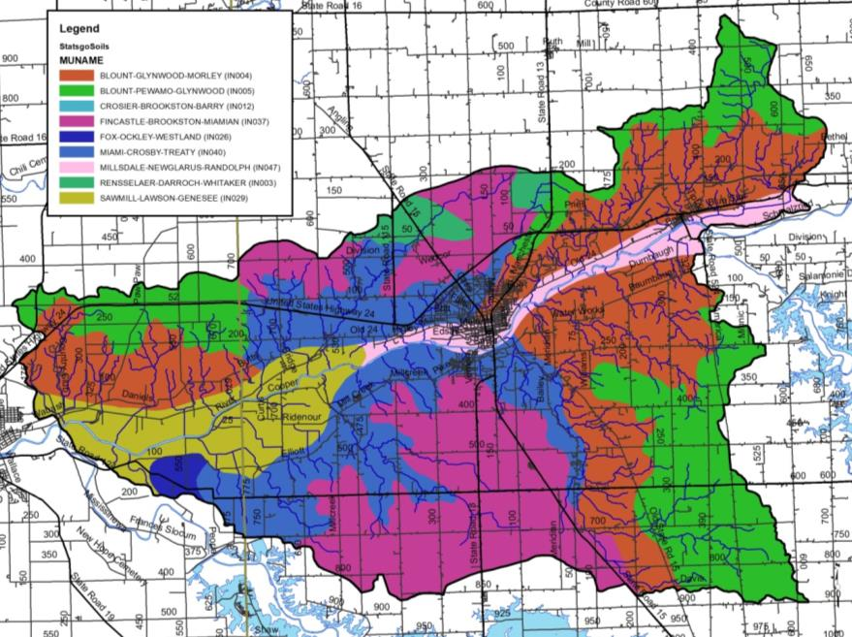
Figure 6. Soil associations in the Treaty Creek-Wabash River Watershed. Source: NRCS, 2018.

Soil Erodibility
Soils that move from the landscape to adjacent waterbodies result in degraded water quality, limited recreational use, and impaired aquatic habitat and health. Soils carry attached nutrients and pesticides, which can result in impaired water quality by increasing plant and algae growth or even killing aquatic life. The ability and/or likelihood for soils to move from the landscape to waterbodies are rated by the Natural Resources Conservation Service (NRCS). The NRCS uses soil texture and slope to classify soils into those that are considered highly erodible, potentially highly erodible, and not highly erodible. The classification is based on an erodibility index which is determined by dividing the potential average annual rate of erosion by the soil unit’s soil loss T value or tolerance value. The T value is the maximum annual rate of erosion that can occur for a particular soil type without causing a decline in long-term productivity. Potentially highly erodible soil determinations are based on the slope steepness and length in addition to the erodibility index value.

Watershed stakeholders are concerned about soil erosion. As detailed above, soils which have high erodibility index values are those that are located on steep slopes and are easily moved by wind, water, or land uses. Figure 7 details locations of highly erodible and potentially highly erodible soils within the Treaty Creek-Wabash River watershed. Highly erodible soils cover 21% of the watershed or 2,532 acres, while potentially highly erodible soils cover an additional 15% of the watershed or approximately 14,639 acres. Highly erodible soils are found throughout the watershed, but are concentrated on steep bluffs adjacent to the Wabash River and along tributaries east of the City of Wabash. Potentially highly erodible soils are located adjacent to highly erodible soils along the less steep areas of Treaty Creek-Wabash River drainages.

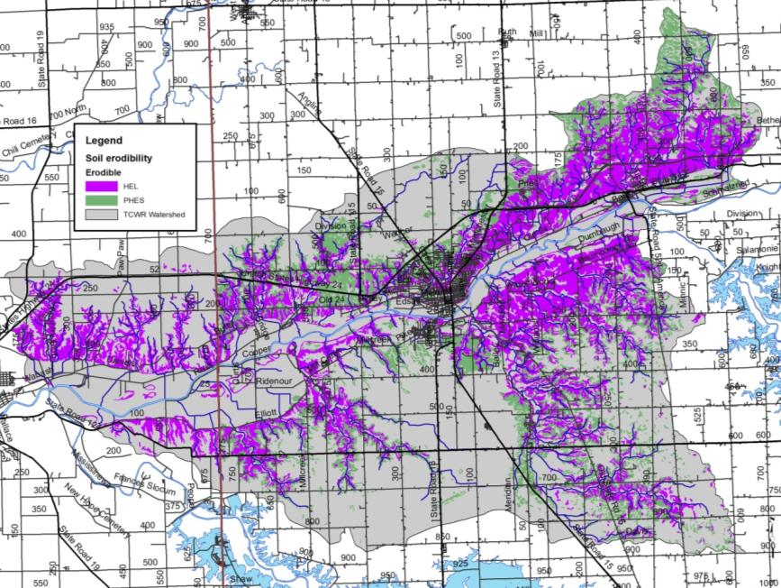
Figure 7. Highly erodible (HES) and potentially highly erodible soils (PHES) in the Treaty Creek-Wabash River Watershed. Source: NRCS, 2018.

Hydric Soils
Hydric soils are those which remain saturated for a sufficient period of time to generate a series of chemical, biological, and physical processes. The oxidation and reduction of iron in the soil, or “redox”, causes color changes characteristic of prolonged fluctuations in the water table. After undergoing these processes, the soils maintain the resultant characteristics even after draining or use modification occurs. Watershed stakeholders are concerned about the conversion of wetlands into agricultural and urban land uses. Historically, approximately 19,619 acres (19%) of the watershed was covered by hydric soils (Figure 8). Hydric soils are found throughout the watershed, with the highest densities located on flat plains away from the watershed drainageways. As these soils are considered to have developed under wetland conditions, they are a good indicator of historic wetland locations and therefore will be revisited in the land use section.
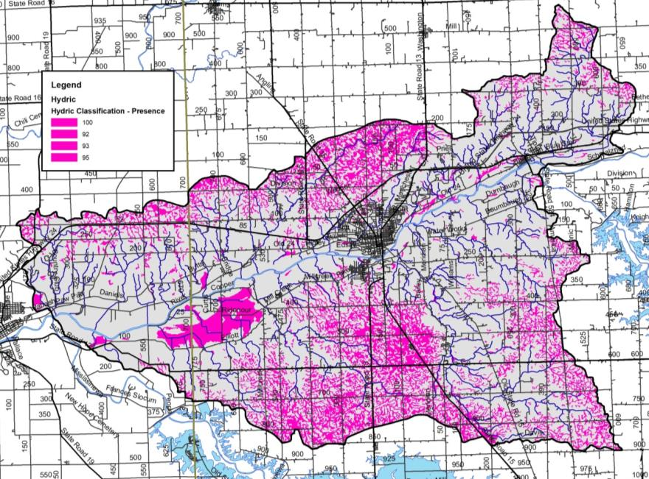
Figure 8. Hydric soils in the Treaty Creek-Wabash River Watershed. Source: NRCS, 2018.

Tile-Drained Soils
Soils drained by tile drains cover 64,288 acres or 64% of the Treaty Creek-Wabash River Watershed as estimated utilizing methods details in Sugg, 2007 (Figure 9). This method of drainage is widely used in row crop agricultural settings within the watershed, and has become even more intensively used within the last ten years. This results in altered hydrology, allowing the water to drain from the landscape more quickly to improve conditions for farming, but also potentially exacerbating downstream flooding and incising streams which cuts them off from their natural floodplains. In these areas, materials such as nutrients applied to agricultural soils are directly transported downstream, bypassing natural features such as filter strips that might otherwise filter out or assimilate nutrients. Both counties represented in the Treaty Creek-Wabash River Watershed use extensive series of tile to drain their lands. As the demands of production on each acre of land increases more tile is put in, typically in a network or series as extensive as 30 to 50 foot spacing between tiles. Impacts to stream water quality can be reduced by the use of tile control structures and drainage water management. Most of these areas are relatively flat where drainage augmentation is required to move water from agricultural fields in order to produce row crops. In these areas, materials applied to agricultural soils are directly transported to downstream waterbodies.

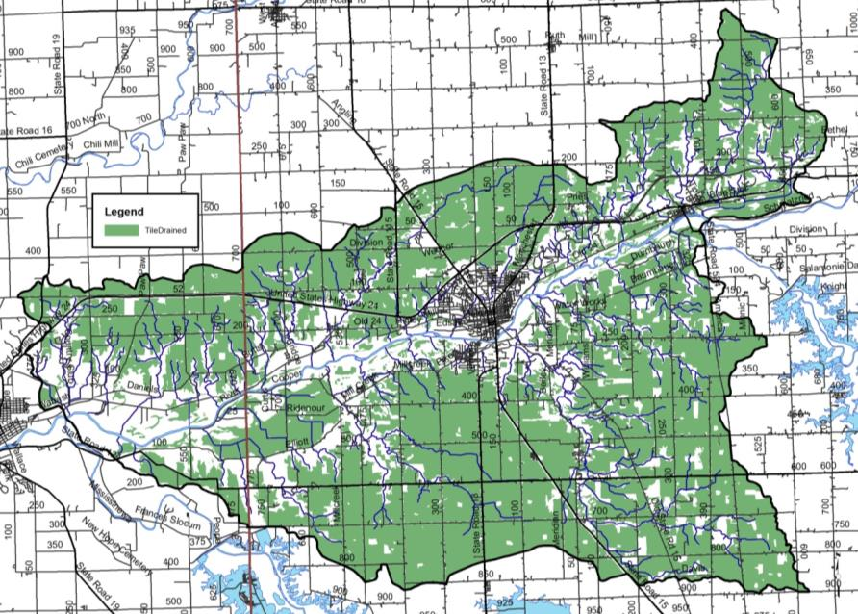
Figure 9. Tile-drained soils in the Treaty Creek-Wabash River Watershed. Source: NLCD, 2011 and NRCS, 2018.

Wastewater Treatment

Soil Septic Tank Suitability
Throughout Indiana, households depend upon septic tank absorption fields in order to treat wastewater. Seven soil characteristics, including position in the landscape, soil texture, slope, soil structure, soil consistency, depth to limiting layers, and depth to seasonal high water table, are utilized to determine suitability for on-site septic treatment. Septic tanks require soil characteristics that allow for gradual movement of wastewater from the surface into the groundwater. A variety of characteristics limit the ability for soils to adequately treat wastewater. High water tables, shallow soils, compact till, and coarse soils all limit soils abilities in their use as septic tank absorption fields. Specific system modifications are necessary to adequately address soil limitation; however, in some cases, soils are too poor for treatment and therefore prove inadequate for use in septic tank absorption fields.

Until 1990, residential homes located on 10 acres or more and occurring at least 1,000 feet from a neighboring residence were not required to comply with any septic system regulations. In 1990, a new septic code corrected this loophole. Current regulations address these issues and require that individual septic systems be examined for functionality. Additionally, newly constructed systems cannot be placed within the 100-year floodplain and systems installed at existing homes must be placed above the 100-year flood elevation. However, many residences grandfathered into this code throughout the state have not upgraded or installed fully functioning systems (Krenz and Lee, 2005). In these cases, septic effluent discharges into field tiles or open ditches and waterways and will likely continue to do so due to the high cost of repairing or modernizing systems ($4,000 to $15,000; ISDH, 2001). Lee et al. (2005) estimates that 76,650 gallons of untreated wastewater is expelled in the state of Indiana annually. The true impact of these systems on the water quality in the Treaty Creek-Wabash River Watershed cannot be determined without a complete survey of systems.

The NRCS ranks each soil series in terms of its limitations for use as a septic tank absorption field. Each soil series is placed in one of three categories: severely limited, moderately limited, and slightly limited. Some soils are also unranked. Severe or very limited limitations delineate areas whose soil properties present serious restrictions to the successful operation of a septic tank tile disposal field. Using soils with a severe limitation increases the probability of the system's failure and increases the costs of installation and maintenance. Areas designated as having moderate or somewhat limited limitations have soil qualities which present some drawbacks to the successful operation of a septic system; correcting these restrictions will increase the system's installation and maintenance costs. Slight limitations delineate locations whose soil properties present no known complications to the successful operation of a septic tank tile disposal field. Use of soils that are rated moderately or severely limited generally require special design, planning, and/or maintenance to overcome limitations and ensure proper function.

Watershed stakeholders are concerned about the lack of maintenance associated with septic tanks, the use of soils that are not suited for septic treatment, and the presence of straight pipe systems within the watershed. These concerns are exacerbated by the fact that severely limited soils cover essentially the entire watershed (Figure 10). Nearly 97,939 acres or 97% of the watershed is covered by soils that are considered very limited for use in septic tank absorption fields. Nearly 1,253 (1.2%) acres are somewhat limited meaning that these soils are generally suitable for septic systems. The remaining 1,667 acres (1.7%) not rated for septic usage as it is not generally industry standard to install a septic system in these geographic locations..

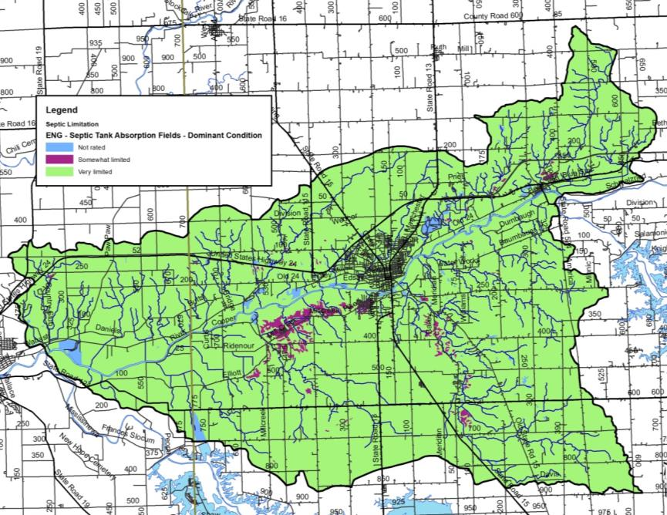
Figure 10. Suitability of soils for septic tank usage in the Treaty Creek-Wabash River Watershed. Source: NRCS, 2018.

Wastewater Treatment and Solids Disposal
Several facilities which treat wastewater and are permitted to discharge the treated effluent are located within the watershed. These facilities are regulated by National Pollution Discharge Elimination System (NPDES) permits. These include several wastewater treatment plants ranging in size from small, local plants to larger, publicly-owned facilities, and school facilities. In total, 8 NPDES-regulated facilities are located within the watershed (Figure 11). Table 4 details the NPDES facility name, activity, and permit number. More detailed information for each facility will be discussed on a subwatershed basis in subsequent sections.

Table 4. NPDES-regulated facility information.
MapID | NPDES ID | Facility Name | Receiving Stream | Designed Flow
1 | IN0030635 | SOUTHWOOD ELEMENTARY SCHOOL | Treaty Creek | 0.011
2 | IN0039063 | WABASH ALLOYS, L.L.C. | Wabash River | 0.060
3 | IN0059510 | WABASH WATER TREATMENT/IAWC | Treaty Creek | 0.190
4 | IN0024741 | WABASH MUNICIPAL SEWAGE TR. PL | Wabash River | 4.000
5 | IN0045357 | LAKEVIEW TRAILER COURT & SUBDI | Kentner Creek | 0.010
6 | IN0054127 | LAKEVIEW MOBILE HOME WWTP | Kentner Creek | 0.012
7 | IN0003484 | CELOTEX CORP | Wabash River | 0.055
8 | IN0051861 | CARRIAGE HOUSE ESTATES MHP | Chamberlain Ditch | 0.006
Source: USEPA EnviroFacts Warehouse, 2018
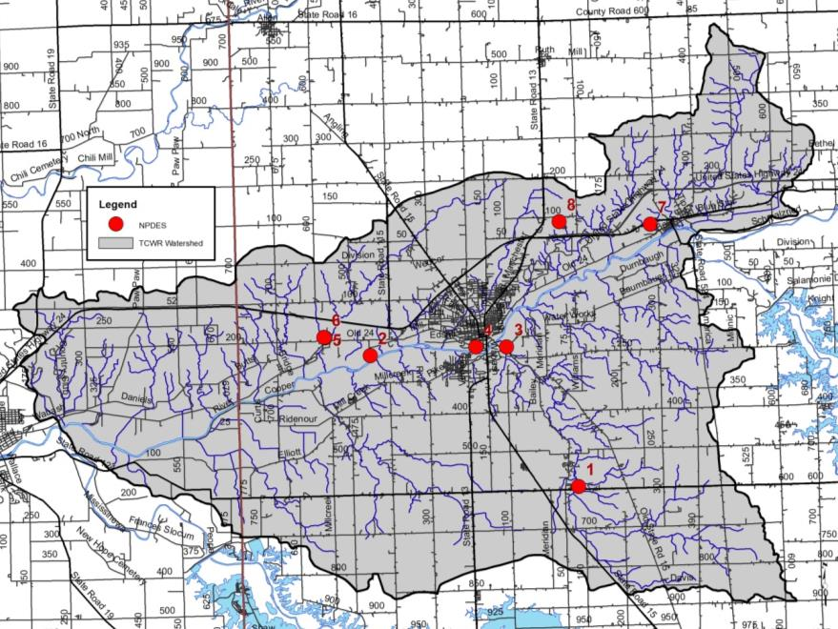
Figure 11. NPDES-regulated facilities in the Treaty Creek-Wabash River Watershed.

Municipal Wastewater Treatment and Combined Sewer Overflows
In the relatively rural Treaty Creek-Wabash RIver Watershed, there are two wastewater treatment facilities discharging to Kentner Creek, both are part of the Lakeview Mobile Home Park; one wastewater treatment plant discharging to Chamberlain Ditch from Carriage House Estates; one wastewater water facility discharging to the Wabash River from the City of Wabash; and the Southwood Elementary School wastewater facility and Indiana American Water, a drinking water facility, which discharges to Treaty Creek. Eight Combined Sewer Overflow (CSO) points are located within the City of Wabash discharging to Charley Creek and its tributary, Priser Ditch, or to the Wabash River (Figure 12). Sludge from municipal wastewater treatment plants is applied on 4,504 acres throughout the watershed. Much of this application occurs within the Stone Creek-Treaty Creek and Enyeart Creek Subwatersheds (Figure 12).

City of Wabash WWTP
The City of Wabash wastewater treatment plant treats effluent from the city’s 8.65 square mile drainage servicing the cities 81 miles of sewer pipes (United Consulting, 2003). In 1960-1961, the City of Wabash constructed a 2.76 MGD activated sludge plant. In 1994, the wastewater plant was renovated and converted almost entirely to a sludge handling plant. Two submersible pumps with an 8 MGD capacity were installed to address combined sewer overflows. The current operation utilized son screw pump, one submersible pump with VFD controls, and one submersible pump with across the line starting. As flows to the facility increase above the screw pump’s capacity, the submersible VFD pump control is initiated which results in a greater than 10 MGD peak hourly rate. The system also includes a UV disinfection system which allows for nearly 100% kill of coliforms under normal, dry weather conditions. The system includes 8 CSOs, all of which are monitored by flow meters, which cover approximately 30% of the 81 sewer miles (Figure 12). The majority of the sewer system south of the Wabash River is more than 35 years in age and is generally in poor condition, which allows for stormwater and ground water infiltration. In 2002, the City of Wabash initiated a downspout disconnection program removing nearly 10,000,000 gallons of inflow annually from the sewer system.

Unsewered Areas
Three unsewered, dense housing areas covering 370 acres were identified within the watershed (Figure 12). Areas that have at least 25 houses within a square mile outside of the sanitary district boundaries were classified as dense, unsewered areas.

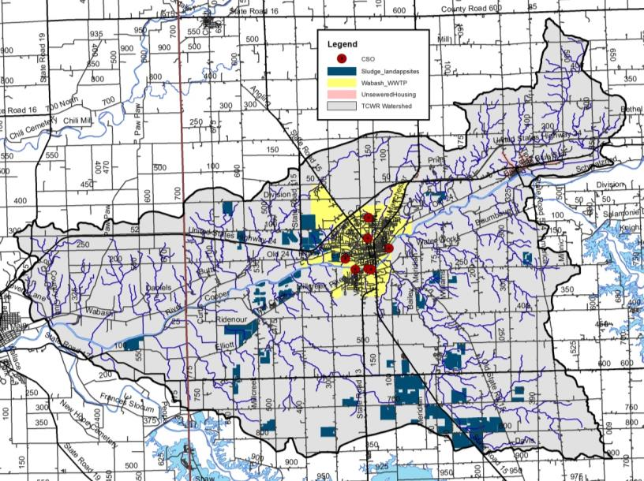
Figure 12. Wastewater treatment plant service areas, municipal biosolids land application sites, dense unsewered housing, and combined sewer overflow outfalls within the Treaty Creek-Wabash River Watershed. Sources: United Consulting, 2016; IDEM, 2018.

Hydrology
Watershed streams, reservoirs, legal drains, floodplains, wetlands, storm drains, groundwater, subsurface conveyances, and manmade drainage channels all contribute to the watershed’s hydrology. Each component moves water into, out of, or through the system. Their contributions will be covered in further detail in subsequent sections.

Watershed Streams
The Treaty Creek-Wabash River Watershed contains approximately 297 miles of streams, regulated drains, and regulated tile drains. Of these, approximately 7.8 miles are regulated drains. Including Koontz Drain, Peebles Ditch, Unger Ditch, and Stauffer Ditch. The majority of streams in the Treaty Creek-Wabash River Watershed are not regulated; however, drain status and locations should be confirmed on a case by case basis with the Wabash County Surveyor. It should be noted that regulated drains are maintained by the county surveyor’s office and both of the regulated drains within the watershed have both a regular maintenance fund and a regular maintenance schedule. Maintenance practices can include dredging with large construction equipment to maintain flow, debris removal, and vegetation management both within the regulated drain and the riparian zone. As these waterbodies are subject to periodic cleaning, it is important to work with the county surveyor to establish priorities for these waterbodies in terms of water quality improvement and erosion control.

The major tributaries to the Wabash River within the Treaty Creek-Wabash River include Treaty Creek, Shrock Creek, Schrom Creek, Ross Run, Ridgeway Creek, Rager Creek, Mill Creek, Charley Creek, Lagro Creek, Kentner Creek, Helm Creek, Enyeart Creek, Gilbert Branch, Engleman Creek, Asher Branch, Daniel Branch, Burr Creek, and Daniel Cree (Figure 13). Treaty Creek and the Wabash River are used for recreational kayaking and canoeing, as well as fishing, swimming, and aesthetic enjoyment. Charly Creek and its waterfall are a common source of aesthetic enjoyment within the watershed. Stakeholders are concerned with maintaining the recreational value of the Wabash River and its tributaries, and have some concerns because portions of the watershed have been designated as impaired by IDEM for E. coli, nutrients, and impaired biotic communities.

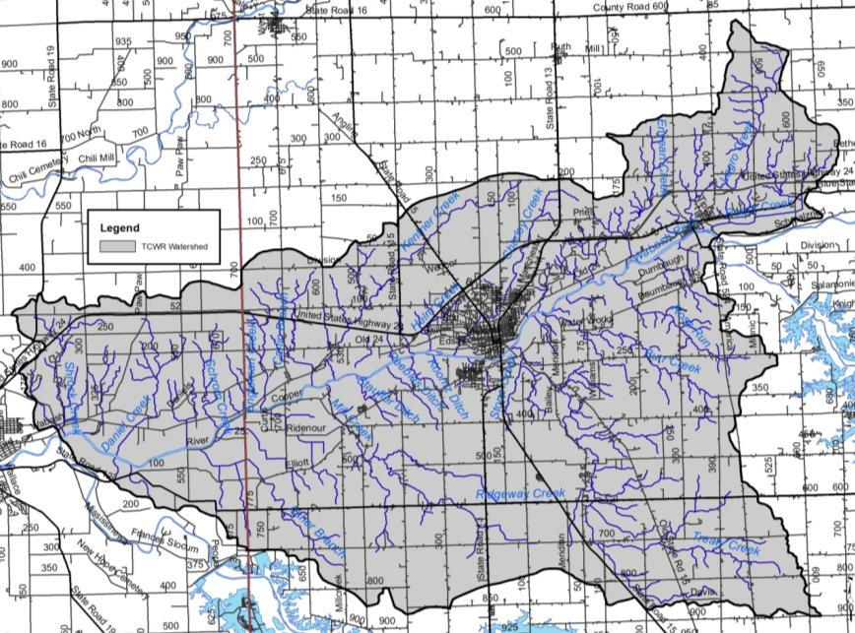
Figure 13. Streams in the Treaty Creek-Wabash River Watershed. Source: USGS, 2018.

Lakes, Ponds and Impoundments
Multiple small lakes and farm ponds dot the Treaty Creek-Wabash River Watershed landscape. These provide local swimming holes, recreational boating options, and localized fishing as well as providing water storage and retention to assist with flooding. Many are located in tributary headwaters and offer some water retention; however, most are insignificant in size or water quality impact. Most recreational boating and fishing occurs on the adjacent Salamonie or Mississinewa Reservoirs or on the Wabash River itself.

Impaired Waterbodies (303(d) List)
The impaired waterbodies, or 303(d), list is prepared biannually by the Indiana Department of Environmental Management. Waterbodies are included on the list if water quality assessments indicate that they do not meet their designated use. More information on the listing process is included in section 3.2.1. Seven stream segments within the Treaty Creek-Wabash River Watershed are included on the list of impaired waterbodies. Table 5 details the listings in the watershed, while Figure 14 maps the segments and their locations within the watershed. Waterbodies are listed as impaired for E. coli (19.2 miles), impaired biotic communities (13.1 miles), nutrients (19.2 miles), mercury and PCBs (19.2 miles). Based on the development of the Wabash River Nutrient and Pathogen TMDL Development (TetraTech, 2008), the E. coli and nutrient impaired segments are considered category 4 impaired waterbodies, while impaired biotic community, and mercury and PCB impaired segments are considered category 5 impairments.

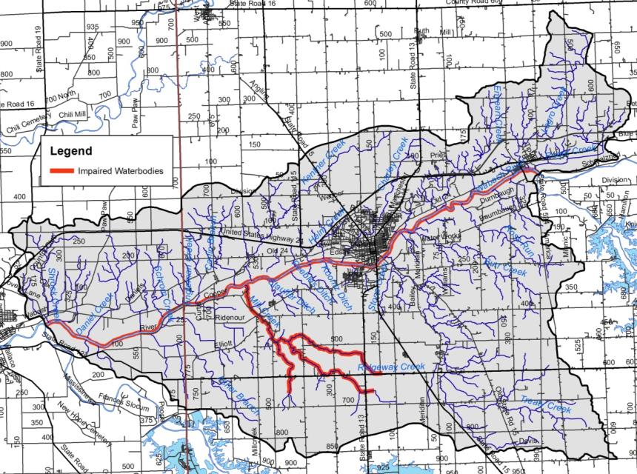
Figure 14. Impaired waterbody locations in the Treaty Creek-Wabash River Watershed.
Source: IDEM, 2013.

Table 5. Impaired waterbodies in the Treaty Creek-Wabash River Watershed 2016 IDEM 303(d) list.
HUC | Waterbody | Assessment Unit | County | Impairment
051201011401 | Wabash River | INB01E3_M1011 | Wabash | E.coli, nutrients, mercury, PCBs
051201011401 | Wabash River | INB01F1_M1012 | Wabash | E.coli, nutrients, mercury, PCBs
051201011403 | Wabash River | INB01F2_M1013 | Wabash | E.coli, nutrients, mercury, PCBs
051201011405 | Wabash River | INB01F2_M1014 | Wabash | E.coli, nutrients, mercury, PCBs
051201011406 | Wabash River | INB01F5_M1015 | Miami, Wabash | E.coli, nutrients, mercury, PCBs
051201011406 | Wabash River | INB01F8_M1015 | Wabash | E.coli, nutrients, mercury, PCBs
051201011404 | Mill Creek | INB01F7_00 | Wabash | Impaired biotic communities

Floodplains
Flooding is a common hazard that can affect a local area or an entire river basin. Increased imperviousness, encroachment on the floodplain, deforestation, stream obstruction, tiling, or failure of a flood control structure all are mechanisms by which flooding occurs. Impacts of flooding include property and inventory damage, utility damage and service disruption, bridge or road impasses, streambank erosion and riparian vegetation loss, water quality degradation, and channel or riparian area modification.

Floodplains are lands adjacent to streams, rivers, and other waterbodies that provide temporary storage for water. These systems act as nurseries for wildlife, offer green space for humans and wildlife, improve water quality, and buffer the waterbody from adjacent land uses. Local stakeholders are concerned about impacts to floodplains from development, lack of landowner maintenance, and soil erosion and deposition within the floodplain.

Figure 16 details the locations of floodplains within the Treaty Creek-Wabash River Watershed. Extensive floodplains lie adjacent to the Wabash River with narrow floodplain areas adjacent to Mill Creek, Charley Creek, and Treaty Creek. Wabash River flooding, especially when the Salamonie Reservoir is releasing water into the river, has been noted as a historic issue and continues to be of concern to stakeholders. Approximately 7.6% (8,472 acres) of the Treaty Creek-Wabash River Watershed lies within the 100-year floodplain (Figure 15). This 100-year floodplain is composed of three regions:
- Zone A is the area inundated during a 100-year flood event for which no base flood elevations (BFE) have been established. Slightly more than half of the Treaty Creek-Wabash River Watershed floodplain is in Zone A or nearly 4,210 acres (3.8% of the watershed).
- Zone AE is the area inundated during a 100-year flood event for which BFEs have been determined. The chance of flooding in Zone AE is the same as the chance of flooding in Zone A; however, floodplain boundaries in Zone A are approximated, while those in Zone AE are based on detailed hydraulic models which allows Zone AE floodplains to be more accurate. Nearly half of the Treaty Creek-Wabash River Watershed floodplain is in Zone AE or 4,001 acres (3.6 % of the watershed).
- Zone X includes areas outside the 100-year and 500-year floodplains which have a 1% chance of flooding to a depth of one foot of water. No BFEs are available for these areas and no flood insurance is required. The remainder of the watershed is classified as Zone X. An additional 260 acres (0.2 %) of Treaty Creek-Wabash River Watershed floodplain lies in Zone 3.

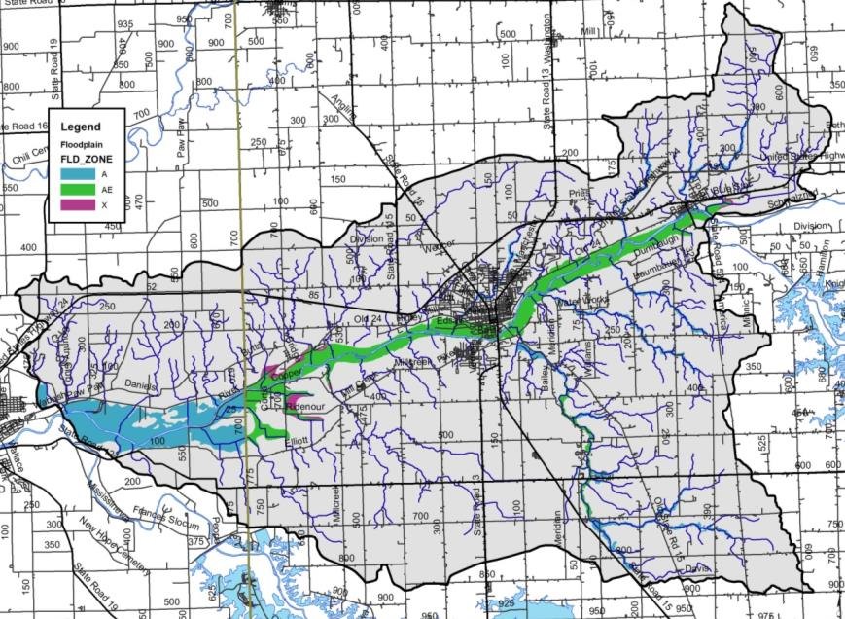
Figure 15. Floodplain locations within the Treaty Creek-Wabash River Watershed.

Wetlands
Approximately 25% of Indiana was covered by wetlands prior to European settlement (Clark, 1994). Overall, 85% of wetlands have been lost resulting in Indiana ranking fourth in the nation in terms of percentage of wetland loss. Wetlands provide numerous valuable functions that are necessary for the health of a watershed and waterbodies. Wetlands play critical roles in protecting water quality, moderating water quantity, and providing habitat. Wetland vegetation adjacent to waterways stabilizes shorelines and streambanks, prevents erosion, and limits sediment transport to waterbodies. Additionally, wetlands have the capacity to increase stormwater detention capacity, increase stormwater attenuation, and moderate low water levels or flow volumes by allowing groundwater to slowly seep back into waterbodies. These benefits help to reduce flooding and erosion. Wetlands also serve as high quality natural areas providing breeding grounds for a variety of wildlife. They are typically diverse ecosystems which can provide recreational opportunities such as fishing, hiking, boating, and bird watching. It should be noted that natural wetlands are regulated through the IDEM and the U.S. Army Corps of Engineers while USDA has jurisdiction over wetlands on agricultural fields. Any modification to wetlands requires permits from these agencies.

Wetlands cover 1,389 acres, or 1.3%, of the watershed. When hydric soil coverage is used as an estimate of historic wetland coverage, it becomes apparent that more than 85% of wetlands have been modified or lost over time. This represents 28.5 square miles of wetland loss within the Treaty Creek-Wabash River Watershed. As commodity prices continue to go up and down, area land values remain high and as a result individuals are spending a great deal of money to drain small natural wetlands in their fields in order to be able to farm that additional couple acres of land as it is cheaper to tile it than to buy ground already in production.
Figure 17 shows the current extent of wetlands within the Treaty Creek-Wabash River Watershed. Wetlands displayed in Figure 16 results from compilation efforts by the U.S. Fish and Wildlife Service as part of the National Wetland Inventory (NWI). The NWI was not intended to map specific wetland boundaries that would compare exactly with boundaries derived from ground surveys. As such, NWI boundaries are not exact and should be considered to be estimates of wetland coverage. Using this map will help us to identify which portions of the watershed would make ideal candidates for wetland restoration efforts which would reduce the amount of sediment and nutrients reaching the creek, as well as helping to restore the natural hydrology of the area which could help to reduce flooding impacts locally.

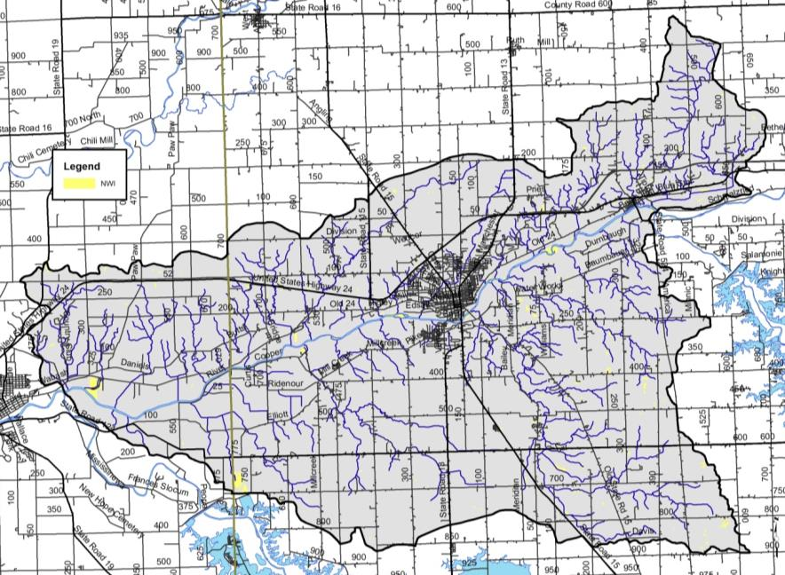
Figure 16. Wetland locations within the Treaty Creek-Wabash River Watershed. Source: USFWS, 2017.

Stormwater and Storm Drains
Under natural conditions, the majority of precipitation is allowed to infiltrate the soil and recharge groundwater resources. The volume of infiltration and groundwater recharge diminishes as development increases. To handle the large volume of precipitation falling in urban areas, stormwater systems have been constructed. Storm drain systems are present in most urban areas throughout the watershed. In total, more than 30 miles of storm drain pipe are present within the watershed. The City of Wabash works to mitigate stormwater impacts to the Treaty Creek-Wabash River watershed including Charley Creek and its tributaries, the most urban tributary in the watershed via its MS4 program (Figure 17).

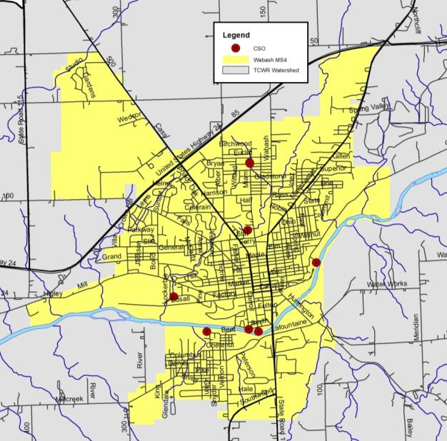
Figure 17. City of Wabash MS4s boundary and CSO overflow locations.

The City of Wabash has eight combined sewer overflows (CSOs) which discharge to three streams: an unnamed tributary to Charley Creek, locally known as Priser Ditch; Charley Creek; and the Wabash River (United Consulting, 2003). CSOs 007 and 008 discharge to Priser Dich, CSOs 005 and 006 discharge to Charley Creek, and CSOs 001, 002, 003, and 004 discharge directly to the Wabash River (Figure 17). The city’s Stream Reach Characterization and Evaluation Report concluded that the CSO discharges negatively impact receiving streams. To address these impacts, the city enacted a best operation and maintenance plan including posting warning signs at all CSO outfalls, continued system inspection and maintenance, employee education, enacting a downspout disconnection program, and establishing a public education program including news releases.

Wellfields/Groundwater
In general, municipal water which supplies, Lagro and Wabash, is taken from unconsolidated deposits of relatively clean, coarse-textured sand and gravel deposited in gravel outwash (Grove, 2007). In total, seven aquifers cover Wabash and Miami counties. Aquifer thickness varies from 50 to 125 feet in some areas and exceeds 400 feet near LaFontaine and trending northwest into Miami County along the Wabash River. The Till Veneer Aquifer System covers much of the Wabash River mainstem. This aquifer encompasses areas of unconsolidated material which is predominantly thin glacial till or alluvium overlying eroded bedrock (Grove, 2007). Much of the Treaty Creek-Wabash River Watershed is drained by the Bluffton Till and Bluffton Complex aquifer systems. These aquifers generally contain deposits of varying material and thickness but typically measure greater than 50 feet in thickness. Intratill sand and gravel lenses are overlain by thick deposits or separated from the surface by thick till layers within these aquifer systems (Grove, 2007).

Table 6 lists wellhead protection areas within and adjacent to the Treaty Creek-Wabash River Watershed. The wellhead protection areas and wellhead protection plans associated with each area will be discussed in additional detail in subsequent sections. Potential pollution from construction, sewage outfalls or overflows, illegal dumping, agriculture, and storm water runoff must be avoided or controlled due to the recharge of these aquifers from runoff and river water. The sensitivity to surface contamination is shown in Figure 18. While areas of aquifer within Wabash County north and south of Wabash and along the western Wabash County/eastern Miami County border are highly sensitive to contamination, much of the Treaty Creek-Wabash River Watershed possess low to moderate sensitivity to surface contamination.

Table 6. Wellhead protection areas in and adjacent to the Treaty Creek-Wabash River Watershed.
County | PWSID | System name | Population
Wabash | 5285003 | Indiana American Water - Wabash | 11,015
Wabash | 5285005 | Lagro Municipal Water Department | 454
Wabash | 5285006 | Lake View Mobile Home Park | 50
Wabash | 5285011 | Rhoades Wheel In Mobile Home Park | 60
Wabash | 5285019 | Carriage House Estates | 25

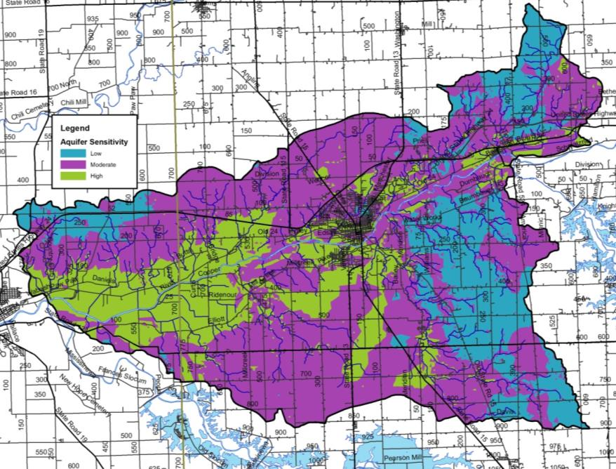
Figure 18. Aquifer sensitivity within the Treaty Creek-Wabash River Watershed. Source: IGS, 2015.

Natural History
Geology, climate, geographic location, and soils all factor into shaping the native flora and fauna which occurs in a particular area. Categorization of these floral and faunal communities has been completed by a number of ecologists since the earliest efforts by Coulter in 1886. Since this time, Petty and Jackson (1966) identified regional communities; Homoya et al. (1985) classified Indiana into natural regions, while Omernik and Gallant (1988) categorized Indiana into ecoregions. Homoya et al. (1985) note that prior to European settlement, much of Miami and Wabash counties were covered by a mix of wetland land uses, including bog, fen, marsh, sedge meadow, swamp, seep, and spring, as well as a mix of lakes and deciduous forest. Upland areas were likely covered by red, white, and black oak; maple, and shagbark and pignut hickory. More wet areas were covered by beech, sugar maple, black maple, and tulip poplar. Historically, wet habitat mixed with upland habitat throughout the watershed.

Natural and Ecoregion Descriptions
According to Homoya et al.’s (1985) classification of natural regions in Indiana, the Treaty Creek-Wabash River Watershed lies in Homoya’s Central Till Plain Natural Region. The Treaty Creek-Wabash River Watershed also lies in the Clayey High Lime Till Plains within the Eastern Corn Belt Plains Ecoregion as defined by Omernik and Gallant (1988). Petty and Jackson (1966) indicate that the Treaty Creek-Wabash River Watershed is within the Beech-Maple Association.

Wildlife Populations and Pets
Individuals are concerned about local wildlife and pet populations, the impact that these have on pathogen levels, and the impact that changing land uses could have on these populations. These will be quantified in subsequent sections. With these concerns in mind, wildlife density can be estimated from a variety of sources. The Indiana Department of Natural Resources (IDNR) is tasked with managing wildlife populations throughout the state. In order to complete this task, the IDNR must have an idea of the population density within specific areas, counties, or regions. The most recent survey of wildlife populations for which data are publicly available occurred in 2005. Those densities are shown in Table 7 with deer, squirrels and turkey being the most common wildlife present within the region. It should be noted that these numbers could both underestimate and overestimate populations within the watershed. Densities are recorded based on animal observations per 1000 hours of overall observation. If observations areas are not equally spread throughout the region, over or underestimates of the populations could occur. Likewise, animals are not likely equally distributed throughout the region; therefore, the regional density may again over or underestimate the true density of the animal in question. Nonetheless, these estimates provide the best guess at wildlife densities.

Table 7. Surrogate estimates of wildlife density in the IDNR northeast region, which includes the Treaty Creek-Wabash River Watershed.
Animal | 2005 Population Observation  (per 1000 hrs of observation)
Beaver | 0.7
Bobcat | 1.6
Bobwhite | 8.1
Coyote | 19.6
Deer | 1112.5
Fox squirrel | 640.3
Gray fox | 2.0
Gray squirrel | 89.1
Grouse | 7.2
Domestic cat | 26.8
Muskrat | 6.3
Opossum | 16.4
Rabbit | 33.1
Raccoon | 72.8
Red fox | 1.7
Skunk | 5.1
Turkey | 15.4
Source: Plowman, 2006.

Pet populations can affect pathogen levels similar to the impacts provided by wildlife. While a count of pets for the Treaty Creek-Wabash River Watershed was not completed, dog and cat populations were estimated for the Watershed using statistics reported in the 2012 U.S. Pet Ownership & Demographics Sourcebook. Specifically, the Sourcebook reports that on average 37.4 percent of households own dogs and 32.9 percent of households own cats. Typically, the average number of pets per household is 1.7 dogs and 2.2 cats. However, pets are likely only a significant source of E. coli in population centers. The estimated number of domestic pets in cities and towns in the Treaty Creek-Wabash River Watershed is based on the average number of pets per household multiplied by the population of the watershed resulting in a suggested population of 9,823 cats and 7,590 dogs.

Endangered Species
The Indiana Natural Heritage Data Center, part of the Indiana Department of Natural Resources, Division of Nature Preserves, maintains a database documenting the presence of endangered, threatened, or rare species; high quality natural communities; and natural areas in Indiana. The database originated as a tool to document the presence of special species and significant natural areas and to assist with management of said species and areas where high quality ecosystems are present. The database is populated using individual observations which serve as historical documentation or as sightings occur; no systematic surveys occur to maintain the database.

The state of Indiana uses the following definitions to list species:
- Endangered: Any species whose prospects for survival or recruitment with the state are in immediate jeopardy and are in danger of disappearing from the state. This includes all species classified as endangered by the federal government which occur in Indiana. Plants currently known to occur on five or fewer sites in the state are considered endangered.
- Threatened: Any species likely to become endangered within the foreseeable future. This includes all species classified as threatened by the federal government which occur in Indiana. Plants currently known to occur on six to ten sites in the state are considered threatened.
- Rare: Plants and insects currently known to occur on eleven to twenty sites.

In total, 47 observations of listed species and/or high quality natural communities occurred within the Treaty Creek-Wabash River Watershed (Figure 19; Clark, personal communication). These observations include one amphibian, five bird species, two mammals, nine mollusks, four plants, and four community types or geologic features. Many of these species were historically located adjacent to the Wabash River or a tributary or within their riparian habitats. State endangered species include mollusk species: round hickory nut (1989, 2008, 2009), eastern fanshell pearlymussel (1988), snuffbox (1988, 2008, 2009), rayed bean (1988, 2009); the greater redhorse (1989), redside dace (2008, 2010), and the cerulean warbler (1994). State threatened species include the prairie-rocket wallflower, while state rare species include the false hop sedge and Michaux’s stitchwort. Species of special concern include the bald eagle, American badger, hooded warbler, broad-winged hawk, least weasel, Ohio pigtoe, kidneyshell, wavyraded lampmussel, and four-toed salamander. High quality natural communities include the waterfall and cascade, central till plain mesic upland forest, central till plain dry-mesic upland forest, and limestone cliff and are located on high quality natural areas including the Asherwood Nature Preserve, Frances Slocum State Recreation Area, Hathaway Preserve at Ross Run Nature Preserve and Salamonie River State Forest. Appendix C includes the database results for the Treaty Creek-Wabash River Watershed, as well as county-wide listings for Miami and Wabash Counties.

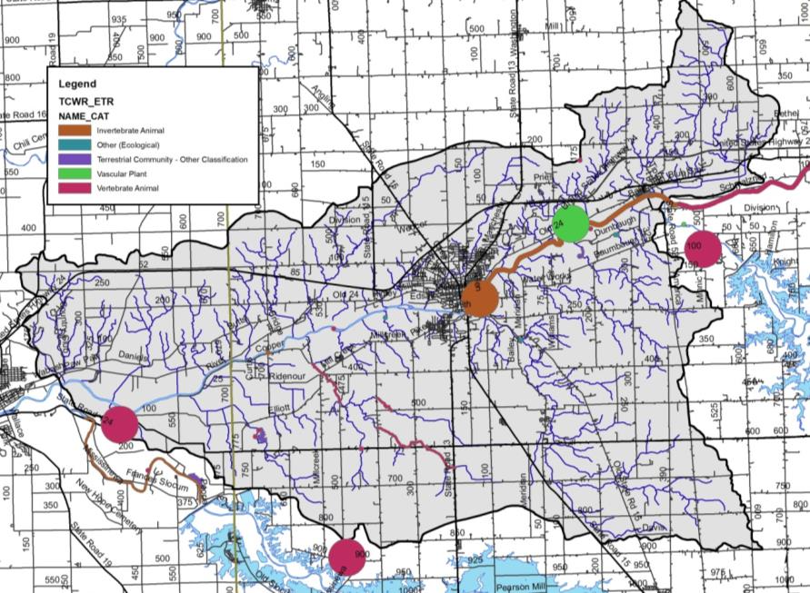
Figure 19. Locations of special species and high quality natural areas observed in the Treaty Creek-Wabash River watershed. Source: Clark, 2018.

Recreational Resources and Significant Natural Areas
A variety of recreational opportunities and natural areas exist within the Treaty Creek-Wabash Watershed. Recreational opportunities include parks, fish and wildlife areas, nature preserves, fairgrounds, golf courses, and school grounds (Figure 20). Portions of the Salamonie State Forest and Mississinewa Dam properties are located within the watershed. Additionally, Acres Land Trust owns and manages Ross Run and the Hanging Rock and Wabash Reef National Monument, a portion of which is located in the watershed, while Marion County Schools manages Asherwood Nature Preserve. The City of Wabash maintains the Paradis Spring Historical Park and Riverwalk, Hanna Park, Erie Community Center, Charley Creek Park, and Broadmore Park, while the Town of Lagro manages the Lagro Park and Community Building. The Wabash River is also a popular stream with canoe and kayak enthusiasts at certain times of the year. Additional recreational opportunities exist at various schools, golf complexes and sporting clay facilities.

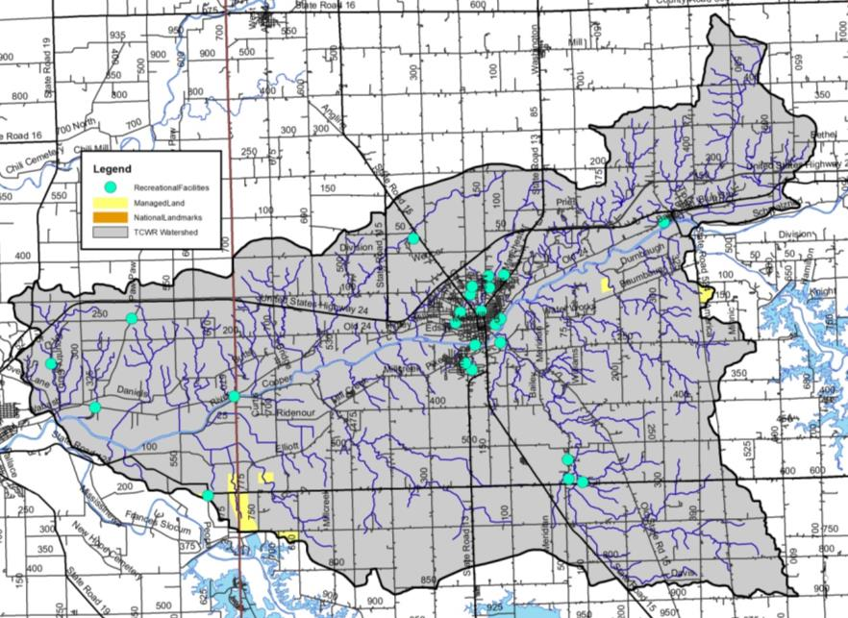
Figure 20. Recreational opportunities and natural areas in the Treaty Creek-Wabash River Watershed.

Land Use
Water quality is greatly influenced by land use both past and present. Different land uses contribute different contaminants to surface waters. As water flows across agricultural lands it can pick up pesticides, fertilizers, nutrients, sediment, pathogens, and manure, to name a few. However, when water flows across parking lots or from roof tops it not only picks up motor oil, grease, transmission fluid, sediment, and nutrients, but it reaches a waterbody faster than water flowing over natural or agricultural land. Hard or impervious surfaces present in parking lots or on rooftops create a barrier between surface and groundwater. This barrier limits the infiltration of surface water into the groundwater system resulting in increased rates of transport from the point of impact on the land to the nearest waterbody.

Current Land Use
Today, the Treaty Creek-Wabash River Watershed is dominated by row crop agriculture (71%) with an additional 2.5% of the watershed covered by pasture or hay (Table 8, Figure 21). Nearly 9% of the watershed is covered by developed open space or is in low, medium, or high intensity developed areas. Grassland, evergreen forest, open water, and wetlands cover the remaining 3.3% of the watershed. Definitions for each land cover type are included in Appendix D.

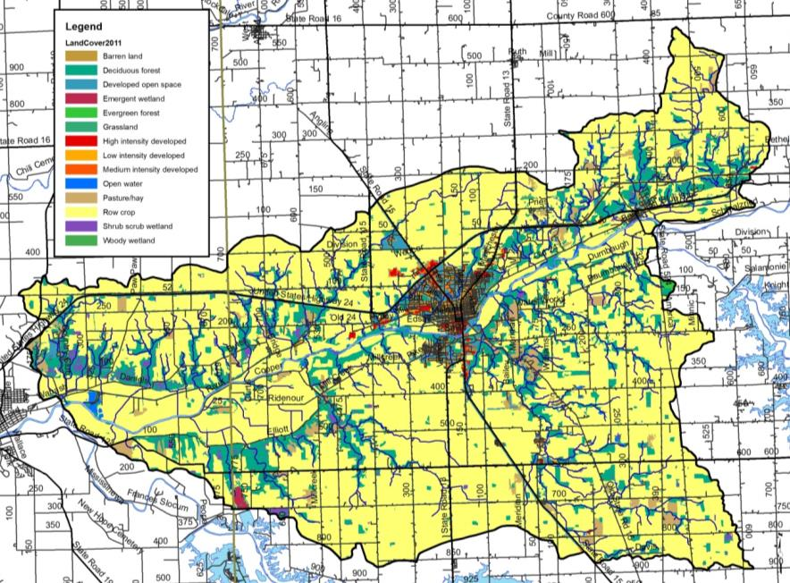
Figure 21. Land use in the Treaty Creek-Wabash River Watershed. Source: NLCD, 2011.

Table 8. Detailed land use in the Treaty Creek-Wabash River Watershed.
Classification | Area (acres) | Percent of Watershed
Row crop | 79,250.5 | 70.9%
Deciduous forest | 15,804.2 | 14.1%
Developed open space | 7,313.9 | 6.5%
Pasture/hay | 2,780.5 | 2.5%
Low intensity developed | 2,227.2 | 2.0%
Shrub/scrub | 1,174.0 | 1.0%
Open water | 1,099.0 | 1.0%
Grassland | 1,044.5 | 0.9%
Medium intensity developed | 512.9 | 0.5%
High intensity developed | 303.9 | 0.3%
Emergent wetland | 221.9 | 0.2%
Evergreen forest | 65.0 | 0.1%
Woody wetland | 38.1 | 0.0%
Total | 111,835.7 | 100%
Source: USGS, 2011

Agricultural Land Use
Individuals are concerned about the impact of agricultural practices on water quality. Specifically, the volume of exposed soil entering adjacent waterbodies, the prevalence of tiled fields and thus the transport of chemicals into waterbodies, the use of agricultural chemicals, and the volume of manure applied via small animal farms and through confined animal feeding operations are concerning to local residents. Each of these issues will be discussed in further detail below.

Tillage Transect
Tillage transect information data for Miami and Wabash counties was compiled for 2017 (Table 9; ISDA, 2017A-B). As reported by ISDA, members of Indiana’s Conservation Partnership (ICP) conduct a field survey of tillage methods. A tillage transect is an on-the-ground survey that identifies the types of tillage systems farmers are using and long-term trends of conservation tillage adoption using GPS technology, plus a statistically reliable model for estimating farm management and related annual trends. Table 7 provides the number of acres and percent of acres on which conservation tillage was utilized for each county by corn and soybeans.

Table 9. Tillage transect data by county for corn and soybeans (ISDA, 2017A-B).
County | Corn (acres) | Corn (%) | Soybeans (acres) | Soybeans (%)
Miami | 61,734 | 83% | 97,306 | 76%
Wabash | 73,315 | 78% | 98,926 | 64%

Agricultural Chemical Usage
Agricultural pesticides and fertilizers are commonly applied to row crops in Indiana. These chemicals can be carried into adjacent waterbodies through surface runoff and via tile drainage. This is especially an issue if a storm occurs prior to the chemicals being broken down and used by the crops.

Data for chemical usage on an individual county or watershed level are not currently collected. Rather, data is collected for the state as a whole in two forms. First, the National Agricultural Statistics Survey (NASS) collects information on chemical usage, number of applications per year, type of chemical applied, and the application rate. These data were last collected in 2006 (NASS, 2006). Additionally, NASS collects farmland data for the number of acres in agricultural production by type (i.e. corn, soybeans, grains) (NASS, 2017). These data indicate that corn (135,050 acres) and soybeans (196,230 acres) are the two primary crops grown in the watershed (Error! Reference source not found.).

Nitrogen is more typically applied to corn than to soybeans. Soybeans have symbiotic bacteria on their roots that act as nitrogen fixers, which means that they pull the nitrogen that they need from the atmosphere then convert it into a form which they can use. Corn does not fix nitrogen; therefore nitrogen needs to be applied. Nitrogen is typically applied twice in Indiana – once at or before planting and a second time when corn reaches approximately one foot in height (NASS, 2007). Fall application of nitrogen also occurs, and is particularly problematic. Agricultural data indicate that corn receives 98% of the nitrogen applied in the state and 87% of the phosphorus. For these reasons, nutrient calculations were only completed for corn as applications to soybeans are likely negligible. Based on these data, it is estimated that 9,953 tons of nitrogen and 4,923 tons of phosphorus are applied annually within Miami and Wabash counties (Table 10).

Table 10. Agricultural nutrient usage for corn in the Treaty Creek-Wabash River Watershed counties.
Nutrient | Acres of Corn | % of Area Applied | Applications (#/year) | Rate/Application (lb/acre) | Total Applied/Year  (tons)
Nitrogen | 135,050 | 100 | 2.2 | 67 | 9,953
Phosphorus | 135,050 | 93 | 1.4 | 56 | 4,923
Source: NASS, 2007

Pesticides are also used on crops grown in Indiana. The Office of the Indiana State Chemist indicates that the two predominant herbicide active ingredients applied are atrazine and glyphosate. Atrazine is most commonly applied as a corn herbicide, while glyphosate is used on both corn and soybean fields as an herbicide. NASS indicates that in 2005, an average of 1.24 pounds of atrazine and 0.6 pounds of glyphosate were applied per acre of corn, and 0.73 pounds of glyphosate were applied per acre of soybeans (NASS, 2006). Using these rates, we estimated that a little over 83 tons of atrazine and approximately 112 tons of glyphosate are applied to cropland in Miami and Wabash Counties annually (Table 11).

Table 11. Agricultural herbicide usage in the Treaty Creek-Wabash River Watershed counties.
Crop | Acres | Application Rate  (lb/acre) | Total Applied  (lbs) | Total Applied/Year  (tons)
Corn (Atrazine) | 135,050 | 1.24 | 167,462 | 83.7
Corn (Glyphosate) | 135,050 | 0.60 | 81,030 | 40.5
Soybeans (Glyphosate) | 196,230 | 0.73 | 143,248 | 71.6
Source: NASS, 2006

Confined Feeding Operations and Hobby Farms
A mixture of small, unregulated and larger, regulated livestock operations (confined feeding operations) is found within the Treaty Creek-Wabash River Watershed. Small farms are those which house less than 300 animals, while larger farms that house large numbers of animals for longer than 45 days per year are regulated by IDEM. These regulations are based on the number and type of animals present. IDEM requires permit applications which document animal housing, manure storage and disposal, and nutrient management plans for farms which maintain 300 or more cows, 600 or more hogs, or 30,000 or more fowl. These facilities are considered confined feeding operations (CFO). There are 38 active and 10 voided confined feeding operations located in the watershed, none of which are large enough to be classified as a concentrated animal feeding operation (CAFO; Figure 22). The facilities house hogs, veal, and dairy and beef cattle with a combined total of 139 boars, 3,958 sows, 19,841 finishing hogs, 13,238 nursery hogs for a total of 37,016 hogs; 4,155 dairy cattle, 1,122 beef cattle, and 2,050 veal. In total, approximately 44,300 animals per year are housed in CFOs in the watershed, generating approximately 510,183,400 pounds of manure per year spread over more than 3,200 acres in the watershed. Manure produced on permitted CFOs contains nearly 538,340 pounds of nitrogen and 392,490 pounds of phosphorus.

More than 60 small, unregulated animal farms housing more than 600 animals were identified during the windshield survey, which is most likely an underestimate of the actual number. These small “mini farms” contain small numbers of cattle, horses, or goats, which could be sources of nutrients and E. coli as these animals exist on small acreage lots with limited ground cover.

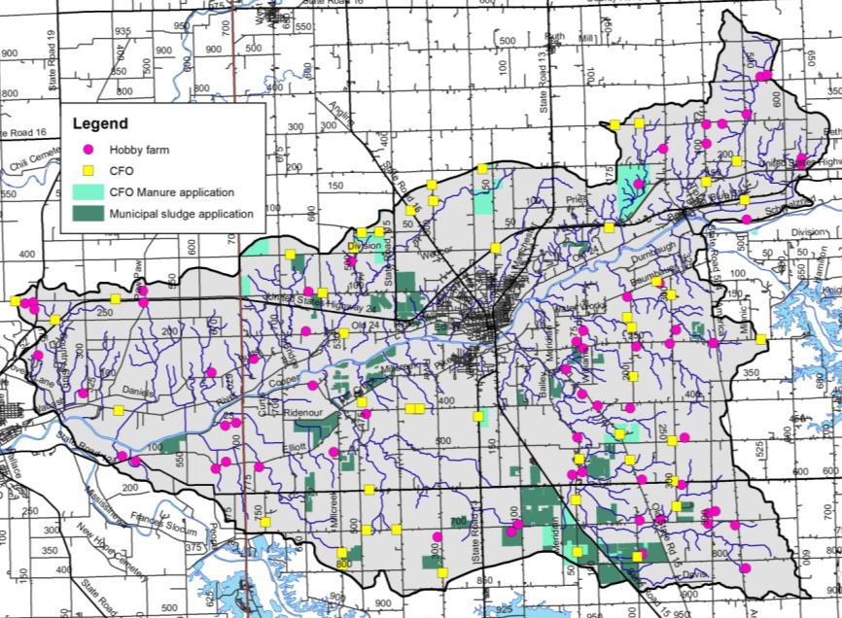
Figure 22. Confined feeding operation and unregulated animal farm locations and associated farm fields for confined feeding operation manure and municipal wastewater treatment plant sludge spreading within the Treaty Creek-Wabash River Watershed. Source: IDEM, 2015.

Natural Land Use
Natural land uses including forest, wetlands, and open water cover approximately 3.3% of the watershed. Forest cover occurs adjacent to waterbodies throughout the watershed, while wetland land uses are isolated throughout the watershed (Figure 21). Many forested tracts are contiguous and large lengths the Wabash River and smaller riparian forests lie adjacent to streams as intact riparian buffers.

Urban Land Use
Urban land uses cover nearly 12% of the watershed (Table 8). Although this is only a very small portion of the watershed, there are some significant issues related to the dev areas. Especially troublesome are issues related to failing septic systems, combined sewer overflows, impervious surfaces, flooding, and stormwater runoff that allow untreated sewage and stormwater to flow into the watershed during heavy rain events. Upgrades needed for facilities such as WWTP’s can be cost-prohibitive.

Impervious Surfaces
Impervious surfaces are hard surfaces which limit surface water from infiltrating into the land surface to become groundwater thereby creating high overland flow rates. Hard surfaces include concrete, asphalt, compacted soils, rooftops, and buildings or structures. In developed areas like Wabash and Lagro, land which was once permeable has been covered by hard, impervious surfaces. This results in rain which once absorbed into the soil running off of rooftops and over pavement to enter the stream with not only higher velocity but also higher quantities of pollutants.

Overall, the watershed is covered by low levels of impervious surfaces. However, high impervious densities are present in Lagro and Wabash and along roads throughout the watershed. Estimates indicate that 8,130 acres (7%) of the watershed are 25% or more covered by hard surfaces. Elvidge et al. (2004) indicated that streams in watersheds with greater than 10% impervious surfaces clearly exhibited degradation. The Center for Watershed Protection (CWP) identified similar impacts from impervious surface density on water quality. The CWP study indicates that stream ecology degradation begins with only 10% impervious cover in a watershed. Higher impervious surface coverage results in further impairments including water quality problems, increased bacteria concentrations, higher levels of toxic chemicals, high temperatures, and lower dissolved oxygen concentrations (CWP, 2003).

Remediation Sites
Remediation sites including industrial waste, leaking underground storage tanks (LUST), open dumps, and brownfields are present throughout the Treaty Creek-Wabash River Watershed (Figure 23). Most of these sites are located within the developed areas of Wabash and along US Highway 24. In total, 13 industrial waste sites, 43 LUST facilities, 3 solid waste facilities, one restricted waste site, and seven brownfields are present within the watershed. There are no Superfund sites within the watershed.

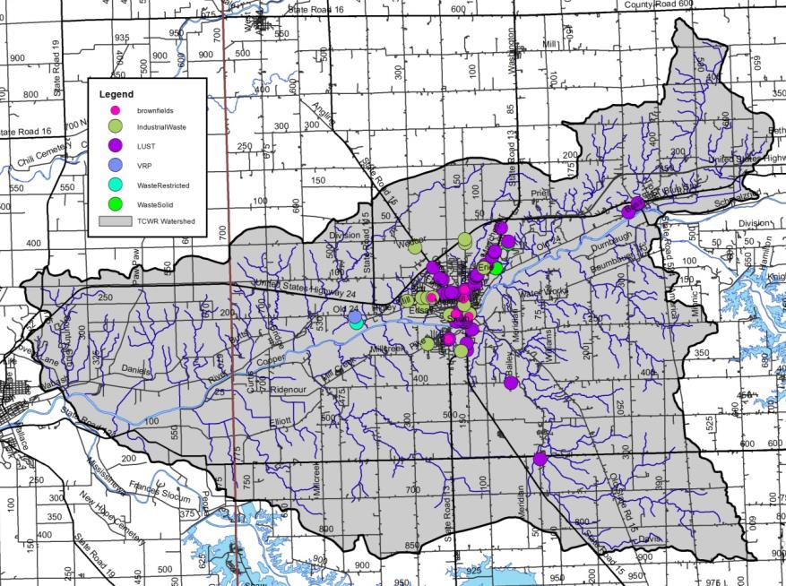
Figure 23. Industrial remediation and waste sites within the Treaty Creek-Wabash River Watershed. Source: IDEM, various.

Population Trends
The Treaty Creek-Wabash River Watershed is relatively a sparsely populated area in general and includes the entirety of the Town of Lagro and City of Wabash. Tracking population changes within a watershed is challenging as data is published by counties and townships rather than watershed boundaries. Estimates of the population of the watershed are derived by calculating percentage of the watershed within a county and extrapolating from county-wide data. The Treaty Creek-Wabash River Watershed lies within two counties. It drains nearly 13% of Miami County and 3% of Wabash County. Population trends for these counties derived from the most recently completed census (2010) are shown in Table 12, while Table 13 displays estimated populations for the portion of each county located within the watershed (StatsIndiana, 2018). These data indicate modest growth in all three counties over the past decade; however most of that growth is associated with Terre Haute and the immediate area.

Table 12. County demographics for counties within Treaty Creek-Wabash River Watershed.
County | Area  (sq mi) | Population (2010) | Population Growth  (2000-2010) | Pop. Density  (#/sq. mi)
Miami | 373.8 | 35,862 | -1063 | 95.8
Wabash | 412.4 | 32,885 | -1442 | 76.2

Table 13. Estimated watershed demographics for the Treaty Creek-Wabash River Watershed.
County | Acres of County  in Watershed | Percent of County  in Watershed | Population
Miami | 239,232 | 6.9% | 1,781
Wabash | 263,936 | 32.9% | 10,513
Total Estimated Population |  |  | 12,294

Planning Efforts in the Watershed
While no one single plan has been dedicated to the Treaty Creek-Wabash River Watershed until the development of this one, several larger plans have encompassed portions of the Treaty Creek-Wabash River Watershed or areas which it drains or outlets into. Planning efforts include those by the Wabash River Heritage Corridor Commission along the length of the Wabash River, into which Treaty Creek-Wabash River drains, the Miami and Wabash County SWCD Master Plans and the Miami and Wabash county-wide master plans.

Wabash County Area Plan
The Wabash County initiated an update to the comprehensive plan in 2009 (Wabash County, 2011). The plan identifies the counties resources and provides guidance for their protection and improvement. Resources identified and mechanisms for protection and improvement include the following:
- Agricultural land: The consumption of agricultural land for non-related purposes, including a loss of farmland acres and overall loss of total farmland in Wabash County, will have a negative economic impact on Wabash County in the long-term. Since 1945, the number of farms in Wabash County decreased by 60% from 2,097 farms in 1945 to 850 farms in 2007. Farmland loss of 17% was observed with acreage decreasing from 240,542 aces in 1945 to 200,689 in 2007. The protection of productive agricultural land from development and the regulation of develop on marginally productive land were highlighted as future goals during the area planning process.
- Environmental areas: Protection of the counties’ reservoirs, lakes, rivers, wetlands, and other features were recognized as part of the planning process. Specifically, the plan recognizes the goal for balancing development with the protection of environmental features. Several goals and objectives were identified including:
  - Protecting today’s environment and natural resources for our benefit and the benefit of future generations through strategic development practices.
  - Working with federal, state and local environmental groups to meet regulations for sewage processing in rural communities with focused development where infrastructure already exists.
  - Protecting underground aquifers from contaminants from improper development or use of land.
  - Maintaining community floodways, floodplains and spillways as natural spaces for flood and erosion control, water quality management and ground water recharge.
  - Providing incentives for the agricultural community to incorporate best practices in agricultural-related operations.
  - Using zoning and ordinances to preserve natural wooded areas and wetlands.
  - Initiating a program in which community members are provided the opportunity to earn their solid waste fee back through obedient recycling.
  - Developing positive relationships with the industrial interests and working together to protect the environment.
  - Holding environmental impacts on recreational areas in check, which is essential in implementing high quality life, good health, and favorable community spirit.

City of Wabash CSO Long-Term Control Plan
The City of Wabash submitted their Combined Sewer Overflow (CSO) Long-term Control Plan (LTCP) in 2003. An addendum to the LTCP was submitted to IDEM in 2010 (United Consulting, 2016). This, in cooperation with the city’s CSO operational plan and issued NPDES permit outline the wet weather operating procedures and design capabilities of the wastewater treatment plant and its collection system. Specifically the plan identifies that all flows received by the wastewater treatment plant will receive full treatment, and that during conditions where wet weather discharges from CSO outfalls 001, 003, 004, 005, 006, 007, or 008 result from a storm event, those conditions will be documented.

Prior to approval of the long-term control plan, the City of Wabash implemented several early action projects. These included:
- Stormwater and sanitary improvements and sewer separation along Vernon Street, Fairfield Drive, Snyder Street, Linlawn Drive, Sivey Stree, and Glenn Avenue;
- Sanitary sewer interceptor replacement from Chestnut and Vernon streets to Hutchens and Middle streets;
- Drainage improvements along LaFountain Avenue; and
- Lift station improvements on Lift Station 10.

The cities LTCP alternative combines several controls that will be constructed over a 17 year period with an approximate cost of $13 million (Figure 24). Once implemented, the LTCP is expected to result in capture and full treatment of flows up to and including a 10 year, 1-hour storm. LTCP projects include the following:
- Construction of various street-specific projects
- Construction of various storm and sanitary sewer improvements
- Construction of lift station 2/CSO 003 improvements.
- Construction of lift station 4 area improvements.
- Installation of mechanical fine screening at the wastewater plant.
- Evaluation of possible elimination of some remaining CSOs after a sufficient post-construction monitoring period.

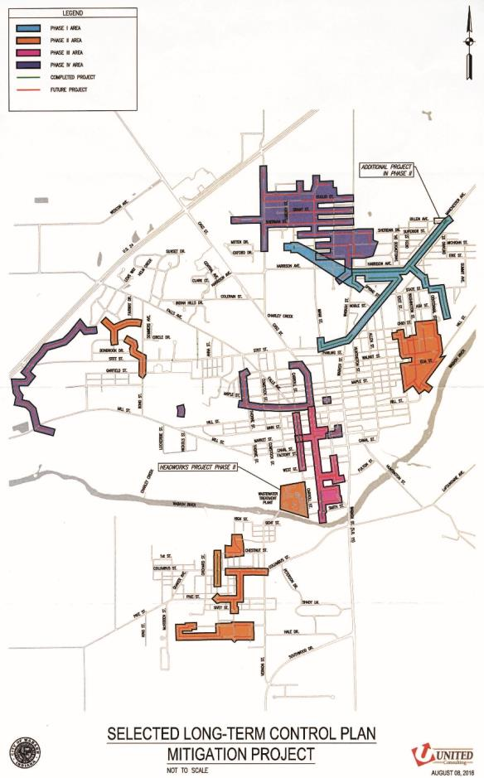
Figure 24. Selected long-term control plan mitigation projects to address combined sewer overflows in the City of Wabash.

Silver Creek-Hanging Rock Watershed Diagnostic Study
The Wabash River Defenders completed the Silver Creek-Hanging Rock Watershed Diagnostic Study in 2017. While the Silver Creek-Hanging Rock Watershed is not located within the Treaty Creek-Wabash River Watershed, it is adjacent to the watershed lying immediately upstream. The completion of this watershed diagnostic study was the first phase in the Wabash River Defenders’ efforts to understand and subsequently, protect and improve, water quality within the Wabash River in Wabash County.

The Silver Creek Hanging Rock Watershed Diagnostic Study is a comprehensive examination of Silver Creek and several minor tributaries to the Wabash River in Huntington and Wabash counties and their surrounding watershed. In 2017, with funding from the Indiana Department of Natural Resources Lake and River Enhancement (LARE) Program, the Wabash River Defenders hired the team of Arion Consultants and Commonwealth Biomonitoring to conduct the study. The scope of the study included the following:
- Data review and mapping current conditions: Collection and review of historic studies, water quality and fisheries reports, and base mapping of watershed conditions.
- Public engagement and outreach: Completion of watershed walking and driving tours and landowner and public meetings.
- Watershed assessment: Completion of stream water quality sampling, macroinvertebrate and fish community assessments, and habitat scoring.
- Analysis and data interpretation: Review of historic and current conditions, assessment of collected water quality data, and compilation of results and recommendations.

The Silver Creek-Hanging Rock Watershed encompasses 25,487 acres (10,314.2 ha) of Huntington and Wabash counties, Indiana. The watershed is 75% row crop agriculture. Forested lands and wetlands account for 17% of the watershed land use, while urban land uses, including urban open space and low, medium, and high intensity developed areas, account for 6% of the watershed.

The study documented high levels of soluble and total phosphorus during base and storm flow conditions and elevated total suspended solids and E. coli concentrations during storm flow conditions. Four of the Silver Creek-Hanging Rock Watershed sites Silver Creek Outlet (Site 1), Silver Creek Headwater (Site 5), Hamilton-Satterthwaite Drain (Site 9) and Kaehr (Site 10) generally possessed poorer water quality conditions than the other stream reaches. The Rapid Bioassessment Protocol (RBP), an index which utilizes invertebrate community structure to measure water quality, documented a range of moderately impacted to non-impaired macroinvertebrate communities. The Index of Biotic Integrity indicates that the fish community in the Silver Creek-Hanging Rock Watershed rates as fair to very poor. Habitat as assessed using the Qualitative Habitat Evaluation Index (QHEI) rated as good to poor. Overall, the Silver Creek-Hanging Rock Watershed provides adequate habitat to maintain good quality fish communities and only moderately impaired macroinvertebrate communities.

Observers identified nearly 14 miles of streambank erosion and an additional 12 miles of streams with narrow buffers throughout the Watershed. Nearly 4,000 acres of row crop agriculture would benefit from soil health-focused projects to reduce soil erosion and improve the biological, chemical, and physical condition of streams throughout the study area. Load reduction calculations were estimated for nitrogen, phosphorus and sediment based on the potential best management practices to be implemented within the Silver Creek-Hanging Rock Watershed. If the Silver Creek-Hanging Rock Watershed is blanketed with the proposed projects, pollutant loading will be reduced as follows: 3,141 lb. nitrogen (84%), 1,033 lb. phosphorus (80%), and 66,601 lb. sediment (84%).

Lower Salamonie River Watershed Management Plan
In 2010, meetings concerning issues within the Salamonie River and reservoir were held to generate stakeholder involvement. The project area included the lower section of the Salamonie River in Blackford, Grant, Wells, Huntington and Wabash counties. Excess nutrient runoff, failing septic systems, endangered species protection, streambank erosion and the need for agricultural BMP usage were identified. In 2013, the Huntington County SWCD received IDEM Section 319 funds to produce a watershed management plan for the Lower Salamonie (Kroeker Consulting, 2016). While this area is located upstream of the Treaty Creek-Wabash River Watershed, stakeholders identified water quantity releases from the Salamonie as one of their concerns. Additionally, water quality issues from the Salamonie directly impact the Treaty Creek-Wabash River Watershed. Goals identified as part of the Salamonie River Watershed Management Plan are as follows:
- Less than 60% of samples will exceed pathogen targets within 5 years with less than 75% of samples exceeding targets in 10 year and only outliers exceeding targets in 30 years.
- Achieve a 10% reduction in nitrogen and phosphorus within 5 years, a 15% reduction in nitrogen and a 20% reduction in phosphorus in 10 years and a 20% reduction in nitrogen and 53-70% reduction in phosphorus in 30 years.
- Reduce sediment by 10% in 5 years, 20% in 10 years and 55% in 30 years.
- Improve mIBI scores in 5 years, mIBI scores match with QHEI scores in 10 years and remove impairments on all stream segments that are listed on the 303(d) list in 30 years.
- Create new access points to rivers and streams; increase walking and riding trails along waterways; educate stakeholders about the values of the river and reservoir; improve riparian areas, aquatic habitats and the fishery; and help organize river clean ups within 30 years.

Wabash River Heritage Corridor Commission Master Plan
In 1990, the Indiana Department of Natural Resources created the Wabash River Heritage Corridor Fund to provide assistance with conservation and recreational development projects along the Wabash River. In 1991, the Wabash River Heritage Corridor Commission (WRHCC) was created by House Enrolled Act 1382. The WRHCC protects and enhances the natural, cultural, historical and recreational resources of the Wabash River within the nineteen counties through which the river runs. This includes Warren and Tippecanoe counties, which are part of the current planning project. Since 1990, approximately 60 projects received funding totaling more than $13 million through the corridor fund (WRHCC, 2004). Additional efforts by the WRHCC include maintenance of a visible presence within the corridor counties, provision of interaction along the length of the corridor, and promotion of the Wabash River and its historical and recreational opportunities.

In 2004, the WRHCC updated its master plan via a series of public meetings along the Wabash River corridor. Since 2010, the WRHCC has updated the master plan as part of their regular bimonthly meeting efforts. The 2004 master plan focused on eight main areas including land use, natural resources, historic resources, recreational resources, corridor connection and linkages, scenic by-way linkages, thematic connections, and tourism. The updated plan includes these same foci. As portions of the watershed are contained within the Wabash River Heritage Corridor, it is important that the goals, strategies, and actions developed as part of this plan be in line with those developed as part of the WRHCC master plan. The 2004 master plan identified the following action items:
- Maintain and enhance the natural diversity of the corridor.
- Restore natural landscapes of the Wabash River Heritage Corridor.
- Ensure that mineral extraction is environmentally sensitive.
- Stabilize the riverbank.
- Re-establish riparian forests and wetlands along the Wabash River.
- Develop and implement set-back programs to reduce surface runoff and non-point source pollution.
- Enforce existing regulations regarding point source pollution related to wastewater treatment plants and septic systems and explore the need for new regulations.
- Promote monitoring of water quality and public education about water quality.
- Preserve large regional natural areas.
- Fish stocking and wildlife reintroduction in and along the Wabash River.
- Conduct a historic resource inventory of the corridor resource and nominate eligible properties for National Register designation within the corridor.
- Develop a prioritized list of historic and cultural resources that are threatened for focused preservation effort by county.
- Identify long-term funding opportunities for historic preservation along the corridor.
- Acquire and develop more recreational areas and opportunities.
- Promote and enhance hunting and fishing opportunities.
- Promote and enhance birding opportunities in the corridor.
- Promote and enhance bicycling opportunities in the corridor.
- Develop trail connections along the river linking corridor communities.
- Increase access to the Wabash River for recreational use, boating, fishing, and enjoyment of the river. Increase overnight facilities access.
- Establish designation of scenic by-way along the river.
- Install directional or identification signs for scenic by-ways along the river.
- Create an image to connect and interpret significant resources.
- Develop a Wabash River Heritage Corridor Center that would introduce and interpret the significance of the Wabash River and the Heritage Corridor and serve as a central repository or records center for Wabash studies.
- Develop a Wabash River and Heritage Corridor education curriculum for teacher training opportunities.
- Create corridor identification.
- Promote and market corridor resources and events.
- Develop and coordinate corridor events as part of the Heritage Corridor identity.
- Provide information to promote local and corridor recreational resources and facilities.
- Develop a natural resources guide specific to the Wabash River Heritage Corridor that will be site specific including river and public access information.

In 2009 legislation was revised to allow a new source of dedicated money to be placed in the fund, derived from royalties of oil and mineral rights beneath the Wabash River. This fund will be used to once again fund projects in the Wabash River Corridor.

The grants have been awarded every other year, in 2012 and 2014 so far, and total approximately $300,000 every two years. Both Treaty Creek-Wabash River Watershed counties are eligible to apply for funding.

Watershed Summary: Parameter Relationships
Several relationships among watershed parameters become apparent when watershed-wide data are examined. These relationships are discussed here in general, while relationships within specific subwatersheds are discussed in more detail in subsequent sections.

Topography, Soils, Septic Suitability, and Hydrology
Much of the topography and terrain characteristics within the Treaty Creek-Wabash River Watershed have a direct correlation to water quality. Approximately 36% of the Treaty Creek-Wabash River Watershed are mapped in highly erodible or potentially highly erodible soils. Highly erodible and potentially highly erodible soils are very susceptible to erosion. Nutrients, such as phosphorus, and sediment erode easily when these soils are not covered. Sediments and nutrients that reach Treaty Creek-Wabash River Watershed waterbodies are likely to degrade water quality. Highly erodible and potentially highly erodible soils that are used for animal production or are located on cropland are more susceptible to soil erosion.

Most of the soils in the watershed are rated as very limited for septic system suitability. Sewers are utilized within the City of Wabash. All other residences utilize septic systems. This is a concern because adequate filtration may not occur and this water may easily reach water sources and groundwater. With a lack of natural filtration of septic fields to groundwater, degradation of water quality is likely if septic systems are not maintained. Septic maintenance is a concern of Treaty Creek-Wabash River Watershed stakeholders.

Soils, Topography and Land Form
Topography within the watershed is generally flat away from the Wabash River, especially in the northern and southern portions of the watershed. Soils in these areas formed on till deposits, are somewhat poorly drained to moderately well drained, and are well suited to agriculture. As a result, approximately 75% of the watershed is in a corn-soybean rotation. Because of the low slope and poor drainage, tile drains are extensively used throughout the watershed. It will be important to address the impacts of row crop agriculture and tile-drained systems, by promoting practices to reduce nutrients transported through tiles and to repair and prevent streambank erosion, in order to improve water quality in the watershed.

The steepest terrain in the watershed occurs along the Wabash River itself where steep cliffs along the river provide dramatic scenery. The steepness of the terrain in this area likely made it very difficult to remove timber, making this portion of the watershed one of the most heavily forested areas today. This area is also where the highest concentration of highly erodible and potentially highly erodible soils are found. Protecting and restoring the forested riparian buffer in this area will be important to reducing streambank erosion and in-stream sediment levels.

High Quality Habitat and ETR Species
In general, most of the higher quality upland habitat in the watershed occurs along the Wabash River and in the steep topography associated with the river’s riparian area. The topography, bedrock and soils in this area support spectacular ravines and mature forest habitats, including areas owned by the DNR and Acres Land Trust. The tributary streams and Wabash River provide rare habitat that is home to many species of wildlife, fish, and plants. The topography here made this area less suitable for farming and so more of the natural community and habitat has been preserved here. Many of the endangered, threatened and rare species and high quality natural communities in the watershed are found along this stretch of the stream corridor, making this an important area to focus habitat preservation and restoration efforts.

- WATERSHED INVENTORY II-A: WATER QUALITY AND WATERSHED ASSESSMENT
In order to better understand the watershed, an inventory and assessment of the watershed and existing water quality studies conducted within the watershed is necessary. Examining previous efforts allowed the project participants to determine if sufficient data was available or if additional data needed to be collected in order to characterize water quality problems. Once the water quality data assessment occurred, the watershed was then characterized to determine potential sources of any water quality issues identified by the data review. Subsequently, pollutant sources could then be tied to stakeholder concerns and collected data could be used to estimate pollutant loads from each identified source location. The following sections detail the water quality and watershed assessment efforts on both the broad, watershed-wide scale and in a focused manner looking at each subwatershed within the Treaty Creek-Wabash River Watershed.

  - Water Quality Targets
Many of the historic water quality assessments occurred using different techniques or goals. Several sites were sampled only one time and for a limited number of parameters. Monitoring committee members were reluctant to draw too many conclusions based on a single sampling event. Nonetheless, the available data are detailed below and compared in general with water quality targets. In order to compare the results of these assessments, the monitoring committee identified a standard suite of parameters and parameter benchmarks. Table 14 details the selected parameters and the benchmark utilized to evaluate collected water quality data.

Table 14. Water quality benchmarks used to assess water quality from historic and current water quality assessments.
Parameter | Water Quality  Benchmark | Source
Dissolved oxygen | 4-12 mg/L | Indiana Administrative Code
pH | 6-9 | Indiana Administrative Code
Temperature | Monthly standard | Indiana Administrative Code
E. coli | <235 colonies/100 mL | Indiana Administrative Code
Nitrate-nitrogen | <1.5 mg/L | Ohio EPA (1999)
Total phosphorus | <0.07 mg/L | Ohio EPA (1999)
Total suspended solids | <30 mg/L | IDEM TMDL Target
Turbidity | <25 NTU | Minnesota TMDL Target
Qualitative Habitat Evaluation Index | >51 points | IDEM (2008)
Index of Biotic Integrity | >36 points | IDEM (2008)
Macroinvertebrate Index of Biotic Integrity | >2.2 points | IDEM (2008)

  - Historic Water Quality Sampling Efforts
A variety of water quality assessment projects have been completed within the Treaty Creek-Wabash River Watershed (Figure 25). Statewide assessments and listings include the integrated water monitoring assessment, the impaired waterbodies assessment, and fish consumption advisories. Additionally, the Indiana Department of Environmental Management (IDEM) and Indiana Department of Natural Resources (IDNR) have both completed assessments within the watershed. Corridor-wide assessments of the fish community along the length of the Wabash River were completed by Depauw University, Ball State University, and The Nature Conservancy. Regional water quality assessments completed as part of the City of Wabash Wastewater Utility, Indiana American Water routine sampling, and assessments of fish community completed by Manchester University as well as volunteer-based sampling of water quality through the Hoosier Riverwatch program all provide additional water quality data with which the watershed can be characterized. A summary of each assessment methodology and general results are discussed below. Specific data results are detailed within subwatershed discussions in subsequent section.

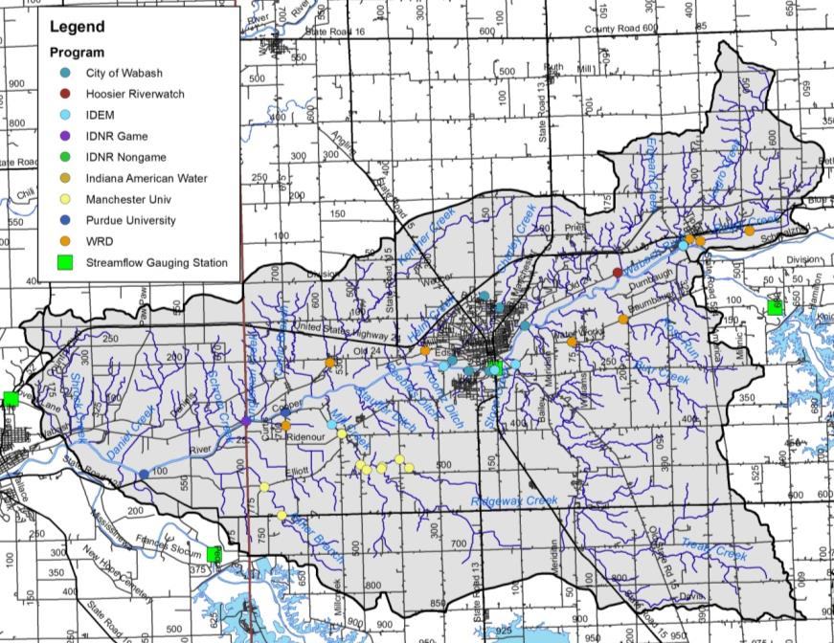
Figure 25. Historic water quality assessment locations.

    - Integrated Water Monitoring Assessment (305(b) Report)
The Indiana Department of Environmental Management (IDEM) is the primary agency tasked with monitoring surface water quality within the state of Indiana. Chapter 305(b) of the Clean Water Act requires that the state report on the quality of waterbodies throughout the state on a biannual basis. These assessments are known as the Integrated Water Monitoring Assessment (IWMA) or the 305(b) Report. The most recent draft report was delivered to the USEPA and underwent public comment in 2016 (IDEM, 2016). To complete this report, the 305(b) coordinator reviews all data collected by IDEM and selected high-quality data collected by other organizations on a waterbody basis. Each assessed waterbody is then assigned a water quality rating based on its ability to meet Indiana’s water quality standards (WQS). WQS are set at a level to protect Indiana waters’ designated uses of swimmable, fishable, and drinkable. Waterbodies that do not meet their designated uses are proposed for listing on the impaired waterbodies list, which is discussed in more detail below. The 2016 IWMA includes 56 waterbody reaches in the Treaty Creek-Wabash River Watershed (IDEM, 2016). Listings include the following:
- Ridgeway Creek and an unnamed tributary are listed as impaired for aquatic life use but with insufficient data to assess fish consumption or recreational uses.
- Six segments of the Wabash River are listed as impaired for fish consumption, aquatic life use, and recreational impairments; however, a TMDL was written for the aquatic life use and recreational impairments.
- Rager Creek is listed for insufficient data to assess impairments.
- Enyeart Creek is listed for insufficient data to assess impairments.
- Treaty Creek and ten unnamed tributary segments are listed for insufficient data to assess impairments.
- Stone Creek is listed for insufficient data to assess impairments.
- Ross Run is listed for insufficient data to assess impairments.
- Burr Creek is listed for insufficient data to assess impairments.
- Charley Creek is listed for insufficient data to assess impairments.
- Helm Creek is listed for insufficient data to assess impairments.
- Koontz Ditch is listed for insufficient data to assess impairments.
- Peebles Ditch is listed for insufficient data to assess impairments.
- Stauffer Ditch is listed for insufficient data to assess impairments.
- Kentner Creek is listed for insufficient data to assess impairments.
- Carlin Branch and an unnamed tributary are listed for insufficient data to assess impairments.
- Unger Ditch is listed for insufficient data to assess impairments.
- Engleman Creek and an unnamed tributary are listed for insufficient data to assess impairments.
- Schrom Creek is listed for insufficient data to assess impairments.
- Gilbert Branch is listed for insufficient data to assess impairments.
- Asher Branch is listed for insufficient data to assess impairments.
- Daniel Creek is listed for insufficient data to assess impairments.
- Mill Creek is listed for insufficient data to assess impairments.
- Eleven unnamed tributaries to the Wabash River are listed for insufficient data to assess impairments.

    - Impaired Waterbodies (303(d) List)
Waterbodies in the Treaty Creek-Wabash River Watershed which are included on the Impaired Waterbodies list are detailed in section 2.7.3 above.

    - Fish Consumption Advisory (FCA)
Three state agencies collaborate annually to compile the Indiana Fish Consumption Advisory (FCA). The Indiana Department of Natural Resources, Indiana Department of Environmental Management, and Indiana State Department of Health have worked together since 1972 on this effort. Samples are collected through IDEM’s rotating basin assessment for bottom feeding, mid-water column feeding, and top feeding fish. Fish tissue samples are then analyzed for heavy metals, PCBs, and pesticides. Table 15 details the advisories for the Treaty Creek-Wabash River Watershed from the from the 2017 report (ISDH, 2017). Advisories listings are as follows:
- Level 3 – limit consumption to one meal per month for adults with pregnant or breastfeeding women, women who plan to have children, and children under 15 consuming zero volume of these fish.
- Level 4 – limit consumption to one meal every 2 months for adults with women and children detailed above having zero consumption.
- Level 5 – zero consumption or do not eat.

Based on these listings, the following conclusions can be drawn:
- The Wabash River is under a fish consumption advisory for selected fish of select size within the length of the river in Miami and Wabash counties.
- No carp or carpsuckers be consumed from any waterbody within the watershed.

Table 15. Fish Consumption Advisory listing for the Treaty Creek-Wabash River Watershed.
Waterbody | Fish Species | Fish Size | Advisory
All | Carp | 15-20 inches | 3
 |  | 20-25 inches | 4
 |  | 25+ inches | 5
Wabash River | Black redhorse | > 19 inches | 3
 | Blue sucker | 21-26 inches | 3
 |  | > 26 inches | 4
 | Carpsucker | all | 3
 | River carpsucker | <14 inches | 3
 | Channel catfish | >15 inches | 3
 | Freshwater drum | >16 inches | 4
 | Shorthead redhorse | >15 inches | 3
 | White crappie | <8 inches | 3
 | Sauger | 13+ inches | 3
 | Smallmouth buffalo | < 20 inches | 3
 |  | 20+ inches | 4

    - Wabash River Total Maximum Daily Load (TMDL) Study
Water quality data collected from the Wabash River indicated that the Wabash River did not consistently comply with the state’s water quality standards. Based on these determinations, segments of the Wabash River have been included on the state’s 303(d) list since its inception. The 2002 listing included segments of the Wabash River in non-compliance for pathogens (E. coli and fecal coliform), nutrients, pH, dissolved oxygen, and impaired biotic communities. Subsequent lists prepared in 2004, 2006, and 2008 replicate these listings. In order to cohesively address impairments, one TMDL was written for the entire length of the Wabash River including the 30 miles in Ohio and the 475 miles in Indiana and Illinois (Tetra Tech, 2006). Within the Treaty Creek-Wabash River Watershed, the TMDL addresses nutrient, dissolved oxygen, and E. coli impairments.

Data collected by several agencies was obtained for water quality model development and TMDL calculation. The following conclusions were drawn with regards to water quality in the Wabash River:
- Nitrate+nitrite concentrations routinely exceeded the Indiana benchmark (10 mg/L); however, median concentrations measured 5 mg/L.
- Median dissolved oxygen concentrations generally exceeded 8 mg/L with only a few stations measuring below the minimum benchmark (4 mg/L). However, several stations routinely exceeded the upper benchmark (12 mg/L).
- Phosphorus concentrations routinely exceeded the phosphorus benchmark (0.3 mg/L) used for impaired waterbody listing by the IDEM.
- Most station impairments resulted from a combination of phosphorus and nitrate+nitrite or dissolved oxygen exceedences.

Due to the routine nature of the listings, one TMDL was developed for the entire Wabash River. The TMDL was calibrated at six locations along the river where sufficient data was available for calculation. The location relevant to Treaty Creek-Wabash River Watershed is the Wabash River at J. Edward Roush Lake. Although this station is located upstream of the watershed, it more closely resembles conditions present along the Wabash River within the watershed than the downstream segment (Wabash River at Lafayette) and is therefore used as the base assessment regarding necessary reductions (Figure 26). Based on the Wabash River TMDL, the following conclusions have been drawn:
- A monthly reduction in E. coli from nonpoint sources from April to October of 94-95% is needed in the Wabash River at J. Edward Roush Lake. No reduction in point source generated E. coli is necessary. This percent reduction results in a reduction of 5,664,700,000,000 E. coli colonies per day or 15,5,00,000,000 colonies per 100 ml per year (TetraTech, 2007).
- Monthly reductions of total phosphorus from nonpoint sources ranging from 12 to 23% are needed in the Wabash River at J. Edward Roush Lake. No reduction in point sources is necessary. This results in an overall reduction of 0.16 lb of phosphorus per day or just less than 57 lb of phosphorus per year.
- No nitrate reductions are required upstream of Lafayette from either point or nonpoint sources.

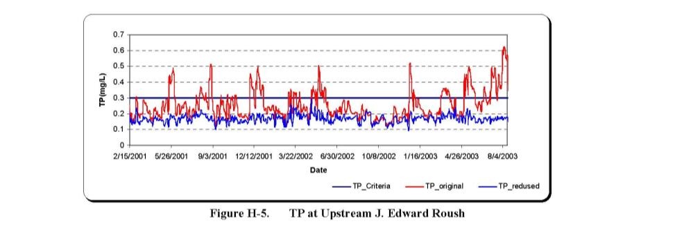
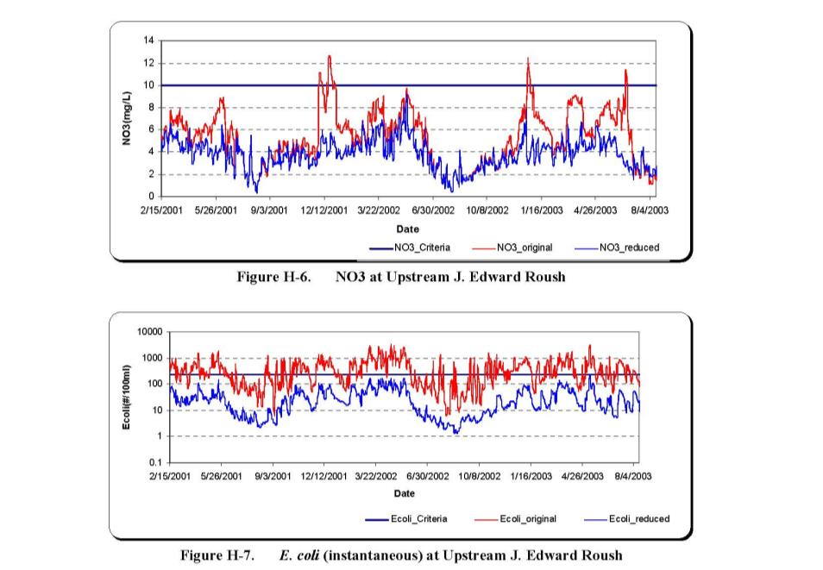
Figure 26. Total phosphorus (TP), nitrate (NO3), and E. coli load reductions identified in the Wabash River TMDL for the J. Edward Roush Lake portion of the Wabash River. Source: TetraTech, 2006.

    - IDEM Fixed Station (1990-2009) and Rotational Basin Assessments
Through IDEM’s fixed station water quality monitoring program, IDEM scientists collect water quality samples once per month at 160 stream and river sample sites throughout the state. One sample site is located on the Wabash River upstream of the Treaty Creek-Wabash River Watershed at Andrews (SR 105). Although the location is upstream of the upper end of the Treaty Creek-Wabash River Watershed, these data provide details as to the quality of water entering the watershed. Based on the fixed station sampling data, the following conclusions can be drawn:
Total phosphorus concentrations exceeded the recommended criteria during a majority (>99%) of months sampled. Samples routinely exceeded 0.3 mg/L resulting in this reach of the Wabash River being listed on Indiana’s impaired waterbodies list.
Total Kjeldahl nitrogen and nitrate-nitrogen concentrations routinely exceeded the recommended criteria with more than 75% of samples measuring above target levels.
- Total suspended solids concentrations and turbidity levels were elevated with more than 75% of samples exceeding target concentrations in a majority of the samples collected in from the Wabash River at Andrews.
- E. coli concentrations varied over time but generally exceeded the state.

In 1991, 1998, 2003, 2008, IDEM sampled water chemistry at several locations in the Treaty Creek-Wabash River Watershed via their rotational basin assessment program. Sampling occurred in Mill Creek, Treaty Creek, and the Wabash River. A majority of the assessments which occurred via the rotational basin program included a single sample event with some assessments including up to three sample events; however, the Wabash River was assessed at River Road, Lagro Road, SR 15 and at SR 524 as part of E. coli assessments which included five samples collected over 30 days and at SR 15 as part of the pesticide assessment program. Based on the rotational basin water chemistry assessments, the following conclusions can be drawn:
- E. coli concentrations exceeded the state standard in the Wabash River during a majority of assessments at all sites.
- Nitrate-nitrogen concentrations exceeded the recommended criteria; however, only three total samples were collected thus conclusions cannot be drawn at this time.
- Total phosphorus concentrations exceeded the recommended criteria in the Wabash River during all assessments at Lagro Road, State Road 15, and State Road 524.
- Turbidity levels exceed target concentrations in the Wabash River at State Road 15, State Road 524, Lagro Road and at River Road.
- Pesticide monitoring in the Wabash River occurred in 1998. Results indicate that pesticide concentrations are low with the exception of atrazine. Atrazine concentrations measured as high as 18 mg/L. Note that EPA recommends limiting atrazine consumption in drinking water to 3 μg/L.

IDEM completed biological and habitat assessments at two watershed sites 1991, 1998, 2008, 2011, and 2015. Fish sampling occurred in the Wabash River at Lagro Road in 2008, in Mill Creek in 2011, and in Treaty Creek in 2015. Macroinvertebrate sampling occurred in the Treaty Creek in 1991 and 1998; in Mill Creek, in 1991, 1998 and 2011; and in the Wabash River in 2008. Both fish and macroinvertebrate samples were collected and habitat was also assessed using the QHEI. Based on these assessments, the following conclusions can be drawn:
- Habitat assessed at all sites rated well with all scores measuring above aquatic life use designated level (51). Scores ranged from 66 to 88 with all sites receiving high substrate, morphology, and riffle/run development scores.
- Macroinvertebrate communities rated as severely impaired in Mill Creek in 1998, while all other sites rated as moderately impaired. Specifically, high numbers of chironomids, low number and diversity of EPT taxa, and high HBI scores indicate limited macroinvertebrate communities within Mill Creek.
- Fish communities in the Wabash River and Mill Creek rated as poor, while the Treaty Creek fish community rated as fair.

    - Wabash River Defenders 2015 Monitoring
The Wabash River Defenders initiated water quality sampling in 2015 to better understand water quality within the Treaty Creek-Wabash River tributaries. Sampling occurred one time at 12 locations throughout the watershed under storm flow conditions. The following conclusions can be drawn:
- Under storm flow conditions, all sampled tributaries exceed target concentrations for nitrate-nitrogen (2 mg/L) with Kentner Creek measuring 10 mg/L or the state water quality standard for drinking water.
- A majority of sites sampled exceeded target TP concentrations with Treaty Creek and Burr Creek samples measuring approximately 0.2 mg/L.
- One quarter of sample sites exceeded target TSS concentrations with Burr Creek measuring 60 mg/L.
- Additionally, 75% of sites sampled contained E. coli concentrations in excess of state standards (235 col./100 mL) with Treaty Creek measuring nearly five times the state standard concentration.

    - Stream Reach Characterization and Evaluation Report (2003)
The City of Wabash is required to complete a Stream Reach Characterization Evaluation Report (SRCER) as a component of the city’s Combined Sewer Overflow (CSO) permit. The purpose of the SRCER was to provide the city with water quality information which assesses the potential impacts of the CSOs on water quality and to enable technically sound evaluation and planning. The SRCERs included evaluation of historically-collected and current water quality data (United Consulting, 2003).

In 2003, United Consultants completed a SRCER for the City of Wabash. As part of this project, the City of Wabash assessed stormwater impacts from two CSO locations (CSO 002 and CSO004) as these are representative of the north of Wabash River and south of Wabash River systems, respectively, as well as the resulting impact of these overflows on the Wabash River. Samples were collected at 15 minute intervals for the first hour of discharge and 30 minute intervals for the next three hours if discharge occurred. During the final sampling event, samples were taken every 30 minutes until discharge ceased. Samples were analyzed for E. coli, BOD, pH, total suspended solids, dissolved oxygen, and temperature. Additionally, three receiving streams were sampled during three wet weather and three dry weather periods. Stream samples were analyzed for heavy metals, cyanide, BOD, pH, total suspended solids, dissolved oxygen, temperature, and E. coli. Based on the City of Lafayette’s SRCER, the following conclusions have been drawn:
- E. coli concentrations are elevated in Priser Ditch, Charley Creek, and the Wabash River with higher concentration observed during wet weather events than during dry weather events.
- Priser Ditch contained E. coli concentrations ranging from 1,000-39,000 col/100 mL during wet weather events.
- Charley Creek contained E. coli concentrations ranging from 10 t0 1,100 col/100 mL at the upstream site and from 600 to 2,600 col/100 mL at the downstream site during dry weather to 9,200 to 190,000 col/100 mL at the upstream site and 30,000 to 170,000 col/100 mL at the downstream site during wet weather events.
- The Wabash River contained E. coli concentrations which ranged from 130 to 900 col/100 mL at the upstream site and from 350 to 1000 col/100 mL at the downstream site during dry weather and from 2,800 to 3,800 col/100 mL at the upstream site and 26,000 to 160,000 col/100 mL at the downstream site during wet weather events.
- CSO002 samples contained elevated BOD concentrations ranging from 12 to 82 mg/L during wet weather sampling. E. coli concentrations were also elevated with concentrations ranging from 120,000 to 5,900,000 col/100 mL. TSS concentrations ranged from 28 to 650 mg/L during the three storm events.
- CSO004 samples contained elevated BOD concentrations ranging from 14 to 120 mg/L during wet weather sampling. E. coli concentrations were also elevated with concentrations ranging from 130,000 to 3,300,000 col/100 mL. TSS concentrations ranged from 2 to 640 mg/L during the three storm events.

    - Manchester University Redside Dace Assessment (2008-2012)
Manchester University, via a State Wildlife Grant, completed a monitoring project to determine the distribution, abundance, habitat, prey selectivity and spawning habits of the state endangered redside dace in the Mill Creek drainage from 2008 through 2012 (Sweeten, 2009; Sweeten, 2010; Sweeten, 2011; Sweeten, 2012; Sweeten et al., 2013). As part of this project, Manchester University determined the genetic makeup of the Mill Creek redside dace population, developed a mechanism to model suitable redside dace release sites for population augmentation, and developed redside dace rearing protocols and tested the habitat selection model via release trials. In 2008, Manchester University established baselines for physical, biological and chemical parameters in Mill Creek through the completion of pebble counts, QHEI assessment, and IBI scoring as well as collection of nitrate, phosphorus, dissolved oxygen, conductivity and suspended sediment concentrations measured weekly. In 2010, redside dace were relocated from Mill Creek to Asher Branch and physical and habitat parameter monitoring occurred within both streams. Based on the Manchester University redside dace study, the following conclusions have been drawn:
- At the start of the study period, redside dace was found in only two streams: Mill Creek in the Treaty Creek-Wabash River Watershed and Hannah Creek in Wayne County.
- Redside dace are widely distributed throughout Mill Creek where they are limited to pools measuring approximately 1 meter deep in areas of heavy shade from adjacent riparian vegetation.
- IBI scores ranged from 36 to 52 with the fish community rating as good to excellent in Mill Creek and Asher Branch.
- QHEI scores ranged from 80 to 90 suggesting good quality habitat within some reaches in the Mill Creek and Asher Branch drainages.
- In 2010 and 2011, approximately 500 redside dace were moved from Mill Creek to the Asher Branch. Early results verify limited spawning in Asher Branch with young of the year1 and 2 juveniles observed.

    - Indiana American Water Assessment
Indiana American Water monitors the Wabash River at State Road 15 as part of their well head protection plan.

    - IDNR Non-Game Assessment (2008)
In 2008, the Indiana Department of Natural Resource assessed freshwater mussel communities within three reaches of the Wabash River within the Treaty Creek-Wabash River Watershed (IDNR, unpublished). Sampling occurred at CR 700 West, at CR 100 North, and at CR 350 East. In total, 46 species were identified. The deertoe and pimpleback were the common species identified. Three state endangered species including round hickory nut, eastern fanshell pearlymussel, snuffbox, and rayed bean were identified during this assessment.

    - Wabash River Fishery Assessment: Ball State University (2001-2017)
Ball State University continued Jim Gammon’s Wabash River assessment efforts starting in 2001 and continuing with an annual assessment through present day (Pyron and Lauer, 2009; Pyron, unpublished). The most recently reported effort included assessment of the fish community and field water chemistry in 500 feet reaches throughout the Middle Wabash. Sampling occurred along four reaches within the Treaty Creek-Wabash River Watershed. Data collected throughout the Middle Wabash indicate relatively similar numbers of individuals (113 in 2017; 116.2 average) and numbers of species per collection (2001 to 2017). Based on these data, the following conclusions can be drawn:
- pH and dissolved oxygen concentrations were elevated along the Wabash River; however, none of the concentrations exceeded the target value.
- The highest species diversity occurred in the below City of Wabash sampling reach with this same reach containing the highest density.
- The lowest density and diversity occurred in the Salamonie reach. Pyron and Lauer (2004) noted that habitat is likely a contributing factor to both high and low densities and diversities.
- All sites possessed IBI scores which exceeded the score at which IDEM indicates streams are not meeting their aquatic life use designation.

    - IDNR Fisheries Assessment (2008)
In July 1999, the Indiana Department of Natural Resources (IDNR) surveyed the length of the Wabash River in 48 one-half to one mile segments. Habitat and general chemistry data were collected concurrent with the fish community assessment. Three segments were located within the watershed; these occurred downstream of the Salamonie Dam outlet, at the City of Wabash, and at the Wabash-Miami County line. During the assessment, between 26 and 34 species and 393 and 396 individuals were collected. In total, 117 species were identified during the assessment. Common carp, river carpsucker, and shorthead redhorse were collected in highest numbers within these reaches. Based on these data, the following conclusions can be drawn:
- Habitat is readily available within these three reaches score between 63 and 75. Water clarity was also low measuring between 11 and 18 inches. Dissolved oxygen concentrations were elevated measuring greater than 11.5 mg/L in each reach.
- Stefanavage (2007) indicated that distribution of species was most explained by individual species biology and its habitat preference rather than any impact from upstream dams or water quality impacts.

    - The Nature Conservancy Wabash River Study
The Nature Conservancy compiled a database of biological, stressor, and threat data for the Wabash River and its tributaries (Armitage and Rankin, 2009). The data were then used to analyze water quality and fish community information on an 11-digit watershed level. Although no new data were collected as part of this study, their analysis methods allow conclusions to be drawn which can be used to compare this watershed with others along the length of the Wabash River. Based on data collected, the following conclusions can be drawn:
- An ideal habitat (QHEI) score for this portion of the Wabash River based on 1800s conditions is 93.5. At that time, habitat would have rated as excellent to near maximum scores for most metrics.
- This segment of the Wabash River was historically home to riffles. TNC hypothesized that increased flashiness, increased peak flows, and modifications in meander patterns occur within the Wabash River in the Treaty Creek-Wabash River Watershed.
- The fish community in this reach is generally lacking in sensitive species with common carp and river redhorse dominating the population.
- Total phosphorus and nitrate-nitrogen concentrations are elevated within the mainstem and tributaries in this reach. The elevated nutrient concentrations present in the tributaries, coupled with the lack of buffers, increased delivery of nutrients via drainage systems and tile drains, and degradation of instream habitat due to altered hydrology.

    - Purdue University Sturgeon Sampling (2003-2004)
Shovelnose sturgeon populations within the Wabash River were assessed by Kennedy et al. (2006) from April 2003 through November 2004. Sturgeon were assessed in two reaches of the Wabash River: near Richvalley and near Peru to determine relative abundance, size, age structure, growth, mortality rate, condition, and gender ratio. Based on these data, the following conclusions can be drawn:
- Relative abundance of shovelnose sturgeon measured greater in the upper reach during the spring than abundances measured in the lower reach. This is likely due to upstream migration associated with spawning activities. This migration suggests that the upper reach contains suitable shovelnose sturgeon spawning habitat that may significantly contribute to sustaining the overall shovelnose sturgeon population.
- Population characteristics observed by Kennedy et al. (2006) indicate that the Wabash River shovelnose sturgeon population is similar to populations reported in other river systems. However, despite shovelnose sturgeon attaining larger body sizes, reaching older age classes, and experiencing lower mortality rates, growth rates and relative weights were lower than those observed in other river systems.

    - Hoosier Riverwatch Sampling (2001-2011)
In 2009 and again in 2018-2019, volunteers trained through the Hoosier Riverwatch program assessed stream sites within the Treaty Creek-Wabash River Watershed. Assessments occurred sporadically with some sites assessed only once during the reporting period, while others were monitored more often. Volunteers monitored stream stage, flow rate, and discharge; collected water chemistry samples for analysis using HACH test kits; assessed instream habitat using the Citizen’s QHEI; and surveyed the stream’s macroinvertebrate community. Using the chemical data, the Water Quality Index (WQI) was calculated. Volunteers calculated a Pollution Tolerance Index (PTI) using the biological data. Based on these data, the following conclusions can be drawn:
- Ross Run was analyzed once in 2009 with all parameters falling within standard concentration. Habitat score 68, which rates as good.

Current Water Quality Assessment
    - Water Quality Sampling Methodologies
As part of the current project, the Wabash River Defenders implemented a one year water quality monitoring program. The program included biweekly water chemistry monitoring and biological (fish and macroinvertebrate) and habitat assessments once during the first year of the planning project. Additionally, the project implemented a volunteer monitoring program to assess water chemistry and macroinvertebrate communities. The program is detailed below and in the Quality Assurance Project Plan for Treaty Creek-Wabash River Watershed Management Plan approved on January 22, 2018. Sites sampled through this program are displayed in Figure 27. Sample sites were selected based on the largest tributary drainage areas to the Wabash River and included high priority drainages including those that are known to receive combined sewer overflows or are suspected to be home to high quality natural communities or ETR species. The biweekly sampling regimen was enacted to create a baseline of water quality data.

Figure 27. Sites sampled as part of the Treaty Creek-Wabash River Watershed Management Plan.

Stream Flow
Stream flow was measured in situ when grab samples were collected.

Field Chemistry Parameters
The Treaty Creek-Wabash River project established twelve chemistry monitoring stations as part of the monitoring program. Stations are located XXX Dissolved oxygen, temperature, pH, turbidity, conductivity, nitrate-nitrogen and ammonia-nitrogen were measured biweekly at the sampling stations from January to December 2018. Appendix E details the parameters measured and potential impacts to particular parameters.

Laboratory Chemistry Parameters
Like the field parameters, biweekly laboratory sample collection and analysis occurred throughout the one year sampling program. Samples were analyzed for total phosphorus, total suspended solids, sulfate, and E. coli. Appendix E details the parameters measured and potential impacts to particular parameters.

Macroinvertebrate Community Assessment
Macroinvertebrates were collected during base flow conditions on XXX using the multihabitat approach detailed in IDEM Protocols for the collection and calculation of the macroinvertebrate Index of Biotic Integrity. The macroinvertebrate samples were processed using the laboratory processing protocols detailed in the IDEM protocol. Organisms were identified to the genus level.

Fish Community Assessment
Data from fish community sampling at each of the sites in the Treaty Creek-Wabash River Watershed on XXX were used to calculate the Index of Biological Integrity for the Central Corn Belt Plains (Simon, 1991). Owen and Karr (1978) found that natural streams support fish communities of high species diversity. Fish communities in natural streams are seasonally more stable than the fish communities of modified streams. “Structurally diverse natural streams typically have a great deal of buffering capacity: meanders tend to moderate the effect of floods, pools offer excellent refuges for fishes during dry periods, and tree shade decreases heat loads and minimizes the oxygen-robbing effect of decomposing and extensive algal blooms” (Karr and Schlosser, 1977). Many endangered species are restricted to specific habitat complexes within streams and have become endangered as a result of habitat loss, fragmentation, or pollution.

Habitat
The physical habitat at each of the biological sample sites was evaluated using the Qualitative Habitat Evaluation Index (QHEI). The Ohio EPA developed the QHEI for streams and rivers in Ohio (Rankin, 1989, 1995) and the IDEM adapted the QHEI for use in Indiana. Purdue University assessed habitat at all twelve sites in the summer of 2012. Appendix E details the QHEI and its individual metrics.

Field Chemistry Results

Flow Duration Curves

Load Duration Curves

Macroinvertebrate Community Assessment Results

Fish Community Assessment Results
    - Habitat Results
    - Summary and Conclusions

  - Watershed Inventory Assessment
    - Watershed Inventory Methodologies
Volunteers completed windshield surveys throughout the Treaty Creek-Wabash River Watershed in spring of 2018. Volunteers conducted surveys by driving all accessible roads throughout the watershed. Large maps with aerial photographs, road and stream names, and public property labels were provided to each volunteer group. Volunteers recorded observations on the provided maps and data sheets, documented field conditions with photographs, and provided all notes to the steering committee for review. The windshield surveys were also used to confirm GIS map layer data throughout the watershed. Items targeted during the surveys included, but were not limited to the following:
- Aerial land use category
- Field or gully erosion
- Pasture locations and condition
- Small animal operations
- Livestock access and impact to streams
- Buffer condition and width
- Bed or bank erosion or stream head-cutting
- Environmental site confirmation (NPDES, CFO, open dump, Superfund, etc.)

Additionally, as much of the Wabash River was not accessible via vehicle, assessment of streambank erosion and riparian buffers along the Wabash River occurred in XXX.

    - Watershed Inventory Results
More than 450 individual road-stream crossings were inventoried by watershed volunteers. A majority of issues identified fall into two categories: stream buffers limited in width or lacking altogether and streambank erosion. Figure 28 details locations throughout the Treaty Creek-Wabash River Watershed where problems were identified. Additional assessments will be on-going; therefore, those identified in Figure 28 should not be considered exhaustive. More than 47.6 miles of tributary streams possessed limited buffers, nearly 51.4 miles of streambank were eroded, and livestock had access to nearly 8.4 miles of streams. Additionally, nearly XX miles of the Wabash River require stabilization and nearly XX acres of land requires buffering within 120 feet of the Wabash River.

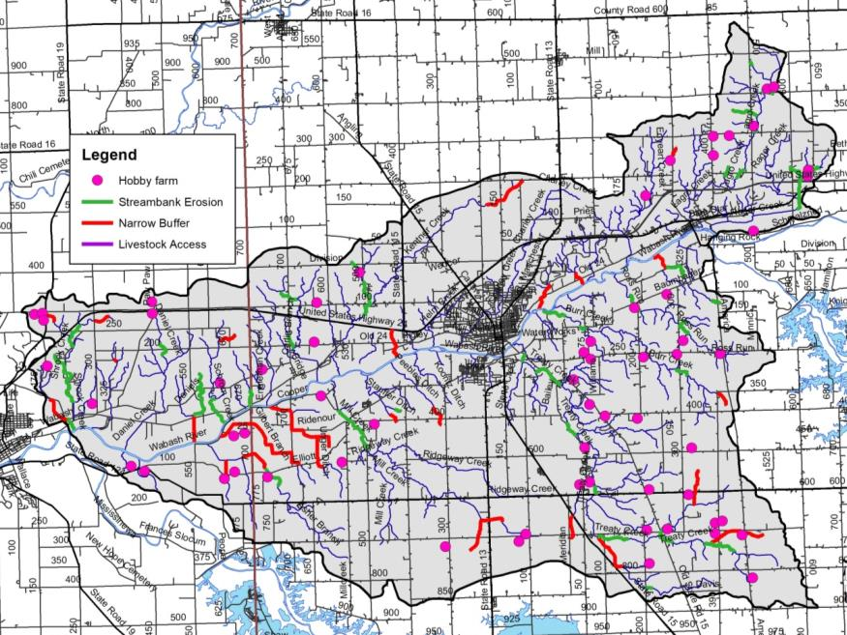
Figure 28. Stream-related watershed concerns identified during watershed inventory efforts.

WATERSHED INVENTORY II-B: SUBWATERSHED DISCUSSIONS
To gather more specific, localized data, the Treaty Creek-Wabash River Watershed was divided into seven subwatersheds with each subwatershed reflecting one 12-digit Hydrologic Unite Code (HUC; Figure 29). These subwatersheds reflect specific tributary drainages and similar land uses and hydrology. Land uses, point and non-point watershed concern areas, and historic water quality sampling locations and results are discussed in detail below for each subwatershed.

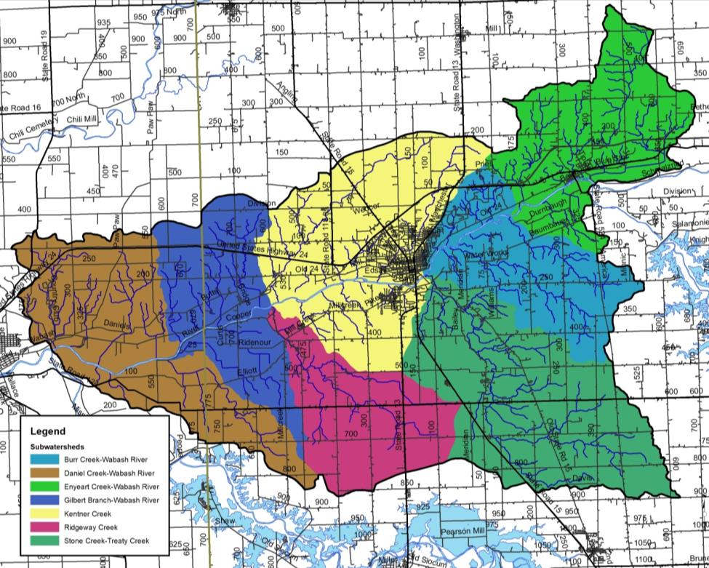
Figure 29. 12-digit Hydrologic Unit Codes in the Treaty Creek-Wabash River Watershed.

Enyeart Creek-Wabash River Subwatershed
The Enyeart Creek-Wabash River Subwatershed is located in Wabash County and forms the northeastern edge of the Treaty Creek-Wabash River Watershed (Figure 30). It includes on 12-digit HUC: 051201011401. The Enyeart Creek-Wabash River Subwatershed drains 13,849 acres or 21.6 square miles. There are 54.6 miles of stream, of which IDEM has classified 3 miles of stream as impaired for E. coliI, nutrients, PCBs, and mercury.

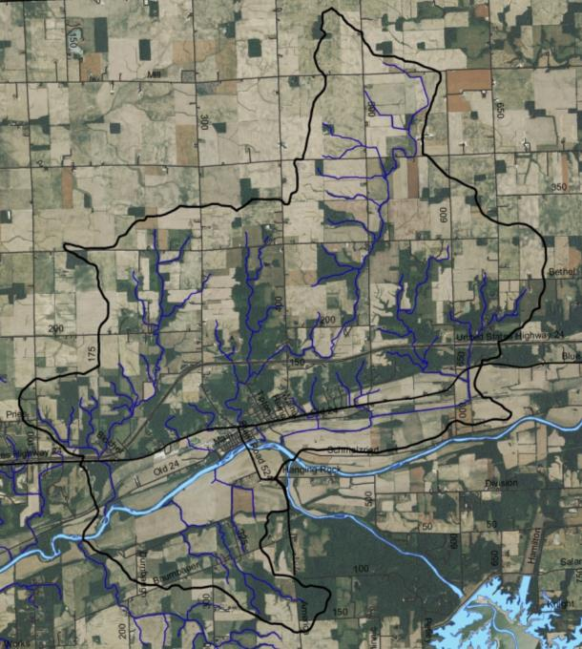
Figure 30. Enyeart Creek-Wabash River Subwatershed.

Soils
Soils in the Enyeart Creek-Wabash River Subwatershed are dominated by Blount-Glynwood-Morley soils, which lie on uplands north and south of the Wabash River floodplain. Millsdale-Newglarus-Randolph soils are found in riparian areas along the Wabash River channel. These soils are typically found in alluvium. The northern subwatershed boundary is covered by Blount-Pewamo-Glynwood soils. These soils are excessively drained and found on gentle to strong slopes. Hydric soils cover 1,181 acres (9%) of the subwatershed, indicating that only a small portion of the land was historically wetlands. Wetlands currently cover 2% (275 acres) of the subwatershed, representing a loss of 77% of historic wetlands. Highly erodible and potentially highly erodible soils are prevalent throughout the subwatershed, covering 40% and 24% of the land, respectively. Nearly the entire subwatershed (98%) has soils which are severely limited for septic use.

Land Use
Agricultural land uses cover the largest percentage of the Enyeart Creek-Wabash River Subwatershed, with 71% (9,888 acres) in row crops or hay/pasture. Forest covers just over 2,569 acres, or 19%, of the subwatershed. Open water, wetlands, and grasslands account for 384 acre or 3% of the subwatershed. The Enyeart Creek-Wabash River Subwatershed contains the Town of Lagro, thus urban lands cover 7% or 1,014 acres of the subwatershed.

Point Source Water Quality Issues
There are few point sources of water pollution in the subwatershed. There are two leaking underground storage tanks (LUST) located west of Lagro (Figure 31). There is one NPDES-permitted facility, Celotex Corporation; however, no brownfields or open dumps are located in this subwatershed.

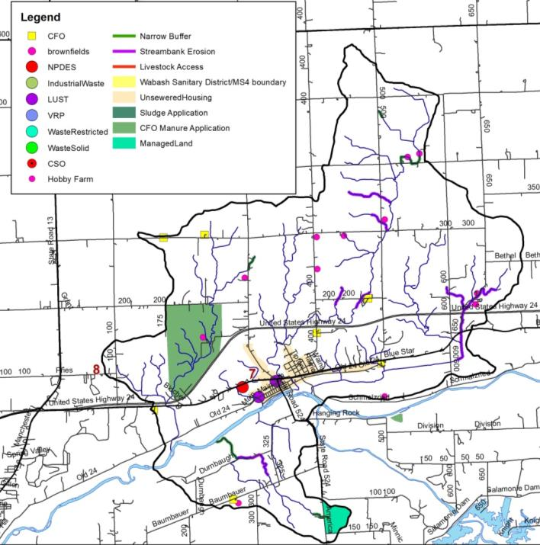
Figure 31. Point and non-point sources of pollution and suggested solutions in the Enyeart Creek-Wabash River Subwatershed.

Non-Point Source Water Quality Issues
Agricultural land uses dominate the Enyeart Creek-Wabash River Subwatershed. A number of small animal operations and pastures are also present (Figure 31). In total, 11 unregulated animal operations were identified during the windshield survey, which house more than 218 animals. NASS county-wide livestock estimates generate a higher density of 940 animals. Five active confined feeding operations are located within the subwatershed housing approximately 12,119 hogs, 500 beef cattle and 1,100 veal. In total, small animal and confined feeding operations generate 55,578 tons of manure. This manure contains almost 157,000 pounds of nitrogen and almost 116,950 pounds of phosphorus. Approximately 11.1 miles of streambank erosion and 3.4 miles of streams with narrow buffers were identified within the subwatershed.

Water Quality Assessment
Waterbodies within the Enyeart Creek-Wabash River Subwatershed have been sampled historically at 4 locations (Figure 32). Assessments include collection of water chemistry data IDEM (2 sites) and 2015 water quality assessment by the Wabash River Defenders (2 sites). The fish community has been assessed by the Indiana Department of Environmental Management (1 site) and the Indiana Department of Natural Resources (1 site). Macroinvertebrates were sampled at one site by the IDEM; freshwater mussels were also assessed at one site by the DNR non-game program. No stream gages are located in the Enyeart Creek-Wabash River Subwatershed. Add water quality details after targets are selected and data has been compiled.

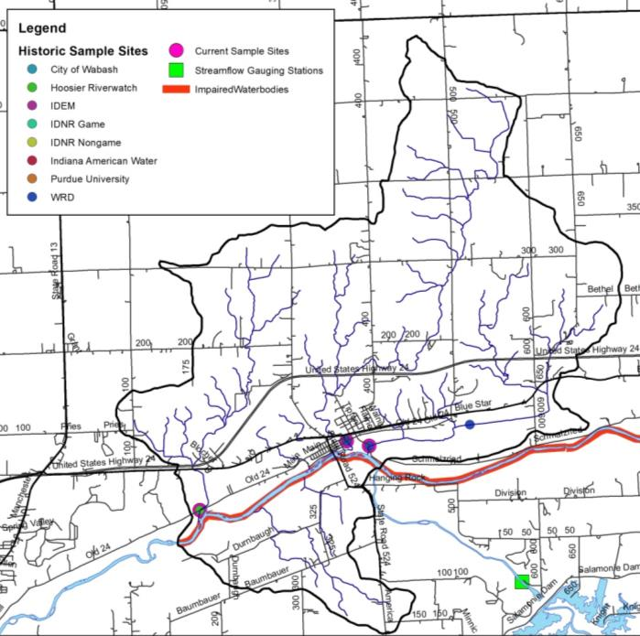
Figure 32. Locations of historic water quality data collection and impairments in the Enyeart Creek-Wabash River Subwatershed.

Enyeart Creek-Wabash River Subwatershed Summary

Stone Creek-Wabash River Subwatershed
The Stone Creek-Wabash River Subwatershed forms the southeast corner of the Treaty Creek-Wabash River Watershed within Wabash County and includes 12-digit HUC watershed: 051201011402 (Figure 39). The Stone Creek-Wabash River Subwatershed drains 19,267 acres or 30.1 square miles. There are 51.7 miles of streams.

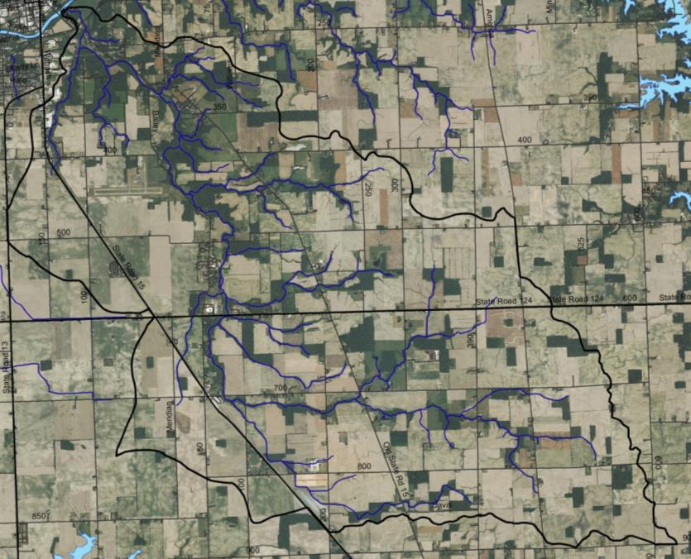
Figure 33. Stone Creek-Wabash River Subwatershed.

Soils
Soils in the Stone Creek-Wabash River Subwatershed transition from Blounty-Pewamo-Glynwood soils, which lie on uplands along the eastern border of the subwatershed to Blount-Glynwood-Morley soils, which are found in areas of loam till. Miami-Crosby-Treaty and Fincastle-Brookston-Miamian soils cover the lower and western portion of the subwatershed. Hydric soils cover 4,234 acres (22%) of the subwatershed, indicating that nearly one-quarter of the land was historically wetlands. Wetlands currently cover 1% (275.1) of the subwatershed, representing a loss of 73% of historic wetlands. Highly erodible and potentially highly erodible soils are prevalent throughout the subwatershed, covering 15% and 19% of the land, respectively. Nearly the entire subwatershed (98%) has soils which are severely limited for septic use.

Land Use
The Stone Creek-Wabash River Subwatershed contains nearly 15,238 acres of agricultural row crop and pasture land (79%). Forested land use cover 2,207 acres or 11% of the Stone Creek-Wabash River Subwatershed. Urban land uses cover nearly 1,450 acres (7.5%) in the subwatershed. Wetlands, open water, and grasslands account for the remaining 2% (381.5 acres) of land within the subwatershed.

Point Source Water Quality Issues
There are few point sources of water pollution in the Stone Creek-Wabash River Subwatershed. There are two leaking underground storage tanks (LUST) located south and west of State Road 15 (Figure 34Figure 31). There is one NPDES-permitted facility, Southwood Elementary School; however, no brownfields or open dumps are located in this subwatershed.

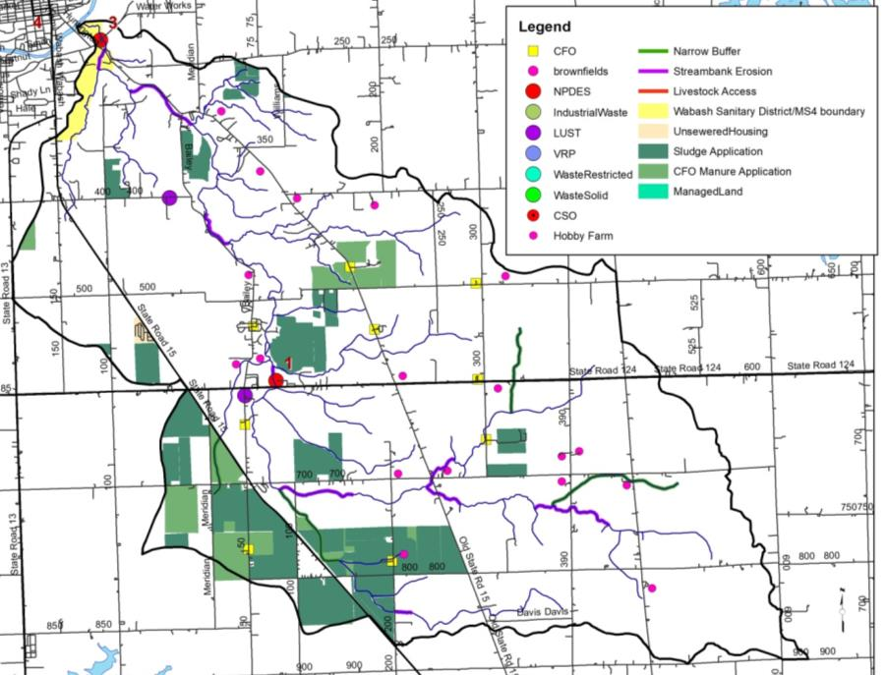
Figure 34. Point and non-point sources of pollution and suggested solutions in the Stone Creek-Wabash River Subwatershed.

Non-Point Source Water Quality Issues
Agricultural land uses dominate the Stone Creek-Wabash River Subwatershed, which is primarily in a corn-soybean rotation. Approximately 18 small animal operations housing nearly 80 animals are present (Figure 34). Areas where livestock have access to the stream were not identified in the subwatershed. Six active confined feeding operations housing more than 22,000 swine and more than 1800 dairy cattle per year are located in the Stone Creek-Wabash River Subwatershed. In total, manure is spread on 1,380 acres in the Stone Creek-Wabash River Subwatershed. Manure from the six CFO and 18 small animal operations produce more than 133,818 tons per year. This contains almost 292,927 pounds of nitrogen and almost 216,040 pounds of phosphorus. Municipal biosolids are applied to 1,989 acres within the subwatershed. Streambank erosion affects 9.4 miles of streams within the subwatershed, while 8.3 miles of streams possess narrow buffers.

Water Quality Assessment
Waterbodies within the Stone Creek-Wabash River Subwatershed have been sampled historically at one location (Figure 35). Assessments include collection of water chemistry data by IDEM (1 site) and via the Wabash River Defenders (1 site). The fish and macroinvertebrate communities have been assessed by IDEM at the same sites. No stream gages are located in the Stone Creek-Wabash River Subwatershed. Add water quality details after targets are selected and data has been compiled.

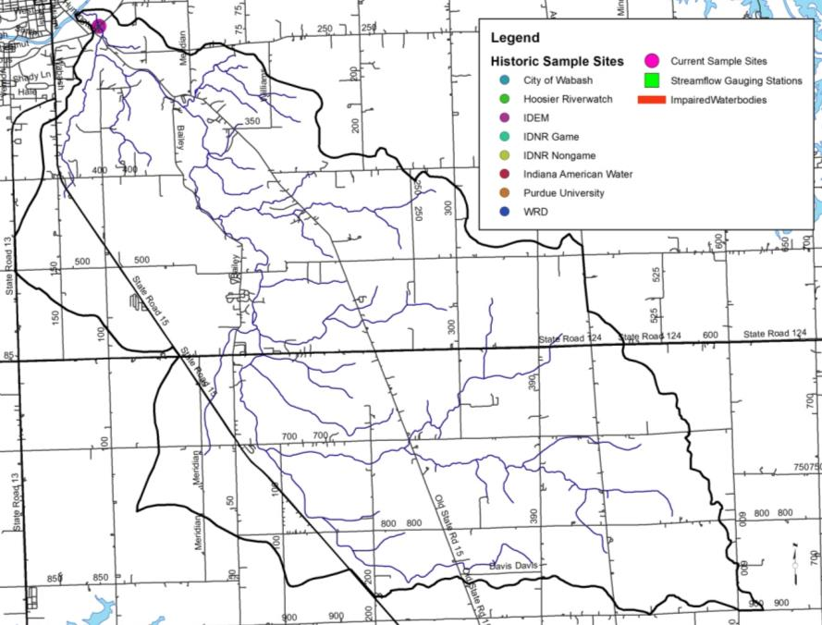
Figure 35. Locations of historic water quality data collection and impairments in the Stone Creek-Wabash River Subwatershed.

Stone Creek-Wabash River Subwatershed Summary

Burr Creek-Wabash River Subwatershed
The Burr Creek-Wabash River Subwatershed forms the eastern boundary of the Treaty Creek-Wabash River Watershed and lies completely within Wabash County (Figure 36). It encompasses one 12-digit HUC watershed: 051201011403. The Burr Creek-Wabash River Subwatershed drains 11,245.7 acres or 17.6 square miles. There are 41.6 miles of stream. IDEM has classified 3.6 miles of stream as impaired for E. coli, nutrients, PCBs, and mercury.

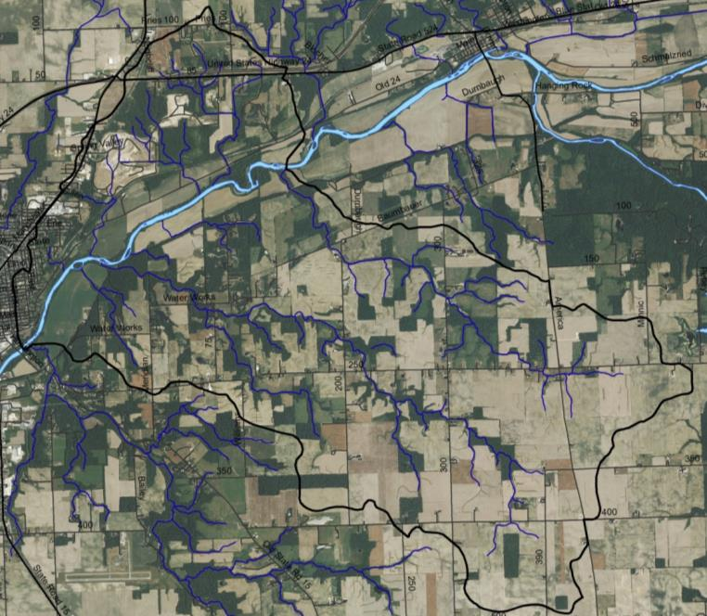
Figure 36. Burr Creek-Wabash River Subwatershed.

Soils
Soils in the Burr Creek-Wabash River Subwatershed are dominated by Blount-Pewamo-Glynwood soils which form the eastern subwatershed boundary. These soils transition to Blount-Glynwood-Morley soils which dominate the Burr Creek-Wabash River Subwatershed. Hydric soils cover 1,030 acres (9%) of the subwatershed, indicating that less than 10% of the subwatershed was historically wetlands. Wetlands currently cover 2% (276.1 acres) of the subwatershed, representing a loss of 73% of historic wetlands. Highly erodible and potentially highly erodible soils are prevalent throughout the subwatershed, covering 41% and 13% of the subwatershed, respectively. Nearly half of subwatershed (52%) has soils which are severely limited for septic use.

Land Use
Agricultural land uses dominate the Burr Creek-Wabash River Subwatershed with 72% (8,116 acres) in agricultural land uses, including row crop and pasture. The 2012 NASS statistics suggest that a majority of row crop agriculture in the Burr Creek-Wabash River Subwatershed is in corn or soybeans with a small percentage in winter wheat. Forested land uses cover 1,863 acres (17%) of the subwatershed. Wetlands, open water, and grassland cover just over 385 acres, or 3%, of the subwatershed. Nearly 8% of the subwatershed (886 acres) are in urban land uses.

Point Source Water Quality Issues
Although the southern edge of the City of Wabash lies within the Burr Creek-Wabash River Subwatershed, there are few point sources of water pollution in the subwatershed (Figure 37). There are six leaking underground storage tanks (LUST) and two solid waste facilities within the subwatershed (Figure 37). No industrial waste facilities, open dumps, brownfields or NPDES-permitted facilities are located within the Burr Creek-Wabash River Subwatershed.

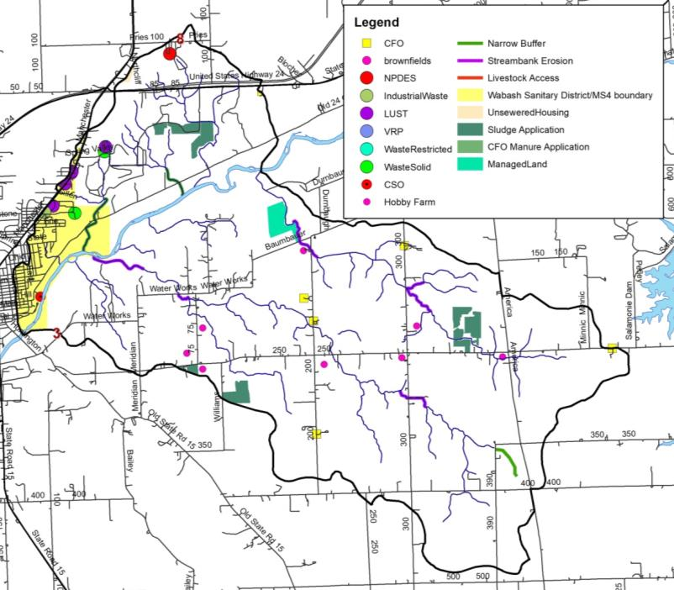
Figure 37. Point and non-point sources of pollution and suggested solutions in the Burr Creek-Wabash River Subwatershed.

Non-Point Source Water Quality Issues
Approximately 8 small animal operations housing more than 40 cows, horses, and poultry were identified during the windshield survey (Figure 37). Observations are lower than estimates produced using county-wide NASS data, which suggest 764 animals are located in the Burr Creek-Wabash River Subwatershed. Three CFOs are located within the subwatershed housing nearly 4,200 swine, dairy cattle and veal. In total, manure from small animal operations and CFO total 46,202 tons per year, which contains almost 37,546 pounds of nitrogen and almost 23,315 pounds of phosphorus. Streambank erosion and lack of buffers are a concern in the subwatershed. Approximately 3.2 miles of insufficient stream buffers and 4.8 miles of streambank erosion were identified within the subwatershed.

Water Quality Assessment
Waterbodies within the Burr Creek-Wabash River Subwatershed have been sampled historically at 3 locations (Figure 38). Assessments include collection of water chemistry data by the Wabash River Defenders (2 sites) and by the City of Wabash as part of the stream reach characterization efforts. Fish and macroinvertebrate communities have not been sampled in this subwatershed. No stream gages are located in the Burr Creek-Wabash River Subwatershed. Add water quality details after targets are selected and data has been compiled.

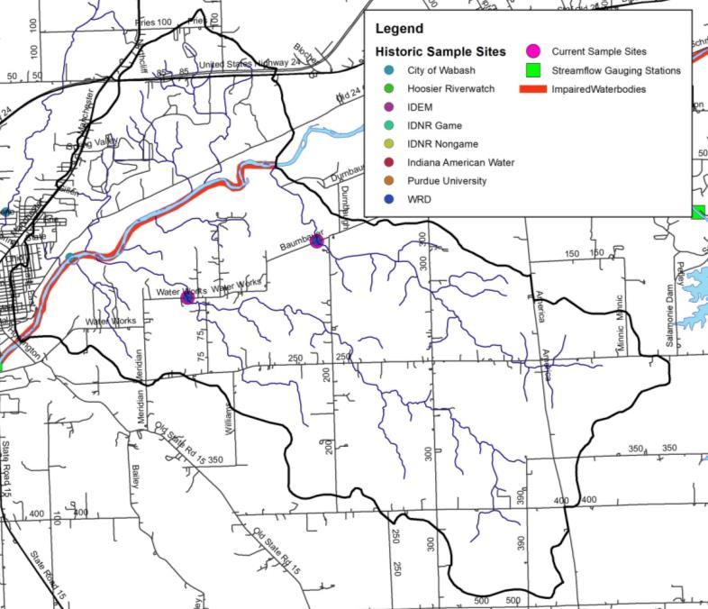
Figure 38. Locations of current and historic water quality data collection and impairments in the Burr Creek-Wabash River Subwatershed.

Burr Creek-Wabash River Subwatershed Summary

Ridgeway Creek Subwatershed
The Ridgeway Creek Subwatershed forms the southern portion of the Treaty Creek-Wabash Watershed south of the City of Wabash lying completely within Wabash County. It includes 12-digit HUC watershed: 051201011404 (Figure 39). The Ridgeway Creek Subwatershed drains 10,324.6 acres or 16.1 square miles. There are 20.3 miles of stream, of which 13 miles are impaired for impaired biotic communities.

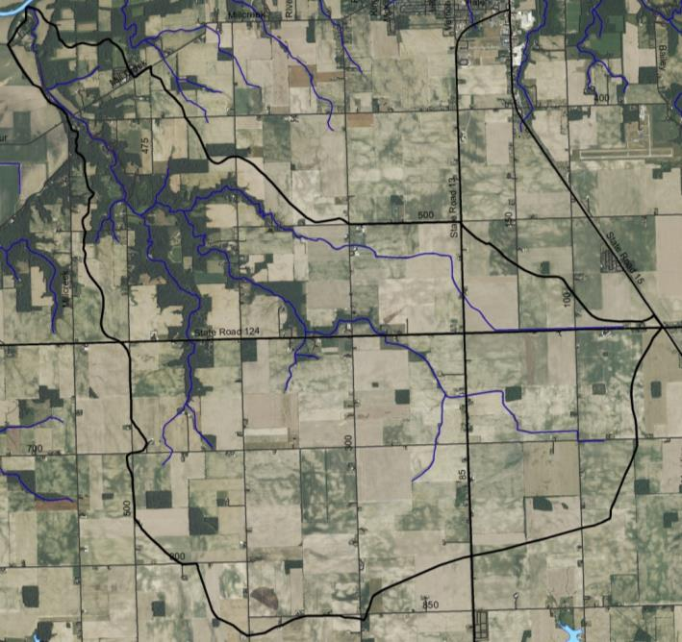
Figure 39. Ridgeway Creek Subwatershed.

Soils
Soils in the Ridgeway Creek Subwatershed transition from Fincastle-Brookston-Miamian soils, which lie on uplands along the southern border of the subwatershed into Miami-Crosby-Greaty soils along the lower portion of the subwatershed. These soils are excessively drained and found on gentle to strong slopes. Hydric soils cover 3,703 acres (36%) of the subwatershed, indicating that nearly one-third the land was historically wetlands. Wetlands currently cover 1% (53.9 acres) of the subwatershed, representing a loss of 99% of historic wetlands. This represents both the lowest wetland acreage and highest wetland loss of any of the Treaty Creek-Wabash River Subwatersheds. Highly erodible and potentially highly erodible soils are prevalent throughout the subwatershed, covering 12% and 20% of the land, respectively. Nearly the entire subwatershed (95%) has soils which are severely limited for septic use.

Land Use
The Ridgeway Creek subwatershed contains nearly 8,708 acres (84%) of row crop and pasture. Forested land uses cover 913 acres (9%) of the Ridgeway Creek Subwatershed. Wetlands, open water, and grasslands account for 2% (547.6 acres) of land within the subwatershed, while urban land uses cover the remaining 547 acres (5.3%).

Point Source Water Quality Issues
As the Ridgeway Creek Subwatershed no point (Figure 41).

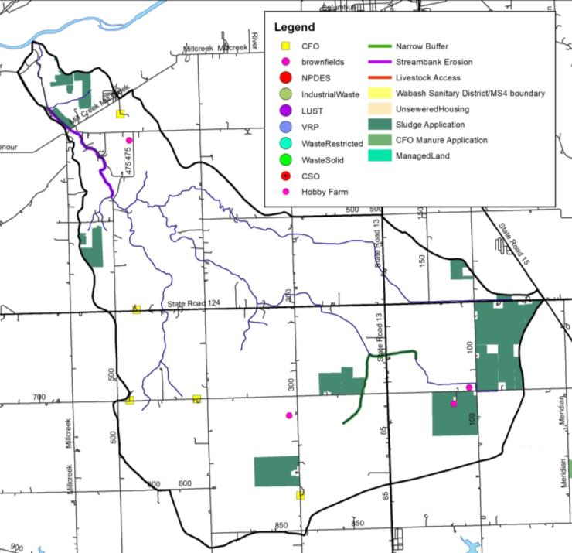
Figure 40. Point and non-point sources of pollution and suggested solutions in the Ridgeway Creek Subwatershed.

Non-Point Source Water Quality Issues
Agricultural land uses dominate the Ridgeway Creek Subwatershed, primarily in a corn-soybean rotation. Approximately 4 small animal operations housing nearly 30 animals are present (Figure 40). Areas where livestock have access to the stream were not identified in the subwatershed. Three active confined feeding operations housing a total of more than 3,900 swine per year are located in the Ridgeway Creek Subwatershed. Manure from the three CFOs and 4 small animal operations produce more than 16,848 tons per year. This contains almost 49,291 pounds of nitrogen and almost 37,202 pounds of phosphorus. Municipal biosolids are applied to 813 acres within the subwatershed. Narrow stream buffers were observed along 3.1 miles of streams within the subwatershed.

Water Quality Assessment
Waterbodies within the Ridgeway Creek Subwatershed have been sampled historically at 2 locations (Figure 41). Assessments include collection of water chemistry data by IDEM (2 sites) and via the Wabash River Defenders (1 site). The fish and macroinvertebrate communities have been assessed by IDNR at 2 sites. No stream gages are located in the Ridgeway Creek Subwatershed. Add water quality details after targets are selected and data has been compiled.

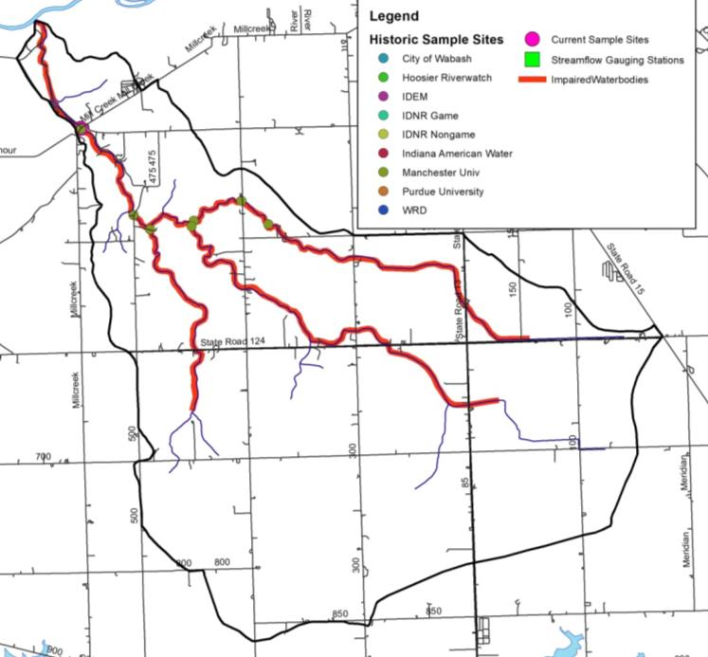
Figure 41. Locations of historic water quality data collection and impairments in the Ridgeway Creek Subwatershed.

Ridgeway Creek Subwatershed Summary

Kentner Creek Subwatershed
The Kentner Creek Subwatershed forms the northcentral portion of the Treaty Creek-Wabash RIver Watershed including much of the City of Wabash (Figure 42). The Kentner Creek Subwatershed encompasses one 12-digit HUC watersheds: 051201011405. The subwatershed drain 18,635 acres or 29.1 square miles. There are 45.9 miles of stream, of which 5.0 mile are impaired for E. coli, nutrients, PCBs, and mercury.

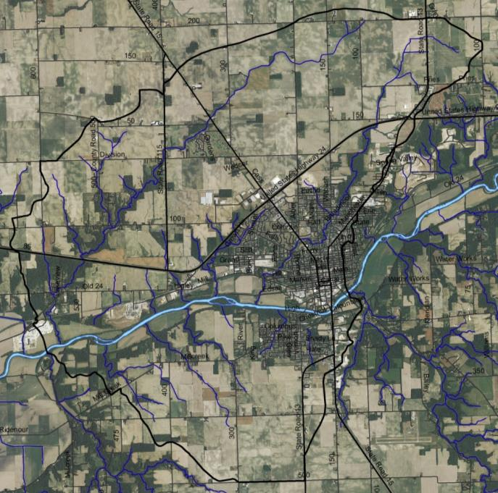
Figure 42. Kentner Creek Subwatershed.

Soils
Fincastle-Brookston-Miamian soils form the northern subwatershed. Miami-Crosby-Treaty soils, which dominate the uplands throughout the subwatershed transition to Millsdale-Newglarus-Randolph soils, which lie along the Wabash River floodplain. Hydric soils cover 4,048 acres (22%) of the subwatershed, indicating that only a small portion of the subwatershed was historically wetlands. In total, 191.6 acres (1% of the watershed) of wetlands remain in the Kentner Creek Subwatershed representing a 96% wetland loss. Highly erodible and potentially highly erodible soils are prevalent throughout the subwatershed, covering 12% and 20% of the land, respectively. Nearly the entire Kentner Creek Subwatershed (95%) has soils which are severely limited for septic use.

Land Use
Agricultural land uses dominate the Kentner Creek Subwatershed with 67% in row crops and hay/pasture. Nearly 4,043 acres of urban land is located within the Kentner Creek Subwatershed covering the largest percentage of any of the Treaty Creek-Wabash River drainages. Forest covers the smallest percentage of any Treaty Creek-Wabash River Subwatershed accounting for just 1,583 acres (8%) of the Kentner Creek Subwatershed. The smallest area (2% or 446.1 acres) of wetlands, open water, and grassland are also found within the Kentner Creek Subwatershed.

Point Source Water Quality Issues
As the Kentner Creek Subwatershed contains the City of Wabash, a number of point sources of pollution are present (Figure 43). There are three NPDES permitted facilities including Lakeview MHP, Wabash Alloys, and the City of Wabash municipal treatment plant. There are 14 industrial waste facilities, one restricted waste facility and two facilities participating in the voluntary remediation program. There are 42 leaking underground storage tank (LUST) located throughout the City of Wabash (Figure 43). There are eight combined sewer overflow points and the entire City of Wabash MS4 is located within the Kentner Creek Subwatershed.

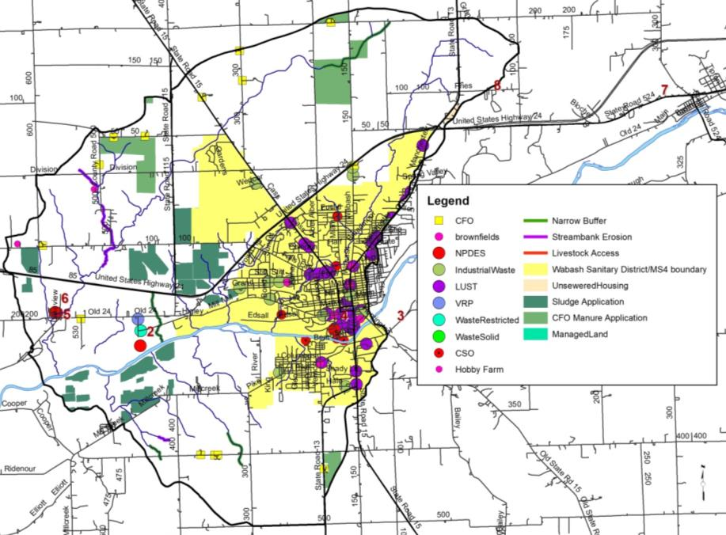
Figure 43. Point and non-point sources of pollution and suggested solutions in the Kentner Creek Subwatershed.

Non-Point Source Water Quality Issues
Only two unregulated animal operations were identified during the windshield survey housing approximately 25 animals. County-wide NASS statistics suggest a higher animal density of 1,266. Less than 0.8 miles of streambank exhibit livestock access impacts in the Kentner Creek Subwatershed. Seven active confined feeding operations are located within the Kentner Creek Subwatershed housing more than 11,280 swine and beef and dairy cattle. Overall, small animal operations and CFOs produce over 56,134 tons per year. This contains almost 139,039 pounds of nitrogen and almost 102,239 pounds of phosphorus. Streambank erosion and lack of buffers are a concern in the subwatershed. Approximately 5.8 miles of insufficient stream buffers and 3.4 miles of streambank erosion were identified within the subwatershed (Figure 43).

Water Quality Assessment
Waterbodies within the Kentner Creek Subwatershed have been sampled historically at 11 locations (Figure 44). Assessments include collection of water chemistry data by IDEM (2 sites), via the City of Wabash as part of their stream reach characterization (4 sites), by Indiana American Water (1 site), and by the Wabash River Defenders (4 sites). The fish community was assessed by Ball State University, the Indiana DNR, and by IDEM. Macroinvertebrates were sampled by IDEM at the same site. The watershed only USGS stream gages is located in the Kentner Creek Subwatershed. Add water quality details after targets are selected and data has been compiled.

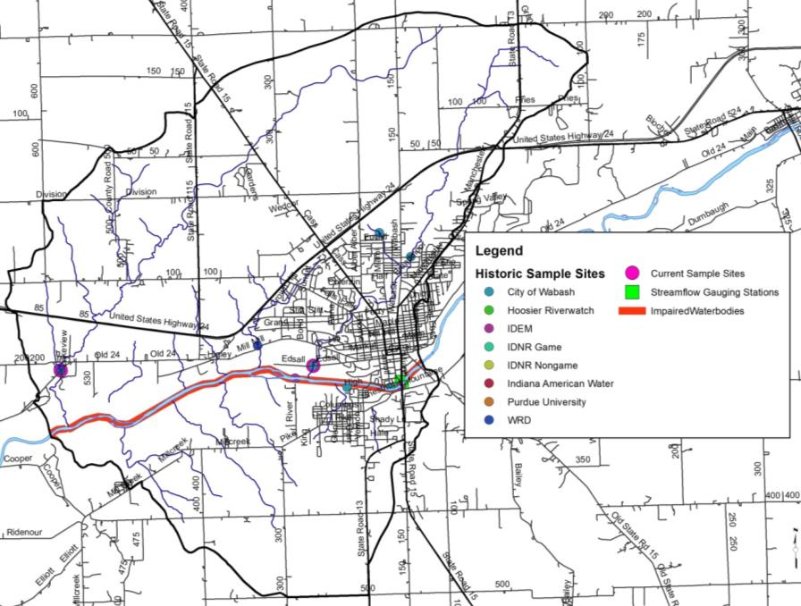
Figure 44. Locations of historic water quality data collection and impairments in the Kentner Creek Subwatershed.

Kentner Creek Subwatershed Summary

Gilbert Branch-Wabash River Subwatershed
The Gilbert Branch-Wabash River Subwatershed lies within Miami and Wabash Counties forming the northern border of the Treaty Creek-Wabash River Watershed west of the City of Wabash (Figure 45). The Gilbert Branch-Wabash River Subwatershed drains 11,224 acres or 17.5 square miles. There are 36.8 miles of stream. IDEM has classified 3.8 miles of stream as impaired for nutrients and E. coli, nutrients, PCBs, and mercury.

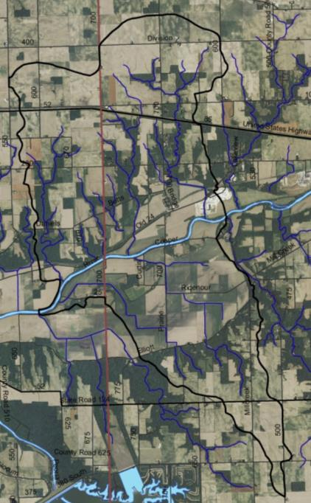
Figure 45. Gilbert Branch-Wabash River Subwatershed.

Soils
Soils in the Gilbert Branch-Wabash River Subwatershed are dominated by Sawmill-Laswon-Genesee soils which cover much of the Wabash River floodplain and corridor. These soils are found on shallowly sloped, relatively well-drained areas. Smaller areas of Blount-Glynwood-Morley, Fincastle-Brookston-Miamian and Miami-Crosby-Treaty soils cover the remainder of the subwatershed. These soils are moderately well-drained and found on shallowly sloped areas. Hydric soils cover 2,679 acres (24%) of the subwatershed, indicating that less than one quarter of the land was historically wetlands. Wetlands currently cover 1% (116.4 acres) of the subwatershed, representing a loss of 96% of historic wetlands. Highly erodible and potentially highly erodible soils are prevalent throughout the subwatershed, covering 16% and 11% of the land, respectively. More than half of the subwatershed (69%) has soils which are severely limited for septic use.

Land Use
Agricultural land uses, including row crop and pasture, account for 8,505 acre (76%) of the subwatershed land use. Forested land uses are present on 1,590 acres (14%) of the Gilbert Branch-Wabash River Subwatershed. Urban land use with nearly 7% (774.8 acres) covered by developed lands. Wetland, open water, and grasslands account for just 3% (360.5 acres) of the Gilbert Branch-Wabash River Subwatershed.

Point Source Water Quality Issues
There are no point sources of water pollution in the Gilbert Branch-Wabash River Subwatershed (Figure 46).

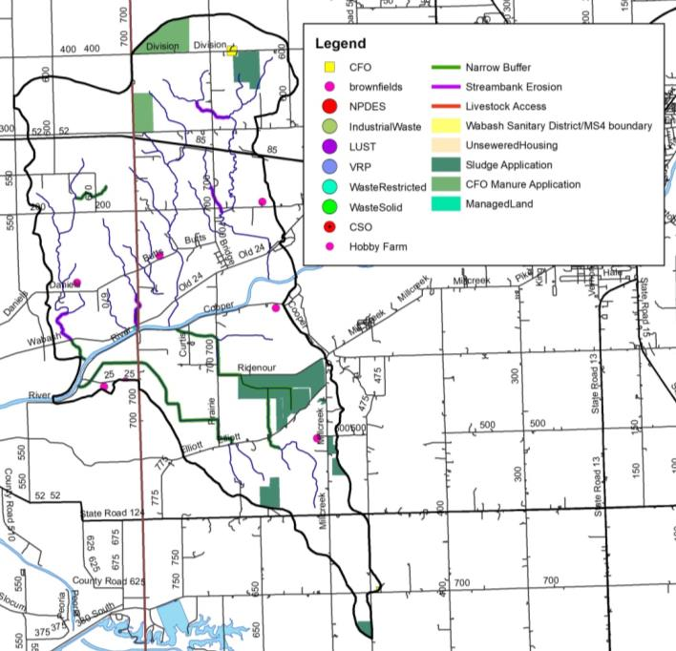
Figure 46. Point and non-point sources of pollution and suggested solutions in the Gilbert Branch-Wabash River Subwatershed.

Non-Point Source Water Quality Issues
Approximately seven small animal operations are present within the Gilbert Branch-Wabash River Subwatershed (Figure 46). These unregulated animal operations housing approximately 76 animals were identified during the windshield survey. NASS county-wide statistics provide a higher estimated density of 762 animals in the Gilbert Branch-Wabash River Subwatershed. One active confined feeding operation housing a total of 1,200 swine per year. Manure from this CFO is spread on 109 acres in the Gilbert Branch-Wabash River Subwatershed. In total, approximately 5,917 tons of manure is generated annually from CFOs and small animal operations. This contains almost 16,038 pounds of nitrogen and almost 12,041 pounds of phosphorus. Municipal biosolids are applied to 476 acres within the subwatershed. Streambank erosion impacts 4.5 miles of stream throughout the Gilbert Branch-Wabash River Subwatershed, while nearly 13.8 miles of streams possess narrow buffers.

Water Quality Assessment
Waterbodies within the Gilbert Branch-Wabash River Subwatershed have been sampled historically at 4 locations (Figure 47). Assessments include collection of water chemistry data by Wabash River Defenders (1 site). The fish community has been assessed by Indiana DNR and Purdue University (1 site), while the mussel community has been assessed at the same site by the Indiana DNR non-game program. Macroinvertebrates have not been sampled in this subwatershed. No stream gages are located in the Gilbert Branch-Wabash River Subwatershed. Add water quality details after targets are selected and data has been compiled.

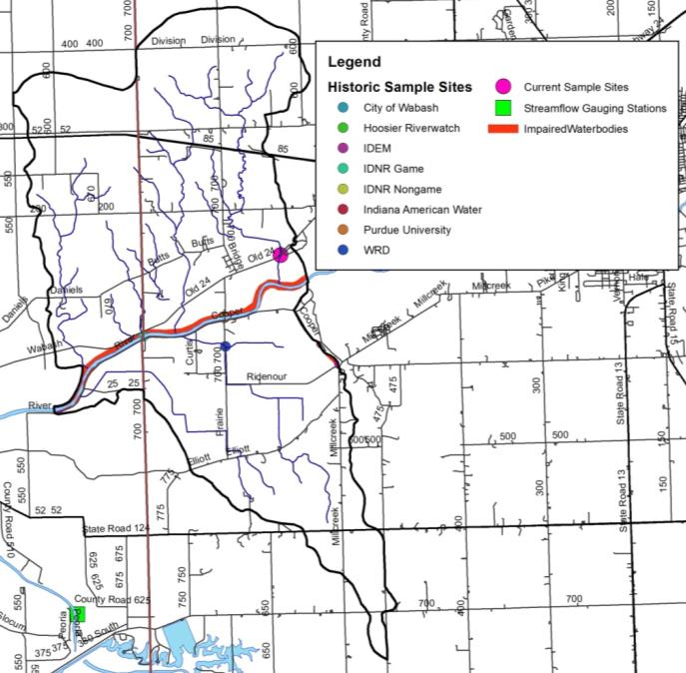
Figure 47. Locations of historic water quality data collection and impairments in the Gilbert Branch-Wabash River Subwatershed.

Gilbert Branch-Wabash River Subwatershed Summary

Daniel Creek-Wabash River Subwatershed
The Daniel Creek-Wabash River Subwatershed is the western-most subwatershed which lies completely within Miami County (Figure 48). It encompasses one 12-digit HUC watershed: 051201011407. The Daniel Creek-Wabash River Subwatershed drains 16,314 acres or 25.5 square miles. There are 46.1 miles of streams of which 3.85 miles are impaired for E. coli, nutrients, PCBs, and mercury.

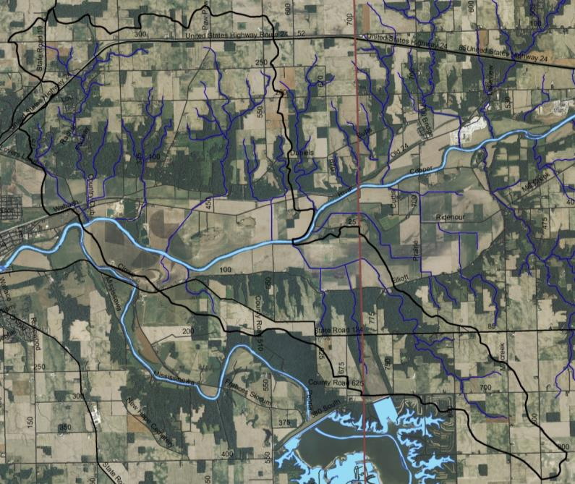
Figure 48. Daniel Creek-Wabash River Subwatershed.

Soils
Soils in the Daniel Creek-Wabash River Subwatershed are dominated by Sawmill-Laswon-Genesee soils which cover much of the Wabash River floodplain and corridor. These soils are found on shallowly sloped, relatively well-drained areas. Smaller areas of Blount-Glynwood-Morley, Fincastle-Brookston-Miamian and Miami-Crosby-Treaty soils cover the remainder of the subwatershed. These soils are moderately well-drained and found on shallowly sloped areas. Blount-Pewamo-Glynwood soils cover the northern border of the subwatershed. Hydric soils cover 2,201 acres (13%) of the subwatershed, indicating that only a small portion of the subwatershed was historically wetlands. Wetlands currently cover 2% (314.4 acres) of the subwatershed, representing a loss of 86% of historic wetlands. Highly erodible and potentially highly erodible soils are present throughout the subwatershed, covering 21% and 3% of the land, respectively. Nearly the entire subwatershed (97%) has soils which are severely limited for septic use.

Land Use
Agricultural land uses are dominant within the Daniel Creek-Wabash River Subwatershed. In total 11,183.2 acres (69%) of the subwatershed is in row crop agriculture or pasture. Nearly 2,924 acres (18% ) of the watershed is in forest land use. Wetlands, open water, and grassland cover 936.3 acres or 6% of the subwatershed. Nearly 1,280 acres (7.8%) of the Daniel Creek-Wabash RIver Subwatershed is in urban land uses including suburban development east of the City of Peru.

Point Source Water Quality Issues
There are no point sources of water pollution in the subwatershed (Figure 49).
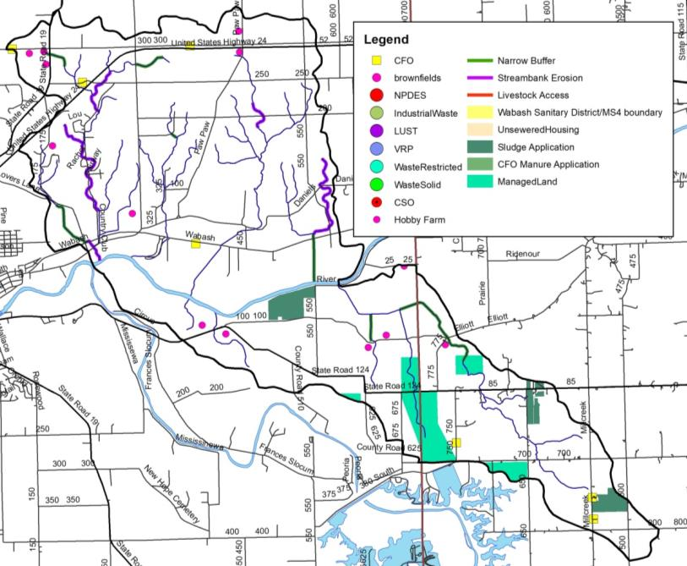
Figure 49. Point and non-point sources of pollution and suggested solutions in the Daniel Creek-Wabash River Subwatershed.

Non-Point Source Water Quality Issues
Non-point sources of pollution are found throughout the Daniel Creek-Wabash River Subwatershed (Figure 49). More than 12 small animal operations housing more than 105 animals were identified during the windshield survey, which house approximately 100 animals. NASS county-wide statistics suggest a higher animal density of 578 animals within the Daniel Creek-Wabash River Subwatershed. Livestock had access to the stream impacting 1.4 miles of streambank. Four active confined feeding operations housing more than 23,000 swine are located within the Daniel Creek-Wabash River Subwatershed. Manure from confined feeding operations and small animal operations totals over 94,850 tons per year. This contains almost 276,762 pounds of nitrogen and almost 211,277 pounds of phosphorus. Approximately 11.2 miles of streambank erosion and nearly 6.6 miles of streams with narrow buffers were identified within the subwatershed.

Water Quality Assessment
Waterbodies within the Daniel Creek-Wabash River Subwatershed have been sampled historically at 1 location (Figure 50). Assessments include collection of water chemistry data via the current project and fish community assessments via Purdue University (1 site). Macroinvertebrates have not been sampled in this subwatershed. No stream gages are located in the Daniel Creek-Wabash River Subwatershed. Add water quality details after targets are selected and data has been compiled.

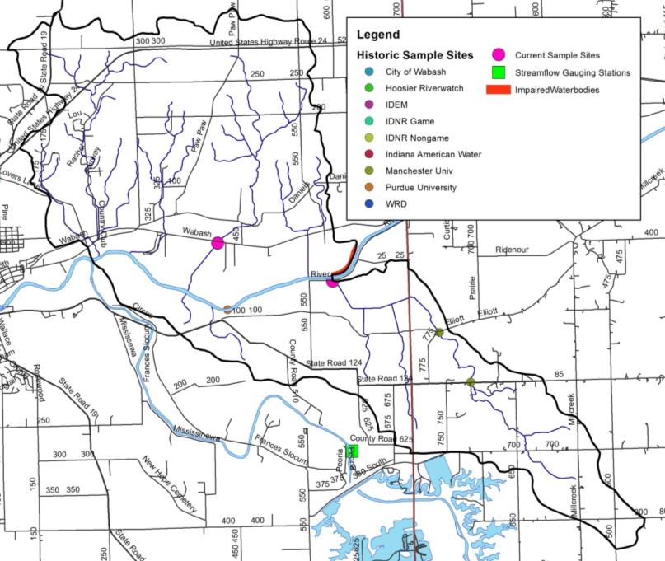
Figure 50. Locations of current and historic water quality data collection and impairments in the Daniel Creek-Wabash River Subwatershed.

Daniel Creek-Wabash River Subwatershed Summary

LITERATURE CITED
Armitage, B.J. and E.T. Rankin. 2009. An assessment of threats to the biological condition of the Wabash River aquatic ecosystem of Indiana. Prepared for The Nature Conservancy, Indiana Chapter, Indianapolis, Indiana.

Center for Watershed Protection. 2003. Effects of impervious cover on aquatic resources. Ellicott City, Maryland.

Clark, F. 1994. Indian GAP analysis: Implecations for biodiversity conservation and restoration. Proceedings of the Indiana Academy of Science, Vol 103(3-4): 215-224.

Clark, T. 2018. ETR and high quality natural communities database search, personal communications, 5 February 2018.

Coulter, J. 1886. Indiana Geological Report for 1886.

Elvidge, C. D., C. Milesi, J. B. Dietz, B. T. Tuttle, P. C., Sutton, R. Nemani, and J. Vogelmann. 2004. U.S. constructed areas approaches the size of Ohio, Eos Trans. AGU, 85(24), 233.

Grove, G. 2007. Bedrock aquifer systems of Wabash County, Indiana. Indiana Department of Natural Resources, Division of Water, Indianapolis, Indiana.

Gutschick, R.C. 1966. Bedrock Geology. In Lindsey, 1966. Natural features of Indiana, Indiana Academy of Science, Indianapolis, Indiana

Homoya, M.A., B.D. Abrell, J.R. Alrich, and T.W. Post. 1985. The natural regions of Indiana. Indiana Academy of Science, 91.

IDEM, 2013. E. coli TMDL report for Otter Creek, Indianapolis, Indiana.

IDEM. 2007. [web site] Wetlands. http://www.in.gov/idem/4138.htm [Accessed 22 February 2018

IDEM. 2016. Indiana integrated water monitoring and assessment report 2016. Section 305(b) water quality report and consolidated list including Section 303(d) list of impaired waterbodies. IDEM, Office of Water Quality, Watershed Branch, Indianapolis, Indiana.

Indiana Department of Environmental Management. 2015. Confined Feeding Operations GIS layer.

Indiana Department of Environmental Management. 2018. Municipal biosolid land application sites, GIS metadata. Indianapolis, Indiana.

Indiana Department of Natural Resources. 2001. [web page] https://www.in.gov/history/markers/20.htm Visited 13 February 2018.

Indiana Geological Survey. 2015. Aquifer sensitivity near surface. Source: IndianaMap

Indiana State Department of Agriculture. 2017. [web page] Tillage transect data. http://www.in.gov/isda/2383.htm [Accessed 4 February 2018]
Indiana State Department of Agriculture. 2017A. [web page] Tillage transect data, Miami County. http://www.in.gov/isda/2383.htm [Accessed 4 February 2018]

Indiana State Department of Agriculture. 2017B. [web page] Tillage transect data, Wabash County. http://www.in.gov/isda/2383.htm [Accessed 4 February 2018]

ISDH. 2017. 2017 Indiana fish advisory. [web page] https://www.in.gov/isdh/23650.htm [Accessed 2 February 2018]

Kennedy, A.J., D.J. Daugherty, T.M. Sutton, and B.E. Fisher. 2007. Population characteristics of shovelnose sturgeon in the Upper Wabash River, Indiana. North American Journal of Fisheries Management, 27: 52-62.

Krenz, J.L. and B.D. Lee. 2004. Mineralogy and hydraulic conductivity of selected moraines and associated till plains in northeast Indiana.

Kroeker Consulting, LLC. 2016. Lower Salamonie River Watershed Management Plan. Indiana Department of Environmental Management EDS A305-3-9.

Lee, B., D. Jones, and H. Peterson. 2005 Septic system failure. Home and Environment 1: 1-3.

Malott, C.A. 1922. The physiography of Indiana, in Handbook of Indiana Geology. Indiana Department of Conservation.

National Agricultural Statistics Service. 2006. [web page] Agricultural chemical use database. http://www.pestmanagement.info/nass/ [Accessed 25 August 2009]

National Agricultural Statistics Service. 2007. [web page] 2007 Census publications State and County profiles. http://www.agcensus.usda.gov/Publications/2007/Online_Highlights/County_Profiles/Indiana/index.asp [Accessed 22 July 2009]

National Land Cover Database. 2011. [web page] https://www.mrlc.gov/nlcd2011.php [Visited 2 January 2018]

Natural Resources Conservation Service. 2018 [ web page] https://websoilsurvey.sc.egov.usda.gov/App/HomePage.htm [Visited 2 January 2018]

Ohio EPA. 1999. Ohio EPA recommended criteria for Warm Water Habitat (WWH) headwater streams in Ohio EPA Technical Bulletin MAS//1999-1-1, Columbus, Ohio.

Omernik, J.M. and A.L. Gallant. 1988. Ecoregions of the Upper Midwest. U.S. Environmental Protection Agency, Corvallis, Oregon. EPA/600/3-88/037.

Petty, R.O. and M.T. Jackson. 1966. Plant communities. In: Lindsey, A.A. (ed) Natural features of Indiana. Indiana Academy of Science, Indiana State Library, Indianapolis, Indiana. page 264-296.

Plowman, B.W. 2006. 2005 Statewide archers index of furbearer populations. Indiana Department of Natural Resources, Wildlife Management and Research Note Number 915, Indianapolis, Indiana. http://www.in.gov/dnr/fishwild/files/MR_915_Archers_Index_2005.pdf

Pyron, M. and T.E. Lauer. 2004. Hydrological variation and fish assemblage structure in the Middle Wabash River. Hydrobiologia 525: 203-213.
Pyron, M. and T.E. Lauer. 2009. Middle Wabash River fish community assessment: Final report for 2008 data. Submitted to Eli Lilly and Company and Duke Energy.

Pyron, M., T. E. Lauer, and J. R. Gammon. 2006. Stability of the Wabash River fish assemblages from 1974-1998. Freshwater Biology 51:1789-1797.

StatsIndiana. 2018. [web page] http://www.stats.indiana.edu/topic/census.asp Visited 27 February 2018

Stefanavage, T.C. 2008. Wabash River fish community, aquatic habitat, and public access survey. Indiana Department of Natural Resources, Indianapolis, Indiana.

Sugg, Z. 2007. Assessing U.S. Farm Drainage: Can GIS lead to better estimates of subsurface drainage extent? World Resources Institute, Washington, D.C.

Sweeten, J. 2009. Redside dace (Clinostomus elongates) in Mill Creek, Wabash County: A strategy for population research. Indiana Department of Natural Resources, State Wildlife Grant annual report, 2009. https://www.in.gov/dnr/fishwild/files/fw-09WildlifeDiversityReportResearchRedSideDace.pdf

Sweeten, J. 2010. Redside dace (Clinostomus elongates) in Mill Creek, Wabash County: A strategy for population research. Indiana Department of Natural Resources, State Wildlife Grant annual report, 2009. https://www.in.gov/dnr/fishwild/files/fw-10WildlifeDiversityReportResearchRedSideDace.pdf

Sweeten, J. 2011. Redside dace (Clinostomus elongates) in Mill Creek, Wabash County: A strategy for population research. Indiana Department of Natural Resources, State Wildlife Grant annual report, 2009. https://www.in.gov/dnr/fishwild/files/fw-11WildlifeDiversityReportResearchRedSideDace.pdf

Sweeten, J. 2012. Redside dace (Clinostomus elongates) in Mill Creek, Wabash County: A strategy for population research. Indiana Department of Natural Resources, State Wildlife Grant annual report, 2009. https://www.in.gov/dnr/fishwild/files/fw-12WildlifeDiversityReportResearchRedSideDace.pdf

Sweeten, J., K. Airgood, M. Bowman, B. Cloud, E. Hammond, D. Losey, H. Manifold, A. Melick, and J. Wenger. 2013. Redside dace in Mill Creek, Wabash County, Indiana: A strategiy research and augmentation. Manchester University funded via an Indiana State Wildlife Grant (T07R07) through the Indiana Department of Natural Resources.

TetraTech, Inc. 2008. Wabash River nutrient and pathogen TMDL development. Illinois EPA and Indiana Department of Environmental Management, Indianapolis, Indiana.

U.S. Climate Date. 2018. [web page] https://www.usclimatedata.com/climate/wabash/indiana/united-states/usin0688. Visited 6 February 2018.

U.S. Environmental Protection Agency. 2018 EPA FRS Facilities State Single Download. Exported 21 February 2018. [web page] https://www.epa.gov/enviro/epa-frs-facilities-state-single-file-csv-download [visted 1 March 2018]

U.S. Fish and Wildlife Service. 2017. National Wetland Inventory. https://www.fws.gov/wetlands/

U.S. Geological Survey. 2018. [web page] National Hydrography Dataset. https://nhd.usgs.gov/ [Visited 2 January 2018]

United Consulting. 2003. Combined Sewer Overflow Stream Reach Characterization and Evaluation Report prepared for the City of Wabash, Wabash, Indiana.

United Consulting. 2016. Combined Sewer Overflow Operational Plan Update prepared for the City of Wabash, Wabash, Indiana.

Wabash County. 2012. Wabash County Comprehensive Plan, Wabash, Indiana.

